Home Learning Booklet
Spring 2
Year 1
This booklet belongs to

Woodlands Primary School
Homework Grid Spring 2

 | Expected |  | Exceeding Expected |  |  |  | Greater Depth
 | These need to be carried out every week |  | Maths |  | English |  | Select 2 projects from the list below to do over the half term
Week 1 | Reading at LEAST 3 times  Revisit all spellings from last term  Complete number bonds sheet to 20 |  | Counting in 2s. Fill the caterpillar with numbers counting up in 2s.
Week 2 | Reading at LEAST 3 times  Complete Spelling Sheet  Complete number bonds sheet  to 20 |  | Education City - |  | Children to practise writing days of the week. |  | - Create a bug hotel. Use small logs, large sticks and pieces of rotting wood. Pile them up in a damp, shady area of your garden, then stuff some dead leaves in the nooks and crannies to make it cosy.  - Grow some vegetables such as tomatoes, cucumbers etc.  - Go on a nature walk and collect parts of plants to use on a woodland piece of art.
Week 3 | Reading at LEAST 3 times  Complete Spelling Sheet  Complete number bonds sheet  to 20 |  | Tens and ones.  Children to write the amount of tens and ones.
Week 4 | Reading at LEAST 3 times  Complete Spelling Sheet  Complete number bonds sheet to 20 |  |  |  | Children to choose from the list the correct day of the week (Yesterday and Tomorrow).  Education City - Reading comprehension
Week 5 | Reading at LEAST 3 times  Complete Spelling Sheet  Subtraction within 20 using a numberline. |  | Place value – Tens and ones.  Children to fill in the table.  84 e.g. 8 tens and 4 ones. |  | Education City – On Cue

Expected
Week 1: Spelling practise: Look, say, cover, write, check
Look | Say | Cover | Write | Check | Write | Check | Write | Check
Kent
sketch
kit
skin
frisky
skill
kettle
kilt
king

Now choose two of the words to write in a sentence.
1. _______________________________________________________________________________________
2. _______________________________________________________________________________________

Expected
Week 1 Number bonds to 20.

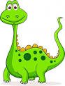
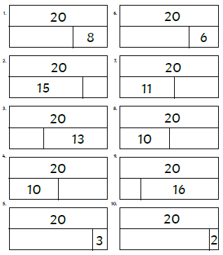
Remember that number bonds to 20 are two numbers that add together to make 20!

Exceeding Expected
Week 1- Counting in 2s
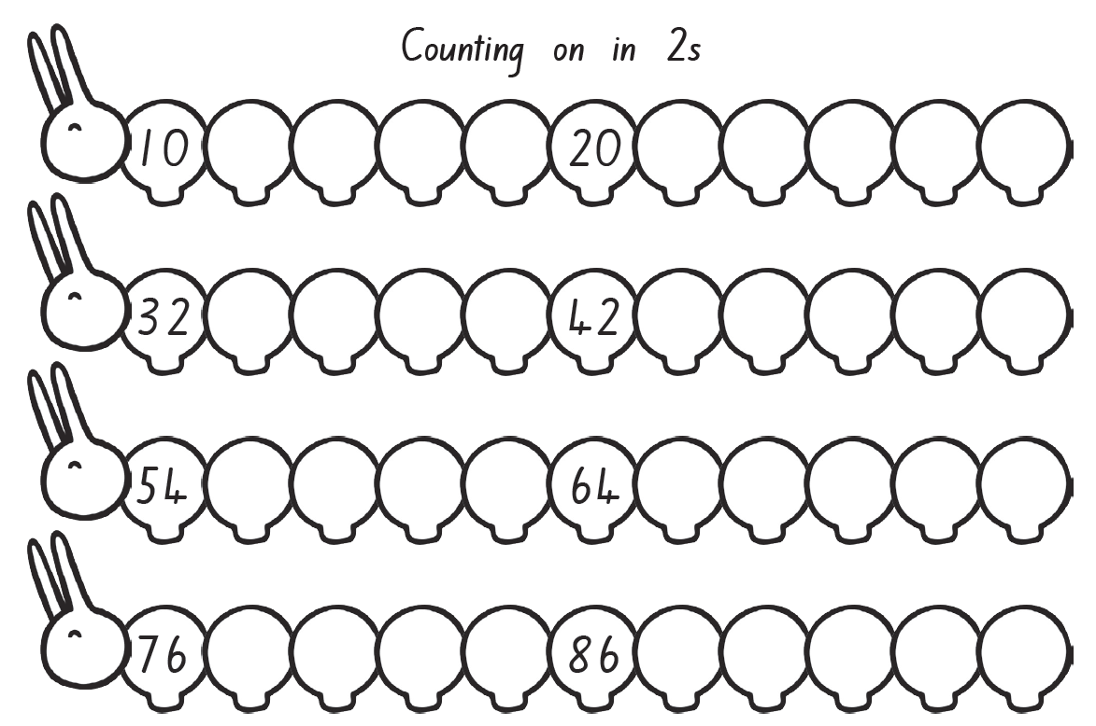

Expected
Week 2: Spelling practise: Look, say, cover, write, check
Look | Say | Cover | Write | Check | Write | Check | Write | Check
made
came
same
take
safe
date
lake
these
theme
complete

Now choose two of the words to write in a sentence.
1. _______________________________________________________________________________________
2. _______________________________________________________________________________________
Expected
Week 2 Number bonds to 20.
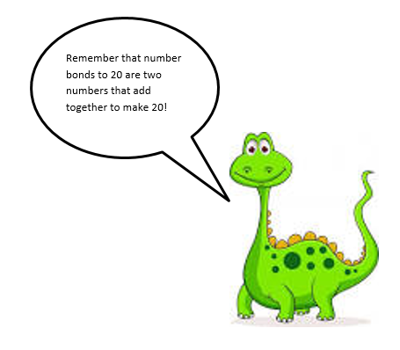
6 + = 20
+ 3 = 20
13 + 7 = hh
1 + = 20
+ 4 = 20
4 + 16 = hh
4 + = 20
+ 8 = 20
- + 19 = hh
10 + = 20
+ 9 = 20
0 + 20 = hh

5 + = 20
+ 6 = 20
9 + 11 = hh
7 + = 20
+ 0 = 20
8 + 12 = hh
6 + = 20
+ 7 = 20
5 + 15 = hh
2 + = 20
+ 10 = 20
3 + 17 = hh

Exceeding Expected Week 2- Days of the week (Spelling)
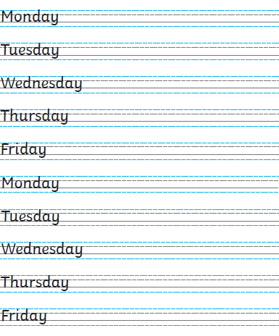

Exceeding expected
Week 2 – Education City
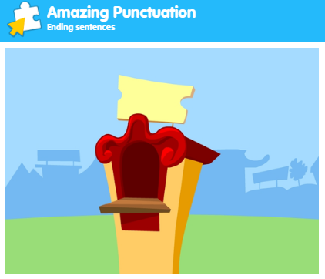
What score did you get?
___________

Expected
Week 3: Spelling practise: Look, say, cover, write, check
Look | Say | Cover | Write | Check | Write | Check | Write | Check
five
ride
like
time
side
home
those
woke
hope
hole

Now choose two of the words to write in a sentence.
1. _______________________________________________________________________________________
2. _______________________________________________________________________________________

Expected
Week 3- Addition and Subtraction within 20
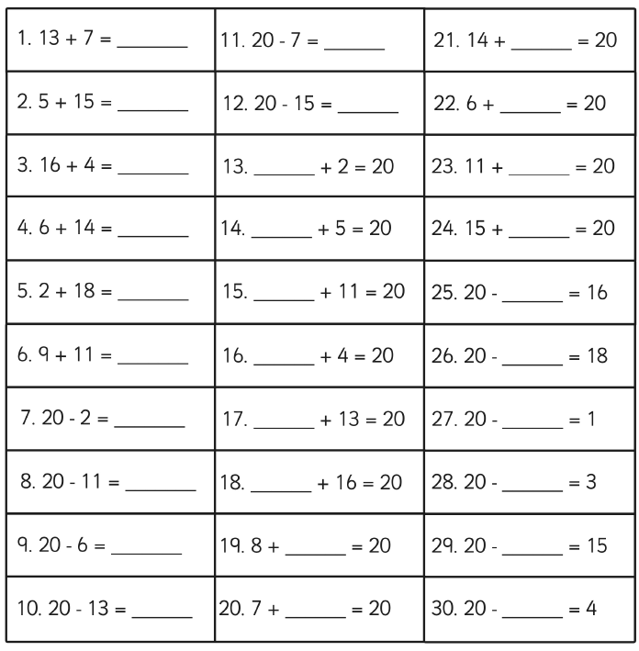
Exceeding Expected
Week 3- Tens and Ones
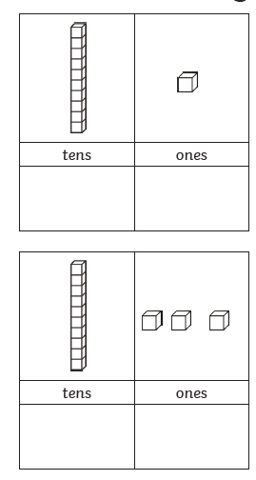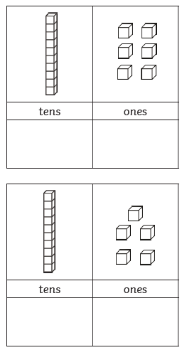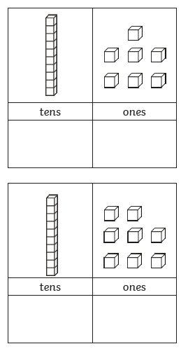

Expected
Week 4: Spelling practise: Look, say, cover, write, check
Look | Say | Cover | Write | Check | Write | Check | Write | Check
June
rule
rude
flute
use
tube
tune
huge
cute
cube

Now choose two of the words to write in a sentence.
1. _______________________________________________________________________________________
2. _______________________________________________________________________________________

Expected
Week 4-Number bonds to 20
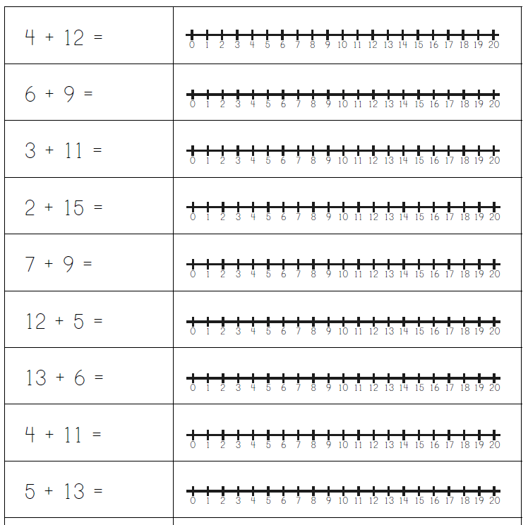
Exceeding Expected
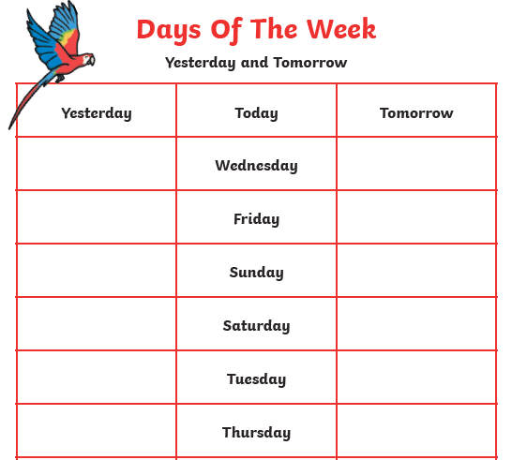
Week 4- Days of the week (Yesterday and Tomorrow)
Monday
Tuesday
Wednesday
Thursday
Friday
Saturday
Sunday

Exceeding expected
Week 4 Reading comprehension
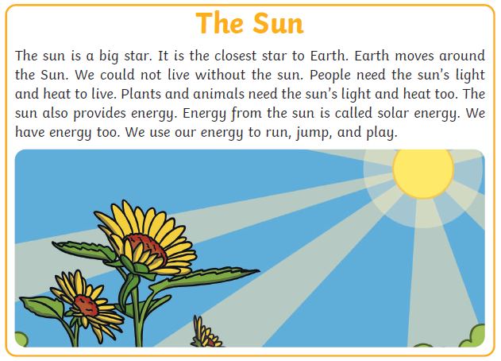
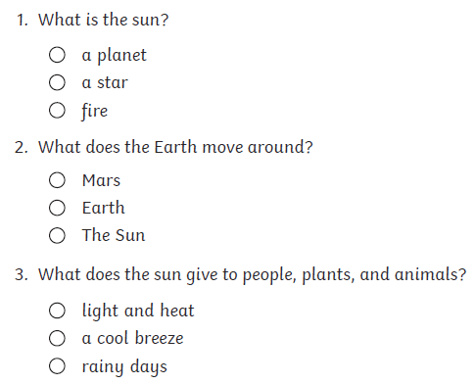

Expected
Week 5: Spelling practise: Look, say, cover, write, check
Look | Say | Cover | Write | Check | Write | Check | Write | Check
food
pool
moon
soon
zoo
book
took
foot
wood
good

Now choose two of the words to write in a sentence.
1. _______________________________________________________________________________________
2. _______________________________________________________________________________________

Expected
Week 5 Subtraction with numberlines.
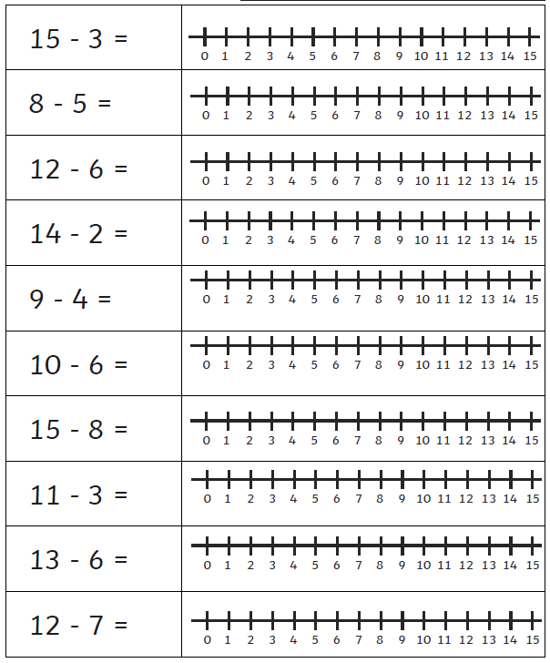
Exceeding Expected
Week 5- Partitioning Numbers (to 50)
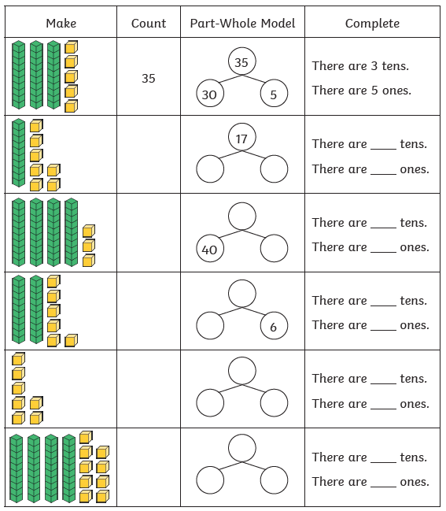
Exceeding Expected
Week 5
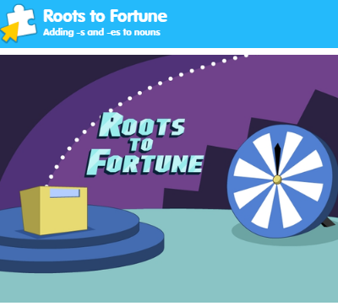
What score did you get?
___________

