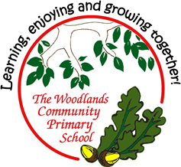

Dear Parents/Carers,

**RE: Puberty**

Next week, as part of the PSHE curriculum, Year 5 and 6 will be taught about the changes that happen to a person’s body as they reach and go through puberty.

We will be approaching all of these lessons in an age-appropriate way and making sure that all of our children are aware that these lessons are designed to help them understand more about themselves both now and in the near future. Such lessons will continue as they begin their new journey in high school.

Year 5 will only take part in a specific part of this lesson: hygiene for both boys and the girls and the year 5 girls will join the year 6 girls for a discussion about menstruation.

If young people can start their transition into adulthood with good information and the confidence and knowledge to understand what is happening to them, they will hopefully grow into confident and healthy adults able to make positive choices. This can start with learning the basics about growing up and the sessions in school may reinforce what you are already doing at home.

As some of our children are already growing into young adults, we feel that this is a very important time for them to learn about menstruation and the changes their bodies will go through during puberty. This lesson will only include a discussion about the changes that boys’ and girls’ bodies will go through, what menstruation is and the children will have the opportunity to look at a variety of hygiene products.

You are welcome to contact your child’s class teacher to discuss the session. Parents can withdraw their child from all or part of the session that does not form part of the statutory national curriculum. **If you wish to withdraw your child from all or part of the session, please contact your child’s class teacher or the office by Wednesday 3rd July**. For further information, see the PHSE/RSE policy under policies on the school website. The session will be taught on Friday 5th July. All children will attend the session unless we hear directly from parents. A copy of this letter can be found on the school website.

Yours sincerely,

Mrs Holliday, Mr Tennuci, Mrs Davies