

Home Learning Booklet

**Year 5 Autumn 2**

**Fallen Fields (WWI)**

This booklet belongs to

**Woodlands Primary School**

**Homework Grid Autumn 2**

|  |  |  |  |  |  |
| --- | --- | --- | --- | --- | --- |
|  | **Expected** | **Exceeding Expected** | | | **Greater Depth** |
|  | These need to be carried out every week | **Maths** | **English** | | Here are some activities for you to complete at home:   * Write a diary entry as a soldier in the trenches * Draw or paint No Man’s Land with poppies growing in the scene. * Investigate WW1 recipes and write a recipe for a chosen meal. * Create your own model of No Man’s Land. |
| Wk 1 | Reading at LEAST 3 times  Complete Spelling Sheet  *Rule: words with silent letters*  Complete times table sheets | Education City  Activity – IV the win  (Roman Numerals) | Relative clauses | |
| Wk 2 | Reading at LEAST 3 times  Complete Spelling Sheet  *Rule: words with silent letters*  Complete times table sheets | Rounding to the nearest 100,000 | Education City  Activity – The cave of verbs  (active and passive verbs) | |
| Wk 3 | Reading at LEAST 3 times  Complete Spelling Sheet  *Rule: modal verbs*  Complete times table sheets | Education City  Activity – Time to chill  (Negative Numbers) | Subordinate clauses | |
| Wk 4 | Reading at LEAST 3 times  Complete Spelling Sheet  *Rule: suffix -ment*  Complete times table sheets | Multi-step word problems | Education City  Activity – How to train your wagon.  (Subordinate clauses) | |
| Wk 5 | Reading at LEAST 3 times  Complete Spelling Sheet  *Rule: adverbs of frequency and possibility*  Complete times table sheets | Education City  Activity – Divisible me  (x and ÷ by 10, 100, 1000) | Synonyms and antonyms | |
| Wk 6 | Reading at LEAST 3 times  Complete Spelling Sheet  *Rule: Year 5 statutory spelling list*  Complete times table sheets | Equivalent fractions | Education City  Activity – Safe and sand  (Perfect tense) | |
|  | **Homework will be given out every Friday. Homework will be collected every Wednesday.** | | |  |

**Expected: Due 09.11.22 Week 1 Spelling practise:** Look, say, cover, write, check

|  |  |  |  |  |  |  |  |  |
| --- | --- | --- | --- | --- | --- | --- | --- | --- |
| **Look** | **Say** | **Cover** | **Write** | **Check** | **Write** | **Check** | **Write** | **Check** |
| example |  |  | *exampel* | 🗶 | *example* | ✓ | *example* | ✓ |
| doubt |  |  |  |  |  |  |  |  |
| lamb |  |  |  |  |  |  |  |  |
| debt |  |  |  |  |  |  |  |  |
| thumb |  |  |  |  |  |  |  |  |
| solemn |  |  |  |  |  |  |  |  |
| autumn |  |  |  |  |  |  |  |  |
| column |  |  |  |  |  |  |  |  |
| knight |  |  |  |  |  |  |  |  |
| knuckle |  |  |  |  |  |  |  |  |
| knot |  |  |  |  |  |  |  |  |

Now apply six of those words in a sentence.

1. ____________________________________________________________________________________________________________________________________________________

2. ___________________________________________________________________________________________________________________________________________________

3. ___________________________________________________________________________________________________________________________________________________

4. ___________________________________________________________________________________________________________________________________________________

5. ­___________________________________________________________________________________________________________________________________________________

6. ___________________________________________________________________________________________________________________________________________________

**Expected -** **Week 1**

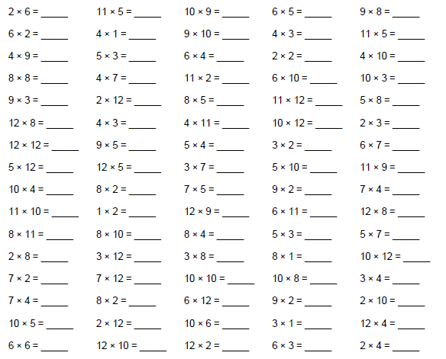

**Exceeding expected- Week 1**

Rewrite these sentences so they include a relative clause. Using the relative pronouns to help you.

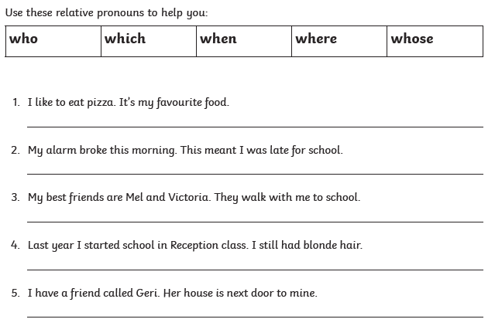

**Expected – Due 16.11.22 Week 2 Spelling practise:** Look, say, cover, write, check

|  |  |  |  |  |  |  |  |  |
| --- | --- | --- | --- | --- | --- | --- | --- | --- |
| **Look** | **Say** | **Cover** | **Write** | **Check** | **Write** | **Check** | **Write** | **Check** |
| example |  |  | *exampel* | 🗶 | *example* | ✓ | *example* | ✓ |
| wrestle |  |  |  |  |  |  |  |  |
| wrapper |  |  |  |  |  |  |  |  |
| island |  |  |  |  |  |  |  |  |
| aisle |  |  |  |  |  |  |  |  |
| debris |  |  |  |  |  |  |  |  |
| mortgage |  |  |  |  |  |  |  |  |
| castle |  |  |  |  |  |  |  |  |
| yacht |  |  |  |  |  |  |  |  |
| guarantee |  |  |  |  |  |  |  |  |
| guilty |  |  |  |  |  |  |  |  |

Now write the words in a sentence.

1. ____________________________________________________________________________________________________________________________________________________

2. ___________________________________________________________________________________________________________________________________________________

3. ___________________________________________________________________________________________________________________________________________________

4. ___________________________________________________________________________________________________________________________________________________

5. ­___________________________________________________________________________________________________________________________________________________

6. ___________________________________________________________________________________________________________________________________________________

7. ___________________________________________________________________________________________________________________________________________________

8. ___________________________________________________________________________________________________________________________________________________

**Expected** - **Week 2**

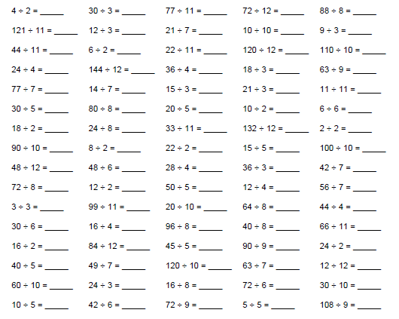

**Exceeding expected- Week** **2**

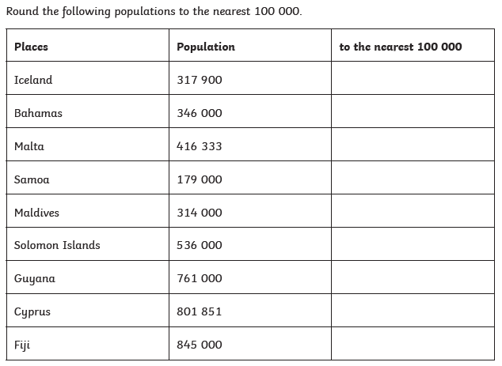

**Expected – Due 23.11.22 Week 3 Spelling practise:** Look, say, cover, write, check

|  |  |  |  |  |  |  |  |  |
| --- | --- | --- | --- | --- | --- | --- | --- | --- |
| **Look** | **Say** | **Cover** | **Write** | **Check** | **Write** | **Check** | **Write** | **Check** |
| example |  |  | *exampel* | 🗶 | *example* | ✓ | *example* | ✓ |
| can |  |  |  |  |  |  |  |  |
| could |  |  |  |  |  |  |  |  |
| may |  |  |  |  |  |  |  |  |
| might |  |  |  |  |  |  |  |  |
| must |  |  |  |  |  |  |  |  |
| shall |  |  |  |  |  |  |  |  |
| should |  |  |  |  |  |  |  |  |
| will |  |  |  |  |  |  |  |  |
| would |  |  |  |  |  |  |  |  |
| ought |  |  |  |  |  |  |  |  |

**Now write the words in a sentence.**

1. ____________________________________________________________________________________________________________________________________________________

2. ___________________________________________________________________________________________________________________________________________________

3. ___________________________________________________________________________________________________________________________________________________

4. ___________________________________________________________________________________________________________________________________________________

5. ­___________________________________________________________________________________________________________________________________________________

6. ___________________________________________________________________________________________________________________________________________________

**Expected - Week 3**

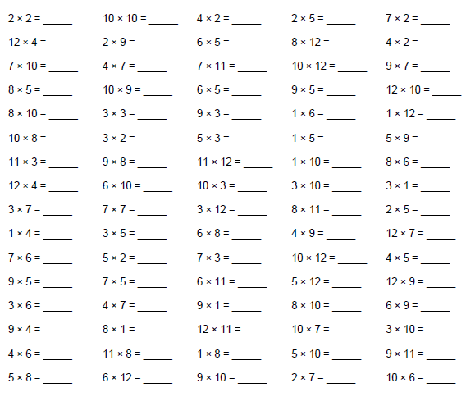

**Exceeding expected – week 3**

Use the following conjucntions to add subordinate clauses to these sentences:

|  |  |  |  |  |  |  |  |  |  |
| --- | --- | --- | --- | --- | --- | --- | --- | --- | --- |
| if | since | as | when | although | while | after | before | until | because |

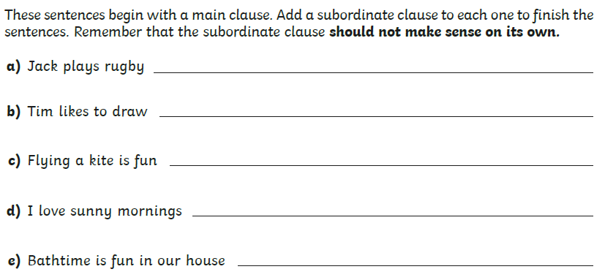

**Expected – Due 30.11.22 Week 4 Spelling practise:** Look, say, cover, write, check

|  |  |  |  |  |  |  |  |  |
| --- | --- | --- | --- | --- | --- | --- | --- | --- |
| **Look** | **Say** | **Cover** | **Write** | **Check** | **Write** | **Check** | **Write** | **Check** |
| example |  |  | *exampel* | 🗶 | *example* | ✓ | *example* | ✓ |
| equipment |  |  |  |  |  |  |  |  |
| environment |  |  |  |  |  |  |  |  |
| government |  |  |  |  |  |  |  |  |
| parliament |  |  |  |  |  |  |  |  |
| enjoyment |  |  |  |  |  |  |  |  |
| document |  |  |  |  |  |  |  |  |
| management |  |  |  |  |  |  |  |  |
| movement |  |  |  |  |  |  |  |  |
| replacement |  |  |  |  |  |  |  |  |
| statement |  |  |  |  |  |  |  |  |

Now write the words in a sentence.

1. ____________________________________________________________________________________________________________________________________________________

2. ___________________________________________________________________________________________________________________________________________________

3. ___________________________________________________________________________________________________________________________________________________

4. ___________________________________________________________________________________________________________________________________________________

5. ­___________________________________________________________________________________________________________________________________________________

6. ___________________________________________________________________________________________________________________________________________________

**Expected - Week 4**

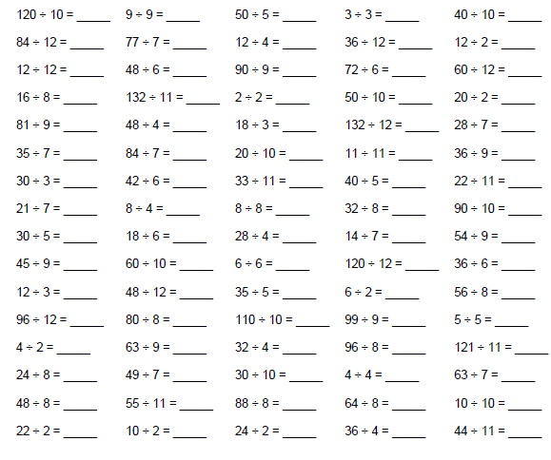

**Exceeding expected – week 4**

Answer the following problems and show your working using column method.

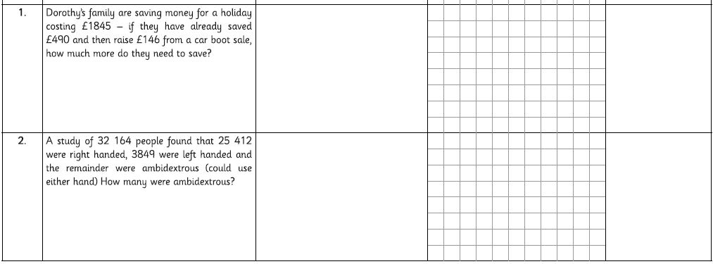

**Expected – Due 07.12.22 Week 5 Spelling practise:** Look, say, cover, write, check

|  |  |  |  |  |  |  |  |  |
| --- | --- | --- | --- | --- | --- | --- | --- | --- |
| **Look** | **Say** | **Cover** | **Write** | **Check** | **Write** | **Check** | **Write** | **Check** |
| example |  |  | *exampel* | 🗶 | *example* | ✓ | *example* | ✓ |
| certainly |  |  |  |  |  |  |  |  |
| definitely |  |  |  |  |  |  |  |  |
| possibly |  |  |  |  |  |  |  |  |
| probably |  |  |  |  |  |  |  |  |
| frequently |  |  |  |  |  |  |  |  |
| often |  |  |  |  |  |  |  |  |
| occasionally |  |  |  |  |  |  |  |  |
| rarely |  |  |  |  |  |  |  |  |
| always |  |  |  |  |  |  |  |  |
| perhaps |  |  |  |  |  |  |  |  |

**Now write the words in a sentence.**

1. ____________________________________________________________________________________________________________________________________________________

2. ___________________________________________________________________________________________________________________________________________________

3. ___________________________________________________________________________________________________________________________________________________

4. ___________________________________________________________________________________________________________________________________________________

5. ­___________________________________________________________________________________________________________________________________________________

**Expected** - **Week 5**

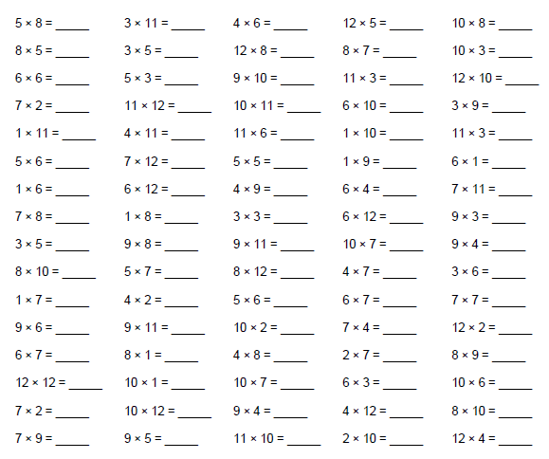

**Exceeding expected – week 5**

Synonyms are words with similar meanings. Antonyms are words with the opposite meaning.

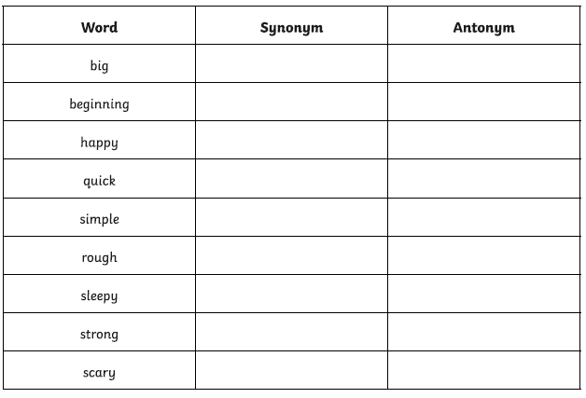

**Expected – Due 014.12.22 Week 6 Spelling practise:** Look, say, cover, write, check

|  |  |  |  |  |  |  |  |  |
| --- | --- | --- | --- | --- | --- | --- | --- | --- |
| **Look** | **Say** | **Cover** | **Write** | **Check** | **Write** | **Check** | **Write** | **Check** |
| example |  |  | *exampel* | 🗶 | *example* | ✓ | *example* | ✓ |
| vegetable |  |  |  |  |  |  |  |  |
| vehicle |  |  |  |  |  |  |  |  |
| bruise |  |  |  |  |  |  |  |  |
| soldier |  |  |  |  |  |  |  |  |
| stomach |  |  |  |  |  |  |  |  |
| recommend |  |  |  |  |  |  |  |  |
| leisure |  |  |  |  |  |  |  |  |
| privilege |  |  |  |  |  |  |  |  |
| occur |  |  |  |  |  |  |  |  |
| neighbour |  |  |  |  |  |  |  |  |

**Now write the words in a sentence.**

1. ____________________________________________________________________________________________________________________________________________________

2. ___________________________________________________________________________________________________________________________________________________

3. ___________________________________________________________________________________________________________________________________________________

4. ___________________________________________________________________________________________________________________________________________________

5. ­___________________________________________________________________________________________________________________________________________________

6. ___________________________________________________________________________________________________________________________________________________

**Expected - Week 6**

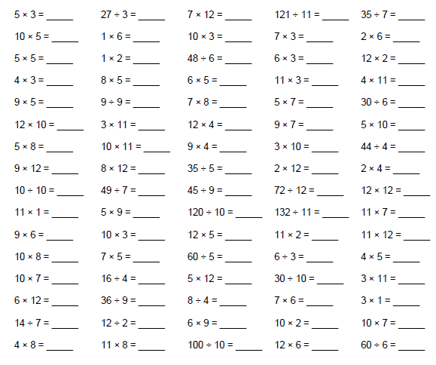

**Exceeding expected – week 6**

Complete these equivalent fractions

