

Home Learning Booklet

**Year 6 Spring 1**

This booklet belongs to



**Woodlands Primary School**

**Homework Grid Spring 1**

|  |  |  |  |  |
| --- | --- | --- | --- | --- |
|  | **Expected** | **Exceeding Expected** | | **Greater Depth** |
|  | These need to be carried out every week | **Maths** | **English** | Here are some activities for you to complete at home:   * Research how the Mayans lived and compare it to our lifestyles * Create a information PowerPoint on Mexico-include transitions, images and writing * Design and make an item of clothing that would be suitable for people who lived in the Mayan civilisation! * Create a top trumps game using facts about Mexico * Complete some sewing or cross stitch inspired by Mexico |
| Wk 1 | Reading at LEAST 3 times  Complete Spelling Sheet  Complete times table sheets | Adding fractions | Modal verbs |
| Wk 2 | Reading at LEAST 3 times  Complete Spelling Sheet  Complete times table sheets | Multiplication in grid formation | Adverbs and adverbial phrases |
| Wk 3 | Reading at LEAST 3 times  Complete Spelling Sheet  Complete times table sheets | Triangles | Homophones |
| Wk 4 | Reading at LEAST 3 times  Complete Spelling Sheet  Complete times table sheets | Time tables | Multi questions practice |
| Wk 5 | Reading at LEAST 3 times  Complete Spelling Sheet  Complete times table sheets | Decimals | Multi questions practice |
| Wk 6 | Reading at LEAST 3 times  Complete Spelling Sheet  Complete times table sheets | Multi question practice | Author writing |
| Wk 7 | Consolidation activities mixed variety and levels of achievement | | |
|  | **Homework will be given out every Friday. Homework will be collected every Wednesday- EDUCATION CITY is checked every Wednesday and there is work continuously set online for completion.** | | | |

**Expected: Due 11.01.23 Week 1 Spelling practise:** Look, say, cover, write, check

|  |  |  |  |  |  |  |  |  |
| --- | --- | --- | --- | --- | --- | --- | --- | --- |
| **Look** | **Say** | **Cover** | **Write** | **Check** | **Write** | **Check** | **Write** | **Check** |
| example |  |  | *example* | 🗶 | *example* | ✓ | *example* | ✓ |
| referring |  |  |  |  |  |  |  |  |
| referred |  |  |  |  |  |  |  |  |
| referral |  |  |  |  |  |  |  |  |
| reference |  |  |  |  |  |  |  |  |
| referee |  |  |  |  |  |  |  |  |
| preferring |  |  |  |  |  |  |  |  |
| preferred |  |  |  |  |  |  |  |  |
| preference |  |  |  |  |  |  |  |  |
| transferring |  |  |  |  |  |  |  |  |
| transference |  |  |  |  |  |  |  |  |

Now apply six of those words in a sentence.

1. ____________________________________________________________________________________________________________________________________________________

2. ___________________________________________________________________________________________________________________________________________________

3. ___________________________________________________________________________________________________________________________________________________

4. ___________________________________________________________________________________________________________________________________________________

5. ­___________________________________________________________________________________________________________________________________________________

6. ___________________________________________________________________________________________________________________________________________________

**Expected -** **Week 1**

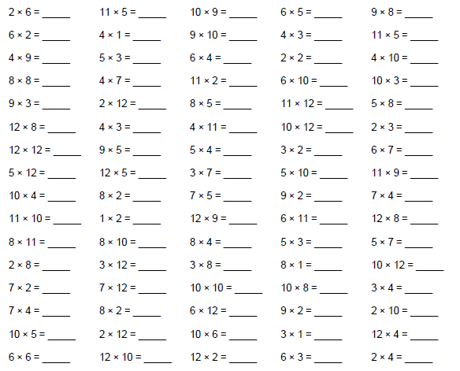

**Exceeding expected- Week 1**

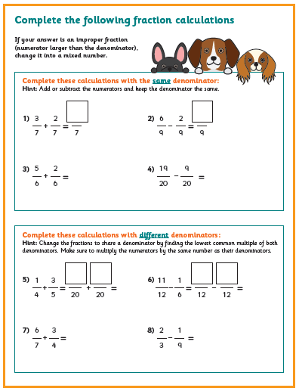

**Exceeding expected Week 1**

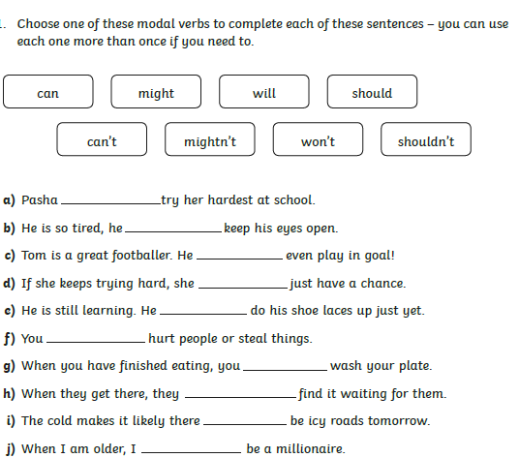

**Expected – Due 18.01.23 Week 2 Spelling practise:** Look, say, cover, write, check

|  |  |  |  |  |  |  |  |  |
| --- | --- | --- | --- | --- | --- | --- | --- | --- |
| **Look** | **Say** | **Cover** | **Write** | **Check** | **Write** | **Check** | **Write** | **Check** |
| example |  |  | *example* | 🗶 | *example* | ✓ | *example* | ✓ |
| siege |  |  |  |  |  |  |  |  |
| niece |  |  |  |  |  |  |  |  |
| grief |  |  |  |  |  |  |  |  |
| chief |  |  |  |  |  |  |  |  |
| fiend |  |  |  |  |  |  |  |  |
| shriek |  |  |  |  |  |  |  |  |
| believe |  |  |  |  |  |  |  |  |
| achieve |  |  |  |  |  |  |  |  |
| convenience |  |  |  |  |  |  |  |  |
| mischievous |  |  |  |  |  |  |  |  |

Now write the words in a sentence.

1. ____________________________________________________________________________________________________________________________________________________

2. ___________________________________________________________________________________________________________________________________________________

3. ___________________________________________________________________________________________________________________________________________________

4. ___________________________________________________________________________________________________________________________________________________

5. ­___________________________________________________________________________________________________________________________________________________

6. ___________________________________________________________________________________________________________________________________________________

7. ___________________________________________________________________________________________________________________________________________________

8. ___________________________________________________________________________________________________________________________________________________

**Expected** - **Week 2**

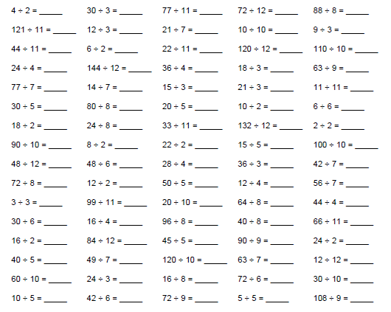

**Exceeding expected- Week** **2**

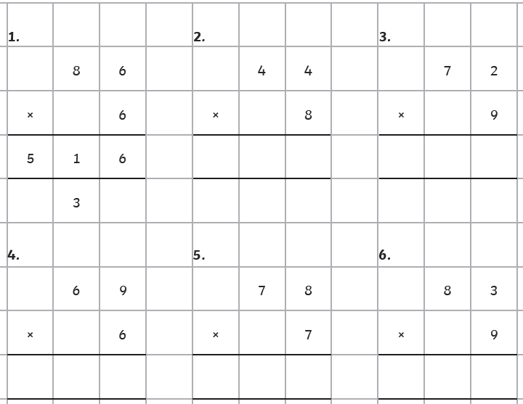

**Exceeding expected week 2:**

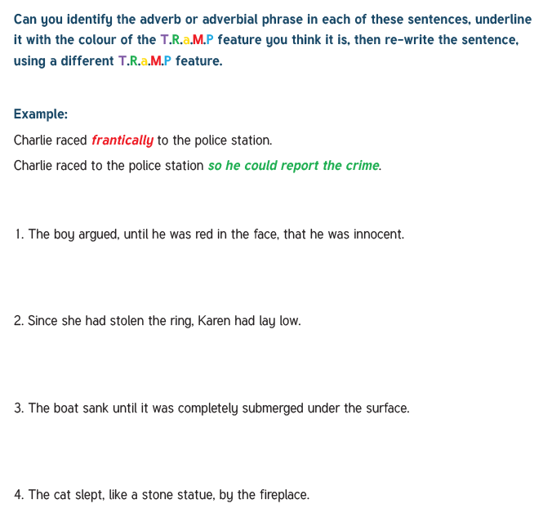

**Now write 2 sentences using different colours underline the adverbs or adverbial phrases in your sentences.**

**Expected – Due 25.01.23 Week 3 Spelling practise:** Look, say, cover, write, check

|  |  |  |  |  |  |  |  |  |
| --- | --- | --- | --- | --- | --- | --- | --- | --- |
| **Look** | **Say** | **Cover** | **Write** | **Check** | **Write** | **Check** | **Write** | **Check** |
| example |  |  | *example* | 🗶 | *example* | ✓ | *example* | ✓ |
| deceive |  |  |  |  |  |  |  |  |
| conceive |  |  |  |  |  |  |  |  |
| receive |  |  |  |  |  |  |  |  |
| perceive |  |  |  |  |  |  |  |  |
| ceiling |  |  |  |  |  |  |  |  |
| receipt |  |  |  |  |  |  |  |  |
| protein |  |  |  |  |  |  |  |  |
| caffeine |  |  |  |  |  |  |  |  |
| seize |  |  |  |  |  |  |  |  |
| neither |  |  |  |  |  |  |  |  |

**Now write the words in a sentence.**

1. ____________________________________________________________________________________________________________________________________________________

2. ___________________________________________________________________________________________________________________________________________________

3. ___________________________________________________________________________________________________________________________________________________

4. ___________________________________________________________________________________________________________________________________________________

5. ­___________________________________________________________________________________________________________________________________________________

6. ___________________________________________________________________________________________________________________________________________________

**Expected - Week 3**

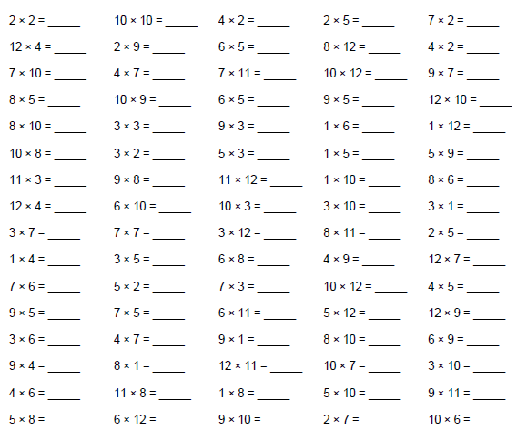

**Exceeding expected – week 3**

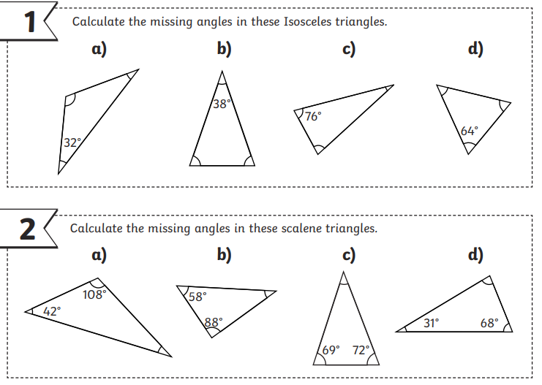

**Exceeding expected week 3:**

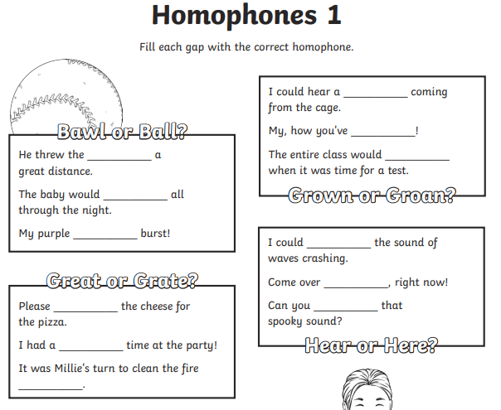

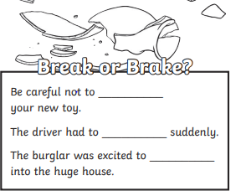

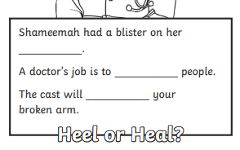

**Expected – Due 01.02.23 Week 4 Spelling practise:** Look, say, cover, write, check

|  |  |  |  |  |  |  |  |  |
| --- | --- | --- | --- | --- | --- | --- | --- | --- |
| **Look** | **Say** | **Cover** | **Write** | **Check** | **Write** | **Check** | **Write** | **Check** |
| example |  |  | *example* | 🗶 | *example* | ✓ | *example* | ✓ |
| commit |  |  |  |  |  |  |  |  |
| committee |  |  |  |  |  |  |  |  |
| transmit |  |  |  |  |  |  |  |  |
| submit |  |  |  |  |  |  |  |  |
| commitment |  |  |  |  |  |  |  |  |
| emit |  |  |  |  |  |  |  |  |
| permit |  |  |  |  |  |  |  |  |
| intermittent |  |  |  |  |  |  |  |  |
| omit |  |  |  |  |  |  |  |  |
| unremitting |  |  |  |  |  |  |  |  |

Now write the words in a sentence.

1. ____________________________________________________________________________________________________________________________________________________

2. ___________________________________________________________________________________________________________________________________________________

3. ___________________________________________________________________________________________________________________________________________________

4. ___________________________________________________________________________________________________________________________________________________

5. ­___________________________________________________________________________________________________________________________________________________

6. ___________________________________________________________________________________________________________________________________________________

**Expected - Week 4**

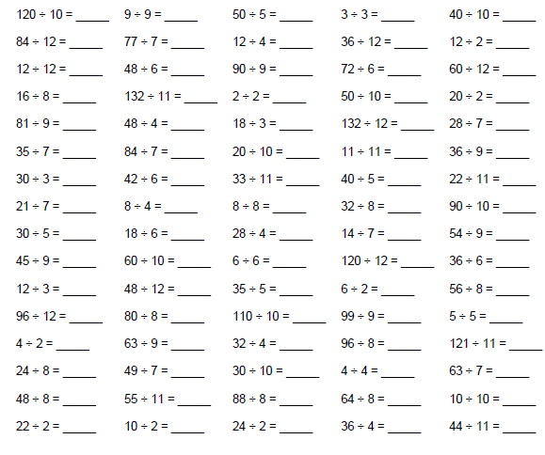

**Exceeding expected – week 4**

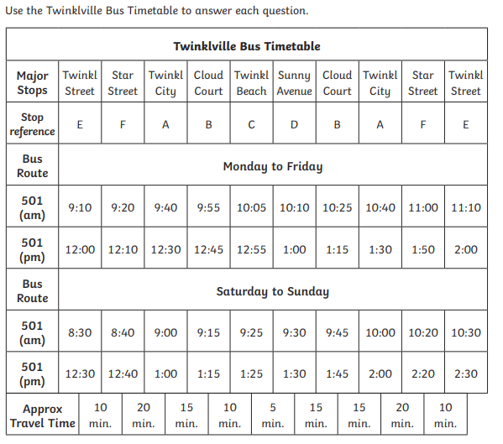

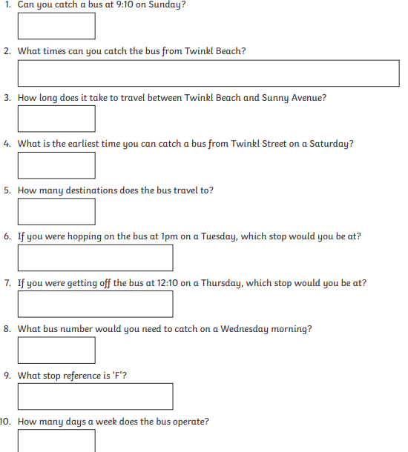

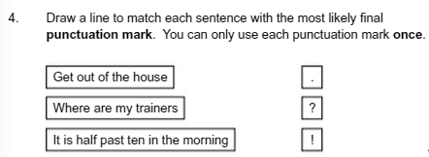**Exceeding expected week 4:**

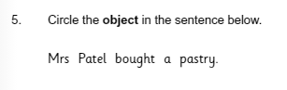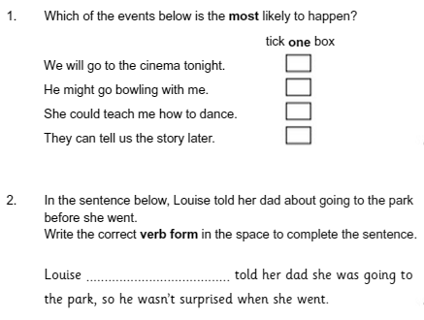

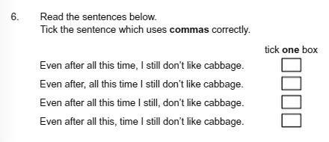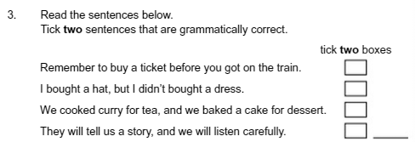

**Expected – Due 08.02.23 Week 5 Spelling practise:** Look, say, cover, write, check

|  |  |  |  |  |  |  |  |  |
| --- | --- | --- | --- | --- | --- | --- | --- | --- |
| **Look** | **Say** | **Cover** | **Write** | **Check** | **Write** | **Check** | **Write** | **Check** |
| example |  |  | *example* | 🗶 | *example* | ✓ | *example* | ✓ |
| interrupt |  |  |  |  |  |  |  |  |
| interfere |  |  |  |  |  |  |  |  |
| intercept |  |  |  |  |  |  |  |  |
| interject |  |  |  |  |  |  |  |  |
| intertwine |  |  |  |  |  |  |  |  |
| interim |  |  |  |  |  |  |  |  |
| internal |  |  |  |  |  |  |  |  |
| intersperse |  |  |  |  |  |  |  |  |
| interloper |  |  |  |  |  |  |  |  |
| interest |  |  |  |  |  |  |  |  |

**Now write the words in a sentence.**

1. ____________________________________________________________________________________________________________________________________________________

2. ___________________________________________________________________________________________________________________________________________________

3. ___________________________________________________________________________________________________________________________________________________

4. ___________________________________________________________________________________________________________________________________________________

5. ­___________________________________________________________________________________________________________________________________________________

**Expected** - **Week 5**

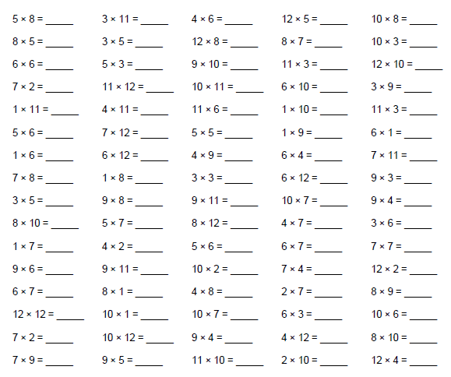

**Exceeding expected – week 5**

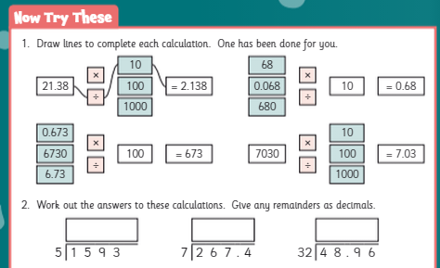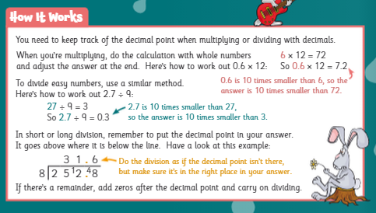

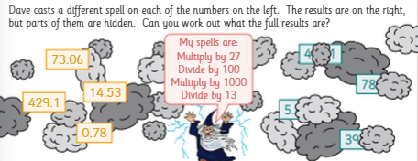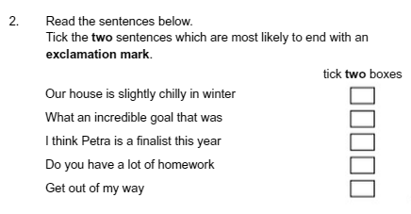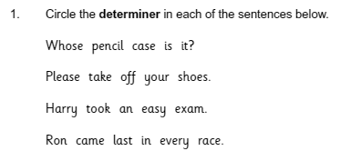**Exceeding expected week 5:**

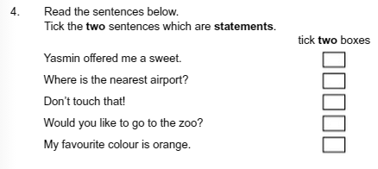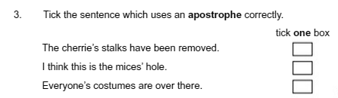

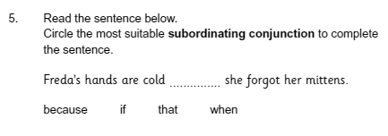

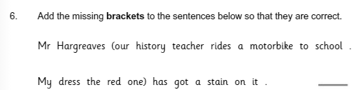

**Expected – Due 15.02.23 Week 6 Spelling practise:** Look, say, cover, write, check

|  |  |  |  |  |  |  |  |  |
| --- | --- | --- | --- | --- | --- | --- | --- | --- |
| **Look** | **Say** | **Cover** | **Write** | **Check** | **Write** | **Check** | **Write** | **Check** |
| example |  |  | *example* | 🗶 | *example* | ✓ | *example* | ✓ |
| attached |  |  |  |  |  |  |  |  |
| available |  |  |  |  |  |  |  |  |
| average |  |  |  |  |  |  |  |  |
| competition |  |  |  |  |  |  |  |  |
| conscience |  |  |  |  |  |  |  |  |
| controversy |  |  |  |  |  |  |  |  |
| correspond |  |  |  |  |  |  |  |  |
| embarrass |  |  |  |  |  |  |  |  |
| especially |  |  |  |  |  |  |  |  |
| exaggerate |  |  |  |  |  |  |  |  |

**Now write the words in a sentence.**

1. ____________________________________________________________________________________________________________________________________________________

2. ___________________________________________________________________________________________________________________________________________________

3. ___________________________________________________________________________________________________________________________________________________

4. ___________________________________________________________________________________________________________________________________________________

5. ­___________________________________________________________________________________________________________________________________________________

6. ___________________________________________________________________________________________________________________________________________________

**Expected - Week 6**

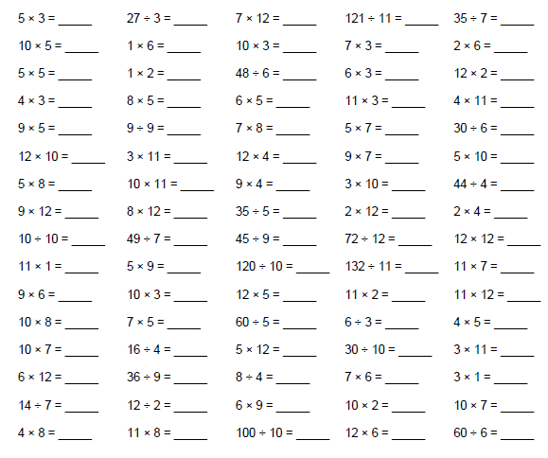

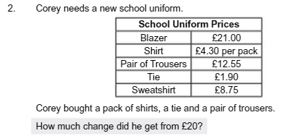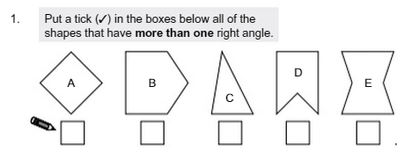**Exceeding expected – week 6**

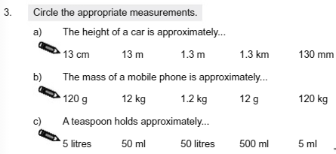

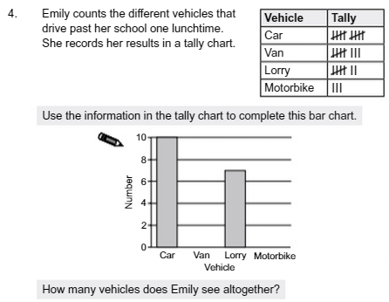

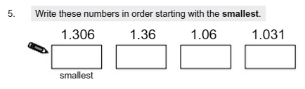





**Exceeding expected week 6:**

**Complete the missing boxes. In the style of the author, write what happened just before the action**

**and just after. Consider what person and tense the extract is written in.**

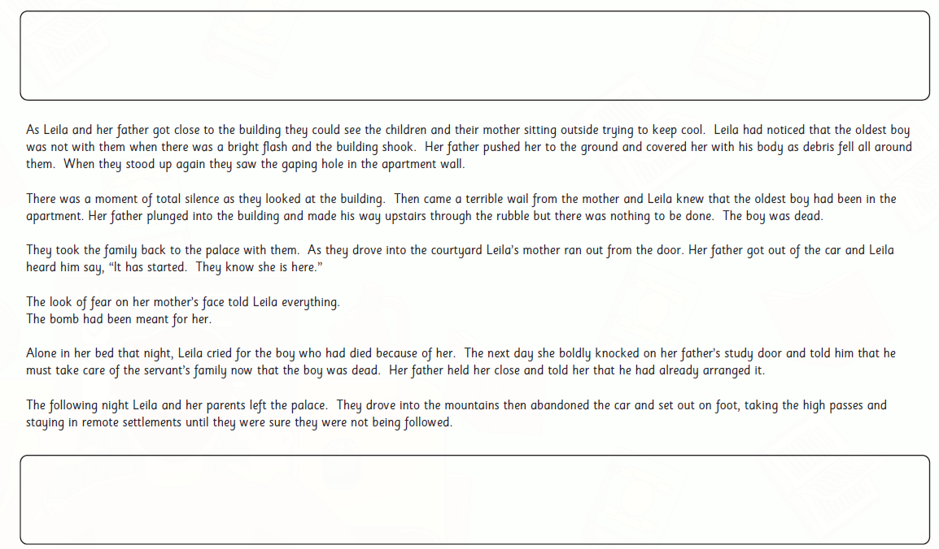

**Week 7: consolidation weeks or these can be comleted as extra weeks homework.**

Circle any of the words which could be used to describe the scene. Use a dictionary to

find out the meaning of the words you are unsure about.

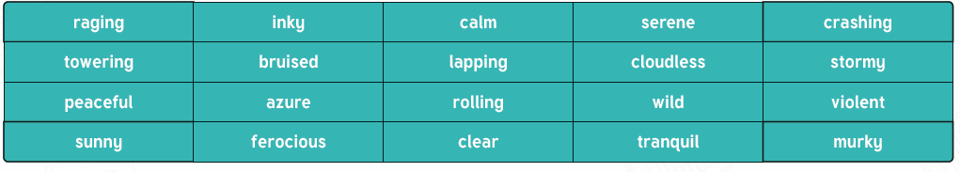

**Use these words to up-level these sentences and make them more exciting.**

**Use similes, metaphors and personification to make your writing more interesting for the reader.**

• The waves were big and made a loud noise when they crashed against the boat.

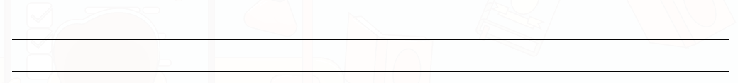

• The sky was dark so it was hard to see where to row the boat. 

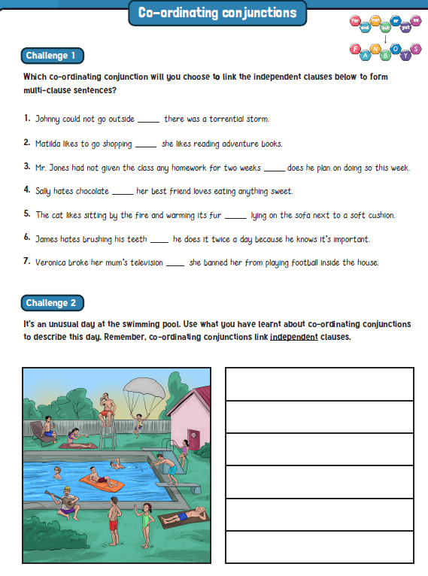**Week 7:**

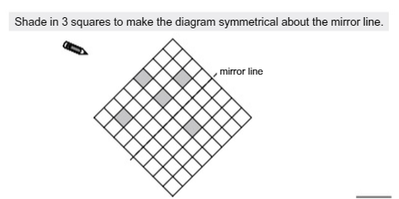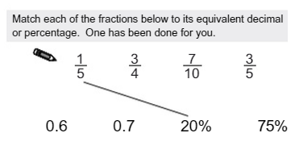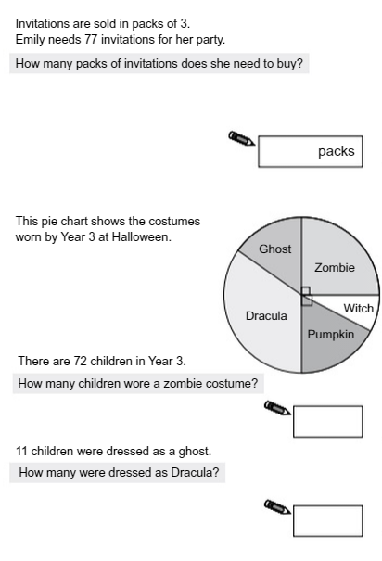

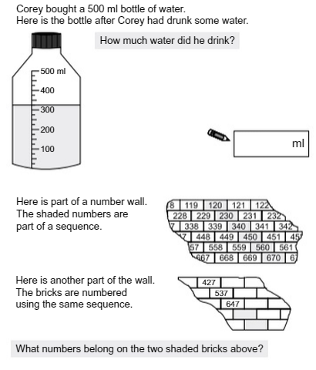

**If you need additional homework please see Miss Bennett.**