Behaviour Regulation Policy

Statutory | Yes
Staff member | J.Baker S.Hodson
Full Governing Body | September 22
Last amendment date
Renewal date | September 23

Contents
1. Aims
2. Legislation and statutory requirements
3. Definitions
4. Bullying
5. Roles and responsibilities
6. Whole school behavioural expectations
7. Positive Behaviour Management
8. Whole school rewards and consequences
9. Pupil support
10. Pupil transition
11. Parents and carers
12. Training
13. Monitoring arrangements
14. Links with other policies
Appendix 1: written statement of behaviour principles Appendix 2 Major and Minor incedents Appendix 3 Behaviour procedure
Appendix 4:Individual Behaviour Support Plan Appendix 5 Regulate, Relate, Reason Appendix 6 Curious Appendix 7 Card Log
…………………………………………………………………………………………………………………………….

Rationale

Restorative practices are increasingly being used to support healthy child development.
Restorative practices focus on increasing the skills of reflection, communication, community building and making amends instead of relying on punishment.
Behaviour management that relies on punishment, coercion or exclusions can increase pupil stress and can fail to support pupils’ and teachers’ future skills for engaging in effective teaching and learning. As struggling pupils spend more and more time away from the classroom, their relationships with peers and teachers weaken, their ability to keep up with academic content reduces and their stress levels increase, creating a cycle of misbehaviour and disengagement. This can result in increased truancy, absenteeism and antisocial behaviours, defeating the purpose of discipline, which should be to support a child as they learn the skills to self-regulate leading to improved behaviour.
Restorative practices and mindsets focus on supporting our young people as they accept accountability for their actions, reflect upon the impact they have on others and, when needed, take steps to repair relationships and build new skills. This inclusive approach deepens relationships by asking pupils to consider how they impact their community and participate in reflective conversations with adults and peers. Strengthening these relationships can reduce stress, support the ongoing healthy development of the young person and provide positive models for pupils as they seek to change their behaviour and contribute to their school community in positive ways.

1. Aims
The Woodlands Community Primary School aims to ensure the good behaviour of all pupils through a combination of high-levels of both nurture and structure. Our reflective approach is embodied by our aspiration to build a nurturing, caring ethos which permeates our school environment. We aim to create a structured and safe environment through the use of strong routines, consistently high expectations and high aspirations for all our children.
Our approach:
- We promote positive behaviour in our school.
- We recognise the crucial importance of strong nurturing relationships between staff and children working alongside parents and carers.
- We are an inclusive school and recognise the specific needs of varying groups of children including those with SEND and those who have experienced trauma.
Our approach rests on our acceptance that:
- All members of our school community deserve respect and care and to feel safe.
- ‘Kids do well, if they can’ (Stuart Ablon). We believe that all children can and want to behave, but some need more support than others to do so.
- All behaviour is communication, the expression of a need or a way to overcome discomfort. It is our job as professionals to best support children so that they can behave, learn and flourish.
- Children should not be intentionally shamed or humiliated
This behaviour regulation policy is written in line with a reflective approach and draws upon the following documents, as well as resources from the Beacon House website. See these documents for further information and linked research.
- Trauma Informed Behaviour Policies and Approaches: A guide for schools and settings
- Beacon House
2. Legislation and statutory requirements
This policy is based on advice from the Department for Education (DfE) on:
- Behaviour and discipline in schools
- Searching, screening and confiscation at school
- The Equality Act 2010
- Use of reasonable force in schools
- Supporting pupils with medical conditions at school
It is also based on the special educational needs and disability (SEND) code of practice.
In addition, this policy is based on:
- Section 175 of the Education Act 2002, which outlines a school’s duty to safeguard and promote the welfare of its pupils
- Sections 88-94 of the Education and Inspections Act 2006, which require schools to regulate pupils’ behaviour and publish a behaviour policy and written statement of behaviour principles, and give schools the authority to confiscate pupils’ property
- DfE guidance explaining that maintained schools should publish their behaviour policy online

3. Definitions
Inappropriate behaviour is defined as:
- Disruption in lessons, in corridors between lessons, and at break and lunchtimes
- Failure to engage with learning.
- Poor attitude
- Ignoring adult instructions
- Hurting others
- Insulting others
Serious inappropriate behaviour is defined as:
- Repeated breaches of the school rules
- Any form of bullying
- Sexual Assault: A person (A) commits an offence of sexual assault if: s/he intentionally touches another person (B), the touching is sexual, B does not consent to the touching and A does not reasonably believe that B consents. (Schools should be aware that sexual assault covers a very wide range of behaviour so a single act of kissing someone without consent or touching someone’s bottom/breasts/genitalia without consent, can still constitute sexual assault.)
- Vandalism
- Theft
- Fighting
- Smoking
- Running away from adults
- Racist, sexist, homophobic or discriminatory behaviour (including on the basis of faith/religion) and or assault
- Aggressive language and swearing
- Possession of any prohibited items. These are:
- Knives or weapons
- Alcohol
- Illegal drugs
- Stolen items
- Tobacco and cigarette papers
- Fireworks
- Pornographic images
- Any article a staff member reasonably suspects has been, or is likely to be, used to commit an offence, or to cause personal injury to, or damage to the property of, any person (including the pupil)

4. Bullying
Bullying is defined as the repetitive, intentional harming of one person or group by another person or group, where the relationship involves an imbalance of power.
Bullying is, therefore:
- Deliberately hurtful
- Repeated, often over a period of time
- Difficult to defend against
Bullying can include:
Type of bullying | Definition
Emotional | Being constantly unfriendly, excluding, tormenting
Physical | Hitting, kicking, pushing, biting, taking another’s belongings, any use of violence
Racial | Racial taunts, graffiti, gestures
Sexual | Explicit sexual remarks, display of sexual material, sexual gestures, unwanted physical attention, comments about sexual reputation, or inappropriate touching
Direct or indirect verbal | Name-calling, sarcasm, spreading rumours, teasing
Cyber-bullying | Bullying that takes place online, such as through social networking sites, messaging apps or gaming sites

5. Roles and responsibilities
5.1 The governing board
The governing board is responsible for reviewing and approving the written statement of behaviour principles (appendix 1).
The governing board will also review this behaviour policy in conjunction with the headteacher and monitor the policy’s effectiveness, holding the headteacher to account for its implementation.

5.2 The Headteacher
The Headteacher is responsible for reviewing this behaviour policy in conjunction with the governing board, giving due consideration to the school’s statement of behaviour principles (appendix 1).
The Headteacher will ensure that the school environment encourages positive behaviour and that staff deal effectively with poor behaviour, and will monitor how staff implement this policy to ensure behaviour is dealt with consistently. The Headteacher will also ensure that all staff read and understand the policy as part of their induction

5.3 Staff
Staff are responsible for:

- Creating a safe and calm environment for all children
- Establishing consistent expectations and routines
- Developing warm and positive relationships with children
- Understanding needs expressed through children’s behaviours
- Modelling positive behaviour
- Understanding the school’s approach to behaviour and implementing the behaviour policy consistently
- Always giving a fresh start to children as required
- Providing a personalised approach to the specific behavioural needs of particular pupils
- Recording behaviour incidents (recorded on My Concern)
The senior leadership team will support staff in responding to behaviour incidents.

5.4 Parents
Parents are expected to:
- Support their child/ren in engaging positively with the school ethos and behaviour expectations
- Maintain good communication with school so that there is a shared understanding of children’s needs
- Inform the school of any changes in circumstances that may affect their child’s behaviour, such as family break-ups or bereavement
- Discuss any concerns about their child’s wellbeing with the class teacher promptly

6. Whole school behavioural expectations
We have high expectations for all our children. Staff model these expectations and take the time to discuss with children what these look like in practice. Our school rules are displayed in every classroom and regularly referred to.
Our expectations for all children are the same, but we recognise that the level of support some children require to meet these expectations can vary. Just as we would differentiate the learning for children through the use of scaffolds, resources and adult allocation, we make similar modifications for children who are struggling with their behaviour.

Our school rules are closely linked to the school Values of RESPECT
1. We try our best (RESILIENCE)
2. We listen to each other (COMMUNICATION)
3. We are kind and respectful (RESPECT and EMPATHY)
4. We respect and celebrate our differences (EMPATHY and TEAMWORK)
5. We look after our school environment (RESPECT and EXCELLENCE)
6. We keep others and ourselves safe (RESPECT and SELF AWARENESS)

7. Positive Behaviour Regulation
Good rapport and warm, consistent relationships between staff and pupils are the bedrock of effective behaviour regulation. Staff make an effort to get to know individual children and let them know that they are valued.
We support all children to behave by:
- Investing in developing strong relationships with pupils
- Sharing and reinforcing expectations frequently.
- Narrating the positive - staff describe the ways in which most children are meeting their expectations in order to support the compliance of all pupils
- Having clear routines and structures (for example making use of visual timetables and daily reminders)
- Regular use of specific feedback and praise
- Regular use of class and school reward systems
- Ensuring that learning is engaging and appropriately differentiated
- Promoting positive attitudes towards learning and making mistakes (growth mindset)
- Developing the Emotional Literacy of all children through daily routines and PSHE lessons (including school-wide work on the Zones of Regulation)
- Helping children to feel emotionally and physically ready for learning by incorporating calming moments, sensory breaks and opportunities for mindfulness in the school day.
- Responding to the changing needs of individual children
As with discipline, staff are mindful of the individual needs of children when making use of public praise and rewards. For a few children with specific needs, praise can be better shared quietly and in private.

8. Whole school rewards and consequences
8.1 Rewards
Across the school a range of strategies are used to promote and reward outstanding behaviour and behaviour for learning. All children are allocated a TEAM and many opportunities are afforded for children to be awarded team points for effort they show during their school day. Teampoints are usually rewarded for when a child has embodied one of our school values.
Whole class rewards are as follows:
- 1 teampoint- for good manners and behaviour
- 2 teampoints for excellent effort
- 5 teampoints for outstanding effort
- Green Card/ 10 teampoints for exceptional effort

An accumulation of 20 house points in a week leads to a shared goal such as ‘golden time’.
Individual behaviour support, including a personalised reward system, may be used when appropriate. They would normally be used to support a child with a particular difficulty and in most cases are a temporary measure. Individual reward systems are not comparative or public.
Other rewards/ methods to promote positive behaviour and outstanding effort include:
- Use of children’s work as an example
- Positive praise using fun actions and phrases (eg. whoosh/ marshmallow clap/ silent cheer)
- Celebrating learning within the class (for example at the end of each session)
- Classroom praise - private/public
- Sharing positive examples with home
- Children share examples of learning with Leadership Team
- House points
- Praising groups and whole class
- Whole class rewards (see above)
8.2 What do we do if a child is showing inappropriate behaviour?
When a child’s behaviour does not meet our high expectations, adults will first of all reaffirm their expectations with the child, and then support the child to meet these expectations where necessary. Staff are encouraged to maintain an attitude of curiosity to the behaviour of all children and to be solution-focused wherever possible. Where the behaviour occurs during direct teaching, the first priority will be to maintain the flow of the lesson and engagement of all pupils. If a child needs to be moved, their teacher will always check-in with them afterwards to discuss potential reasons for their behaviour and decide next steps.

Children will be given a verbal warning and will be made aware of their actions and impact on the learning in the class. This warning is recorded by the class teacher. If the child repeats the inappropriate behaviour a second warning is given and recorded. If the behaviour continues the child is issued with a yellow card and a member of the behaviour support team is called [walkie talkie]. Yellow cards are recorded both on the class behaviour log and My Concern.

***Please see appendices below for each school’s behaviour pathway when dealing with inappropriate behaviour.
NB in cases of sudden or serious inappropriate behaviour (please see definitions above), the first priority is the safety of all children, meaning that the usual behaviour pathway would not necessarily apply.

8.3 Serious inappropriate behaviour- RED CARD
See paragraph 3 for behaviours considered to be serious.
Serious inappropriate behaviour leads to a RED CARD. In all cases where the behaviour is a significant cause for concern, the headteacher will be called for immediately [or a member of the leadership team will be involved in the Head’s absence] The parents of all affected children will be contacted. Appropriate support and/or reparation and consequences must be planned for and agreed.
This process should be logged on the class behaviour log and MY CONCERN. This allows a record of the incident to be made.
If there is a record of a child having engaged in seriously inappropriate behaviour resulting in a RED CARD on more than 3 occasions, a member of leadership would work with the class teacher and parents to decide whether an Individual Behaviour Support Plan would be appropriate.

8.4 Unsafe or dangerous behaviour
Should a situation arise within the school setting where a child’s behaviour becomes unsafe to themselves or others it will be necessary for the teacher to call for support from a member of the Senior Leadership Team. Where a child is obviously struggling to manage their emotions, the member of SLT would support the class teacher with the steps listed above (see Supporting Children to Manage their Emotions).
The aim is to co-regulate with the child to calm them and resolve the situation, allowing all students to continue with the lesson.
Where the member of senior staff considers there to be a risk that inappropriate behaviour may continue, they may remain in the lesson to assist in settling the class.
If there is a risk that the behaviour may result in any children being unsafe then the child will be removed if this can be done safely. If this is not possible, then the other children will leave the classroom/playground/hall etc. whilst a senior member of staff remains with the child who is struggling with their behaviour.
Where a child has caused a significant breach of health and safety, they will be automatically removed from the class safely by a member of staff using positive handling guidelines. Any incidents of positive handling must be recorded on MyConcern as a Positive Handling Incident and parents/carers will be contacted.

8.5 Supporting children affected by the behaviour of others
All children deserve to feel safe in school - this is one of our core expectations. If a child has been hurt, physically or emotionally, by the inappropriate or serious behaviour of another child, then staff are expected to take proactive steps to comfort and protect the child from further harm. When supporting the child, staff should keep in mind the following process:
- If a witness, calmly challenge what has been said/ stop the harmful behaviour immediately. Tell the child/children that this is against our school expectations and explain why
- If being told about an incident, listen carefully to information from all children involved to assess what has happened.
- Facilitate an apology or reparation and decide on a consequence for the child(ren) who has/have caused harm
- Offer practical and or emotional support to the child(ren) affected and add this to the My Concern record of the event
- Communicate with parents what has happened and what action is being taken to prevent a recurrence of the incident
- Keep lines of communication open with all involved
- Link any MyConcern records of incidents to all children involved or affected so that clear tracking can take place
We take incidences of physical aggression and violence very seriously and such behaviour will not be tolerated. Children who have intentionally hurt others may need to be separated from their peers either temporarily or on a planned basis to protect other children whilst an action plan is made to prevent a recurrence of such behaviour. Children can also face fixed-term exclusions as a consequence for violent behaviour. Please see also exclusions policy and the DFE Behaviour in Schools Advice July 22.

8.6 Corrective Consequences
Consequences are not in isolation and should be paired with supportive strategies. Consequences should be proportionate and as closely linked as possible to the behaviours. A consequence should support learning to do better, a corrective consequence, allowing the child to become more self-aware.
Children should be given the opportunity to reflect upon their actions and the impact this may have had on those around them. Below are examples for some situations that may occur in school and the types of response that are appropriate:
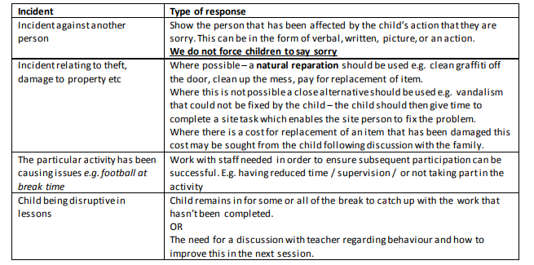
For more detail on consequences during lesson time, please see school-specific appendices below.
In the playground, consequences might include:
- The child is asked to come to sit to calm down. Chat with the child to problem-solve before rejoining game/play
- The child is removed from situation and redirected elsewhere on the playground
- The class teacher/member of SLT is called to speak with the child
- It is agreed that the child cannot join in that game the following day because of their behaviour
- Additional support or shorter playtimes might be put in place until the issue is resolved if there is a repeated problem.
Regarding consequences for serious inappropriate behaviour, please see above and exclusions, below.
Teachers will use their knowledge of the child, and include the child in the discussion, when deciding on appropriate consequences which are in keeping with our trauma-informed approach.

8.7 Exclusions
Consequences for one-off incidences of serious behaviour can include an exclusion, at the discretion of the Headteacher. Exclusions might be internal or external fixed-term dependent on the severity of the behaviour and shared knowledge of the child’s needs and understanding of the situation. Where a child is repeatedly breaching the school rules, which impacts upon the learning and/or wellbeing of themselves or others, an exclusion might also be decided upon as a necessary step.
For full details of the exclusion protocol please see CAT exclusions policy and the DFE Behaviour in Schools Advice
.
8.8 Off-site behaviour
Consequences may be applied where a pupil has shown inappropriate behaviour off-site when representing the school, such as on a school trip or at after school clubs run off site.
Off-site curriculum trips or regular visits
If a pupil has previously demonstrated unsafe or inappropriate behaviour on an off-site trip or is considered within school to be a child who places themselves or others at risk or is a child who cannot/will not follow instructions, then a decision will be made regarding whether this child should be allowed to take part in off-site activities. This includes off –site residential trips such as residential camp in Year 6. The school’s decision will be final.
Children are expected to follow and model the School Rules when off-site and will be supported to do so in line with the behaviour policy.
Children will also be supported to ensure that they follow a venue’s rules when attending a trip.
· Where a child is considered either at risk to themselves or to others when on the trip – at ANY stage - they are accompanied back to school with an adult and a decision is made by the Headteacher regarding future trips premised upon whether or not this child will be safe or endanger other children on future trips. The school’s decision will be final.
Off-site residential trips
Where a child has displayed behaviour that is considered either at risk to themselves or to others, they will need to leave the residential site and return home. Parent/carers will be contacted and will be expected to collect their child from the venue. The child will remain supervised by a member of staff until he/she is collected. The school’s decision will be final.

8.9 Malicious allegations
Where a pupil makes an accusation against a member of staff and that accusation is shown to have been malicious, the Headteacher will deal with this behaviour in accordance with this policy. This would be considered as an incidence of seriously inappropriate behaviour. Such allegations might also be linked to safeguarding concerns.
Please refer to our Child Protection and safeguarding policy for more information on responding to allegations of abuse.

8.91 Reasonable force
(In some circumstances, staff may use reasonable force to a pupil to prevent them:
- Causing disorder
- Hurting themselves or others
- Damaging property
Incidents of physical restraint must:
- Always be used as a last resort
- Be applied using the minimum amount of force and for the minimum amount of time possible
- Be used in a way that maintains the safety and dignity of all concerned
- Never be used as a form of punishment
- Be recorded and reported to parents
8.92 Confiscation

Any prohibited items (listed in section 3) found in pupils’ possession will be confiscated. These items will not be returned to pupils.
We will also confiscate any item which is harmful or detrimental to school discipline. These items will be returned to pupils after discussion with senior leaders and parents, if appropriate.
Searching and screening pupils is conducted in line with the DfE’s guidance.[Searching, screening and confiscation advice for schools July 22

9. Pupil support
The school recognises its legal duty under the Equality Act 2010 to prevent pupils with a protected characteristic from being at a disadvantage.
Our approach to challenging behaviour may be differentiated to cater to the needs of the pupil, on the basis of the understanding that all behaviour is communication. Pupils who might require a modified approach include: children with Special Educational Needs; children who have experienced trauma; children who are looked-after or recently adopted, and children who are experiencing difficulties at home. Staff are trained annually in the specific needs of children who have trauma and attachment issues by the Mental Health Lead. These children can often exhibit more challenging behaviours because of their experiences and, as a trauma-sensitive school, we know how important it is to create tailored behaviour support plans for these children in partnership with their parents/carers. The designated teacher supports class teachers and their parents with a behaviour management approach that meets the needs of the child and allows them to have a positive experience of school, whilst protecting the safety and well-being of all pupils
The school’s special educational needs co-ordinator (SENDCO) will also evaluate pupils who exhibit challenging behaviours to determine whether they have any underlying needs that are not currently being met.

Supporting Children to manage their Emotions
We know that children are sometimes overwhelmed by their emotions and can behave in ways that are particularly challenging as a way of communicating an unmet need.. We realise that in these circumstances, the child needs close support to be able to regulate their emotion and feel safe. Wherever possible, the child should be supported by an adult with whom they have a close and trusting relationship. Following the advice of Beacon House, the following process would be followed:
- Regulate - help the child to calm down through movement, breathing, taking to a safe space etc.
- Relate - connect with the child to let them know that they are understood and they are safe.
- Reason - when the child is calm, consider together what went wrong and how this situation could be avoided again in future. Discuss possible reparations together (i.e. tidying any mess, writing a letter of apology to somebody who was hurt). Be aware that the child might need a significant amount of time before they are ready to engage in rational conversation about their behaviour. (*See visual explainer in the appendices)
This also links to the Emotion Coaching Approach, in which all staff are trained annually. Staff are expected to use the Emotion Coaching Approach to validate the feelings behind the behaviour and also to problem-solve with children to avoid this behaviour in future. At The Woodlands, we call this ‘The 4 W’s’ process. The child is asked –
What happened?
What were you feeling when this happened? The child will be supported in identifying the emotion they were feeling.
What needs to happen now? Discussion will happen to include the child in deciding on an appropriate constructive consequence, linked to the incident.
What can we do differently next time? Discussion and guidance on how to respond next time they are dealing with a similar situation or overwhelming emotional response.

This links to Dan Hugh’s PACE approach:
PACE Model (see http://www.danielhughes.org/p.a.c.e..html for more)
Playfulness (‘I’ve forgotten what to do, can you help?’)
Acceptance (‘I can see you are feeling tired today. Do your first two questions and then I’ll check on you’)
Curiosity (‘It looks to me like you are finding this tricky. Is that right?’)
Empathy (‘I used to worry in maths too. I know how you feel. Let’s work on this together’)

We recognise that some children, particularly those who have experienced trauma, struggle tocontrol their behaviour when their survival response has been triggered. We also understand that our youngest children can be impulsive and are still learning about how their behaviour can impact others. We would therefore be sensitive to such factors when deciding next steps with them.
For children who regularly struggle to regulate their behaviour, the SENDCO/Year Group Lead would support the class teacher to develop an Individual Behaviour Plan focusing on supportive, proactive strategies aiming to reduce the incidences of emotional dysregulation resulting in challenging behaviour.

Individual Behaviour Support Plans (IBSP)
An IBSP (see appendices) will be created for a child who is having difficulty managing their behaviour. This will be drawn up with the class teacher in conjunction with Year Group Leads and shared with parents/carers and the child. The IBSP will outline individualised provision and support including rewards for wanted behaviour appropriate to that child. Where an IBP has been drawn up, support from an outside agency (such as the Malachi Family Support) may be appropriate. We will work with parents to create the plan and review it on a regular basis.
Where necessary, support and advice will also be sought from specialist teachers, behaviour support units, an educational psychologist, medical practitioners and/or others, to identify or support specific needs. When acute needs are identified in a pupil, we will liaise with external agencies and plan detailed support programmes for that child. We will work with parents to create the plan and review it on a regular basis.

10. Pupil transition
To ensure a smooth transition to the next year group, pupils have transition sessions with their new teacher(s). In addition, staff members hold transition meetings, where pupil information is shared to ensure appropriate support is given
To ensure behaviour is continually monitored and the right support is in place, information related to pupil behaviour challenges may be transferred to relevant staff at the start of the term or year. Information on behaviour challenges may also be shared with new settings for those pupils transferring to other schools.

11. Parents and carers
Parents and carers are expected to behave in an adult, mature and amicable fashion at all times when on the school site or in conversation with members of staff. This also encompasses ‘electronic’ communication e.g. emails, texts.
When a parents or carers behaviour is giving cause for concern,such as use of swear words the adult shall be spoken with regarding this concern. If there is no improvement then the governing body has the authority to ban the adult causing concern from school premises and /or from contacting members of staff.
Where an adult’s behaviour is verbally or physically aggressive towards a member of the school community the police may be informed.

12. Training
Our staff are provided with training on behaviour regulation as part of their induction process and with updates on an annual basis. Staff are also given training in supporting children who have experienced trauma, which is updated annually. The SENDCO arranges and leads training sessions on supporting children with additional needs and sensory difficulties.
Behaviour regulation will also form part of continuing professional development.

13. Monitoring arrangements
This behaviour policy will be reviewed by the Headteacher and governing board every two years. The written statement of behaviour principles (appendix 1) will be reviewed and approved by the governing board every two years.

14. Links with other policies
This behaviour policy is linked to the following policies:
- Equalities Statement
- Exclusions Policy [CAT]
- Positive Handling Policy
- Safeguarding and Child Protection Policy

Appendix 1: written statement of behaviour principles

tbc

Appendix 2: Minor and Major incidents list of examples

Minor incidents might include:
- Talking at inappropriate times
- Mistreating school or other property eg. mishandling books, dropping litter, wasting or not taking care of resources
- Not lining up properly leading to disruption
- Distracting other pupils when learning e.g. pulling ‘funny’ faces, trying to attract their attention.
- General behaviour around the school building e.g. Running in the corridors, talking in assemblies
- Play fighting / rough play
- Daydreaming
- Isolated shouting out e.g. an answer
- Not doing sufficient work / lack of co-operation with peers
- Bringing in items from home without permission to play with in class
Major incidents might include:
- *Any prejudice based comments e.g. Racist/ Homophobic/ Faith based/ Transphobic/ Religious/ Ageist comments
- *Gender based comments e.g. “you can’t because you are a girl…”
- * Verbal/written e.g. swearing at others (in any language), making comments intended, or likely, to cause upset or offence to someone else
- Theft
- Vandalism of anybody’s property, including graffiti on school books
- Physical e.g. punching, kicking, pushing, pinching, biting, hitting another person with an object
- Exclusion of peers from games, if intended to cause upset to them
- Defiance after a reasonable request has been specifically directed at the individual by an adult
- Bringing in inappropriate items e.g. weapons, drugs, inappropriate images
- Ongoing multiple issues during a day
*All incidents of a racist, homophobic or transphobic nature, or involving gender discrimination, are treated seriously and are dealt with according to the age, understanding and the nature of the incident. The principles within this policy are used to explore and deal with this situation.

Appendix 3: BEHAVIOUR PROCEDURE and supporting statements
Minor Unacceptable Behaviour  EACH STEP IS RECORDED ON THE CLASS BEHAVIOR RECORD | Major Unacceptable Behaviour
Teacher expresses disappointment and identifies poor behaviour. | The teacher identifies poor behaviour and expresses disappointment. - [Red Card is given to the child ] The child is sent to Head Teacher
If continues - first warning- verbal- the child is made aware of their actions and their impact. This should be in a manner that creates as little disruption to the remainder of the class as possible.
If continues - second warning- written- the child is made aware. The child’s name is also written
If the behaviour still continues a yellow card is distributed…
A member of the Behaviour Support Team is called and an appropriate corrective consequence is allocated
After a yellow card the process repeats from fresh
If continues - first warning- child made aware
If continues - second warning- child made aware
If the behaviour still continues-a Red Card is given to the child and they are sent to the Head Teacher for verbal warning and corrective consequence - loss of time from break and lunchtime. | [Red Card]Head Teacher sees child immediately. Verbal warning given and corrective consequence- loss of time from break and lunch depending on the behaviour.
Parents are informed when a card, of any colour, is issued to a child -see attachment

Behaviour Steps and Supporting Statements –

Low support strategies- everyday classroom management
These strategies are key for everyday good class management and the expectation is that the majority of children respond well to these strategies meaning further escalation or a personal intervention is not necessary.

Medium Support Strategies- leading to yellow card
We move on to Medium Support when a child has not responded appropriately to low support strategies. Medium support for most children will involve an action by the adult that helps the child to refocus on following the rules - i.e. being moved in class, being moved to a partner class or going to have a conversation with a member of the leadership team about how they can improve their behaviour. For some children with additional needs, it may be appropriate for them to have a brain break, complete a movement task or be given additional adult support rather than be moved. Teachers make their judgements based on their knowledge of the needs of individual children. All medium support actions should be recorded and any yellow cards on MY CONCERN and should include a conversation with the child focused on improving their behaviour going forward. This conversation should include curiosity about what might be making behaving difficult.

High Support- Red card
If a child needs regular support to manage their behaviour in school, they will fall under this category. An isolated serious incident would also fall under this category and should be recorded on MY CONCERN. Children who regularly require high support will usually have an Individual Behaviour Support Plan in place, written by their class teacher along with a member of leadership and in partnership with parents. Children under this category might also require a Termly Target Tracker. IBSPs should be shared with all who work with the child and uploaded onto MyConcern.

Nonverbal Intervention
Includes…
Look, pause in speaking, a touch on the shoulder, making use of actions to recapture attention, making use of agreed hand signals for routines (i.e. 1,2,3)
Statements to support positive group correction
- I expect you to sit still with your eyes on me.
- The instruction is to face your talk partner. Emma and Paul did that straight away.
- Mouths quiet, eyes forward. Ready for the line to move. Thanks for setting a great example, Agnes.
- In this school, we listen to each other. I need to see you doing better listening so we can earn that last marble.
- Everyone should be writing the next sentence on their whiteboard. Fantastic start, Jemma.
- You are showing me your thinking thumb and waiting, what would you like to share?
- I expect all eyes on me. Thank you Hannah, thank you Tom.
Statements to support Anonymous Individual Correction
- I'm just waiting for three more people to show me that they are ready.
- We can continue when I see that everyone has followed my last instruction.
- I am waiting for four people to put their lids on their pens
- Year 4, ensure that your hands are in your laps
Statements to support Private Correction and check-in
- I can see you are finding it difficult to concentrate. Let's take a deep breath, stretch and try again.
- It looks to me like you had a tricky playtime. I'll come to speak to you about it once everyone has started with their work.
- James, you need to stop talking and show better listening. Is there a reason you are finding it hard to listen today?
- Elaine, sit up straight and look at me. Thanks. I can see you are tired, let’s chat later this session.
Statements to support lightning-quick public correction
- Beckie, sit on your bottom. Thanks, much better.
- Rowan, that is not safe and I don't want to see you doing that again.
- Bill, pen down and eyes on me. Thanks.
- Alex, put the pencil down and look at me…Thank you, much better.
- Ellie, I don’t want to see you touching other people while I am teaching...Hands together, much better
Statements to support giving a consequence (in private wherever possible, but use your knowledge of the child)
RECORD BEHAVIOUR REQUIRING A CONSEQUENCE ON MY CONCERN
Classroom
- Emily, come and sit at the front so you can focus better.
- Verity, I am going to move you to sit where you cannot disturb other people.
- Jenny, I am sending you next door to work because you are distracting other people.
- Sonia, I want you to go to talk to Miss Johnson about what you are finding difficult today.
- I would like you to stay in class with me now for a chat... In this school we listen to each other. You found that hard today. Why do you think that was? How can we make sure you listen better after break?...Ok, now we have made a plan, please go and tidy your desk and then I will walk you down to play.
Playground
- I can’t let you join Champ if you are going to hurt people, so we will need to think of ways together to stop this happening next time.
- That isn’t safe behaviour and needs to stop or I will need to take you inside. We keep each other safe in this school.
- You weren't following our rule of keeping ourselves and others safe in the playground today. I think you are finding Champ difficult and should have a break from it tomorrow.
- A school rule is to be kind and respectful. We do not hurt other people. I cannot let you continue with that game.
- I can see you are angry and that you have hurt Bill. You need to come here with me now as we don’t want anyone to be hurt in our school.
- You are struggling to control yourself. I need you to come and sit with me until you are calm.
- It looks to me like this is too much for you, let’s find a calm space/go for a walk/find a trusted adult
.

Appendix 4 - Individual Behaviour Support Plan proforma -

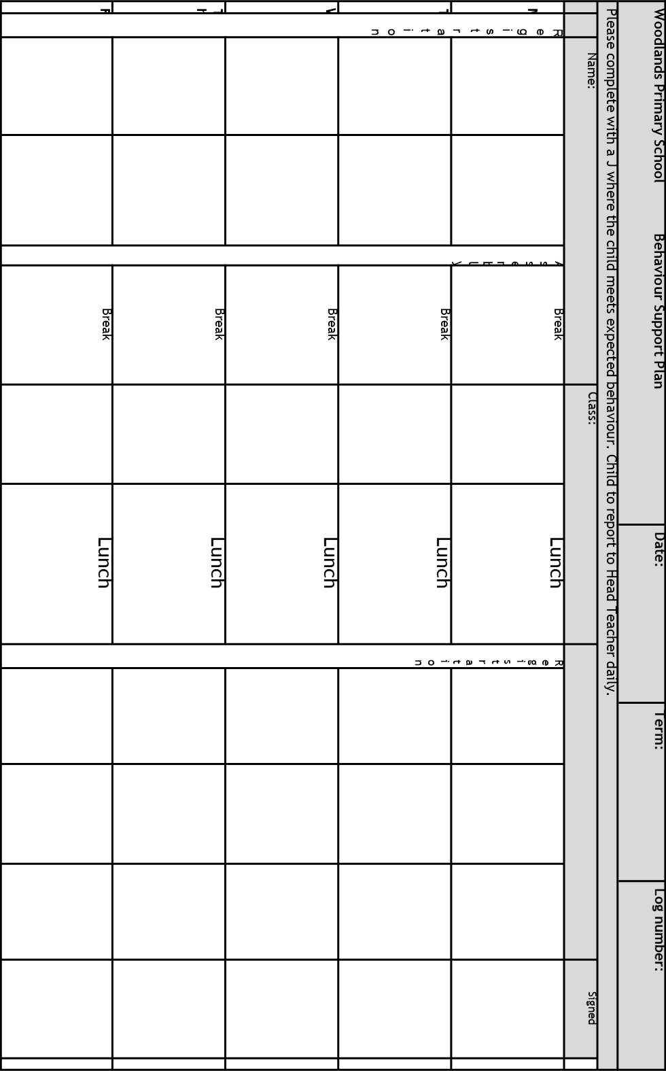

Appendix 5: Regulate, Relate, Reason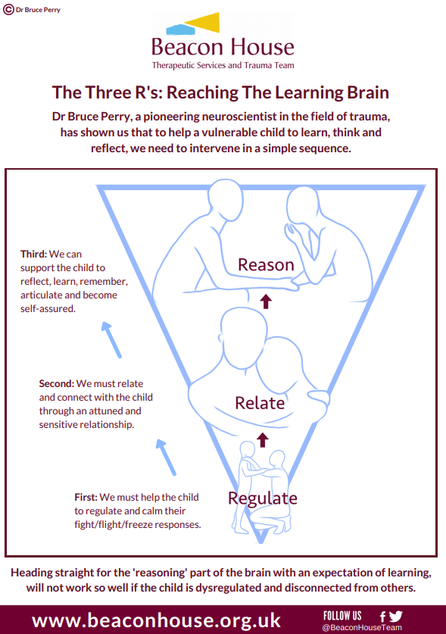

Appendix 6: What if we were curious about behaviour?
