Home Learning Booklet
Autumn 1
Year 2
This booklet belongs to

Woodlands Primary School
Homework Grid Autumn 1 (Bright lights, big cities)
Please return your homework to school on Monday for marking. Booklets will be returned on Tuesday.
 | Expected |  | Exceeding Expected |  |  |  | Greater Depth
 | These need to be carried out every week |  | Maths |  | English |  | Select 2 projects from the list below to do over the half term  - Make a pictogram to show the different vehicles you see while you are out and about with your family.  - Take your favourite teddy on a visit to a city near you. Write a simple diary about teddy’s day out, including what you saw and how you felt.  - Build a real or fantasy city using Lego, blocks or 3D junk material from home.  - Create a 2D shape picture of a city skyline. Label the shape names.  - Search the web and find images of different cities around the world. Present your findings as you wish, you could include facts, images and captions.  - Draw a map of a city and direct a toy or figure using words such as forward, backwards, left, right etc. Write your directions alongside your map.  - Create your own city song to the tune of ‘The wheels on the bus’. Your song should start with ‘I went to the city and I saw…’.
Week 1 | - Read three times a week minimum and record in red reading diary.  - Practise weekly spellings. (See in booklet)  - Practise 2x times tables. |  |  |  | Can I retrieve answers in a text?  Children to read the short passage of text and answer questions based on what they have read.
Week 2 | - Read three times a week minimum and record in red reading diary.  - Practise weekly spellings. (See in booklet)  - Practise 2÷ times tables |  |  |  | Can I retrieve answers in a text?  Children to read the short passage of text and answer questions based on what they have read.
Week 3 | - Read three times a week minimum and record in red reading diary.  - Practise weekly spellings. (See in booklet)  - Practise 2x times tables. |  |  |  | Can I retrieve answers in a text?  Children to read the short passage of text and answer questions based on what they have read.
Week 4 | - Read three times a week minimum and record in red reading diary.  - Practise weekly spellings. (See in booklet)  - Practise 2÷ times tables |  |  |  | Can I spell words in the past tense?  Children to read sentences containing past tense words and correct the spellings so that the sentences make sense.
Week 5 | - Read three times a week minimum and record in red reading diary.  - Practise weekly spellings. (See in booklet)  - Practise 2x times tables. |  | Can I explore odd and even numbers?  Colour in the odd and even numbers. What do you notice?
Week 6 | - Read three times a week minimum and record in red reading diary.  - Practise weekly spellings. (See in booklet)  - Practise 2÷ times tables |  | Can I explore odd and even numbers?  Answer the written questions. What patterns can you spot?
Week 7 | - Read three times a week minimum and record in red reading diary.  - Practise weekly spellings. (See in booklet)  - Practise 2x times tables. |  | Partitioning numbers  Can I partition a number into tens and ones?
Week 8 | - Read three times a week minimum and record in red reading diary.  - Practise the spellings that you found tricky during this half term.  - Practise 2÷ times tables |  | Partitioning numbers  Find different ways to partition numbers.
Expected
Week 1: Spelling practise: Look, say, cover, write, check.
Look | Say | Cover | Write | Check | Write | Check | Write | Check
knock
know
knee
knitting
knife
gnat
gnaw
gnash
gnome
gnarled

Now choose two of the words to write in a sentence.
1. _______________________________________________________________________________________
2. _______________________________________________________________________________________
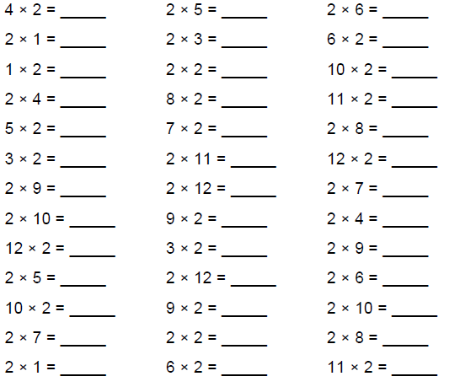
Expected
Week 1 Complete the 2x table’s sheet.

Remember the 2x tables are the same as doubles!
Double 6 = 12.
2 x 6 = 12

Exceeding Week 1- Read through the short passage of text and answer the questions based on what you have read.
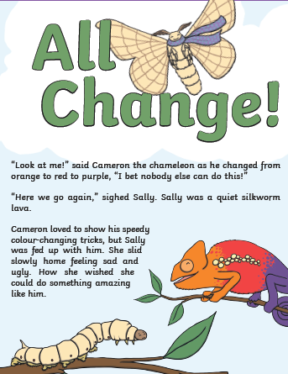

Remember to locate the answers directly from the text.

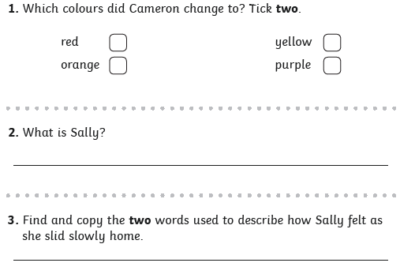

Expected
Week 2: Spelling practise: Look, say, cover, write, check.
Look | Say | Cover | Write | Check | Write | Check | Write | Check
write
written
wrote
wrong
wrap
wrist
wreck
wrestle
wriggle

Now choose two of the words to write in a sentence.
1. _______________________________________________________________________________________
2. _______________________________________________________________________________________

Expected
Week 2 Complete the 2÷ table’s sheet

Remember the 2÷ tables are the same as halving.
Half of 6 = 3.
6 ÷ 2 = 3

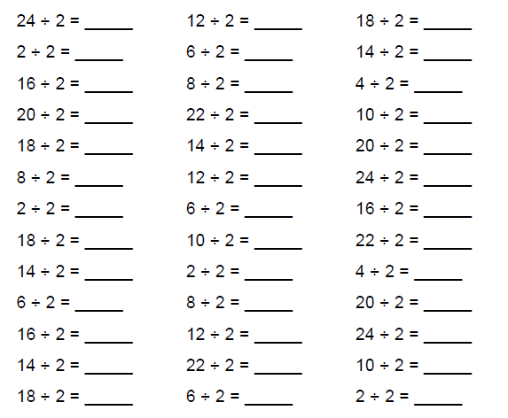

Exceeding
Week 2- Read through the short passage of text and answer the questions based on what you have read.
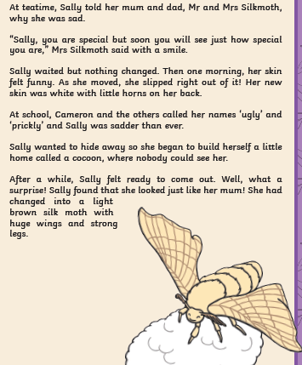

Remember to locate the answers directly from the text.

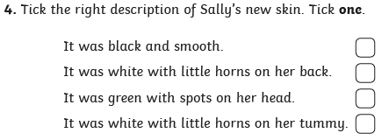
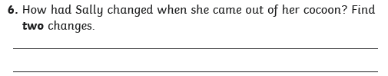
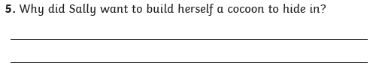
Expected
Week 3: Spelling practise: Look, say, cover, write, check.
Look | Say | Cover | Write | Check | Write | Check | Write | Check
race
ice
cell
city
fancy
face
space
bicycle
circle
spicy

Now choose two of the words to write in a sentence.
1. _______________________________________________________________________________________
2. _______________________________________________________________________________________
Expected
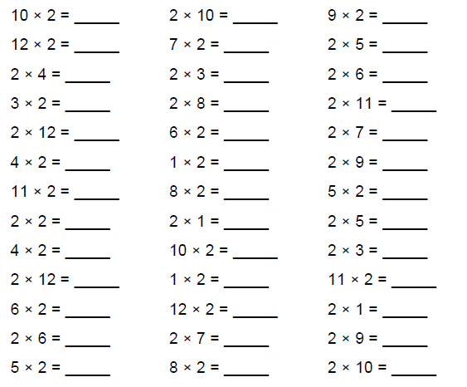
Week 3- Complete the 2x table’s sheet.
Remember the 2x tables are the same as doubles!
Double 6 = 12.
2 x 6 = 12

Exceeding Expected
Week 3- Read through the short passage of text and answer the questions based on what you have read.
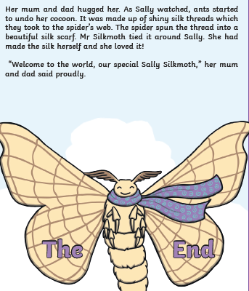

Remember to locate the answers directly from the text.

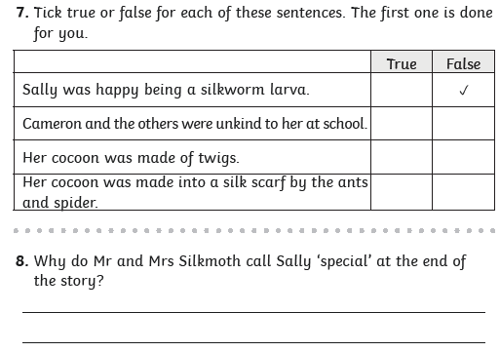

Expected
Week 4: Spelling practise: Look, say, cover, write, check.
Look | Say | Cover | Write | Check | Write | Check | Write | Check
badge
edge
bridge
dodge
fudge
age
huge
change
charge
village

Now choose two of the words to write in a sentence.
1. _______________________________________________________________________________________
2. _______________________________________________________________________________________
Expected
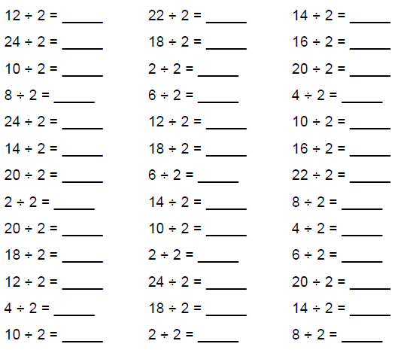
Week 4- Complete the 2÷ table’s sheet

Remember the 2÷ tables are the same as halving.
Half of 6 = 3.
6 ÷ 2 = 3

0+10=10
10+0=10
10-0=10

Exceeding

Remember to start your sentences with a capital letters and apply the correct punctuation.
Week 4- Past tense words- The past tense word in the sentences are spelt incorrect.
Re-write the sentence so that the words are spelt correctly and make sense.

1. On Sunday I runned to the shops.

2. I jumpt on my trampoline with my brother Sam.

3. I startid my homework after my dinner.

4. He talkt to his grandma on the phone.

5. I catched the pink, sparkly ball.

6. She comed to my party.

Expected
Week 5: Spelling practise: Look, say, cover, write, check.
Look | Say | Cover | Write | Check | Write | Check | Write | Check
gem
giant
magic
giraffe
energy
jacket
jar
jog
join
adjust

Now choose two of the words to write in a sentence.
1. _______________________________________________________________________________________
2. _______________________________________________________________________________________
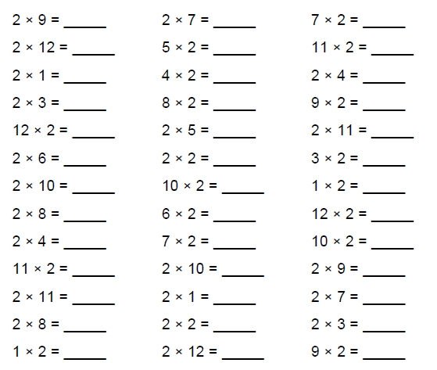
Expected Week 5- Complete the 2x table’s sheet.

Remember the 2x tables are the same as doubles!
Double 6 = 12.
2 x 6 = 12

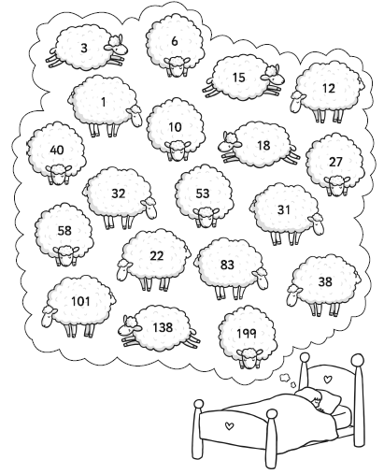
Exceeding expected
Week 5- Colour in all the odd numbers in red and all the even numbers in blue. What do you notice?

Expected
Week 6: Spelling practise: Look, say, cover, write, check.
Look | Say | Cover | Write | Check | Write | Check | Write | Check
door
floor
again
wild
children
climb
parents
most
only
both

Now choose four of the words to write in a sentence.
1. _______________________________________________________________________________________
2. _______________________________________________________________________________________
Expected
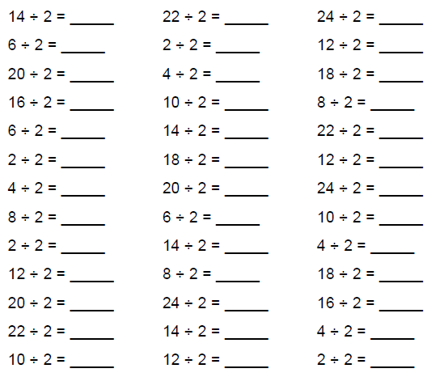
Week 6- Complete the 2÷ table’s sheet

Remember the 2÷ tables are the same as halving.
Half of 6 = 3.
6 ÷ 2 = 3

Exceeding expected
Week 6- Exploring odd and even numbers. Answer the written questions. What patterns can you spot?

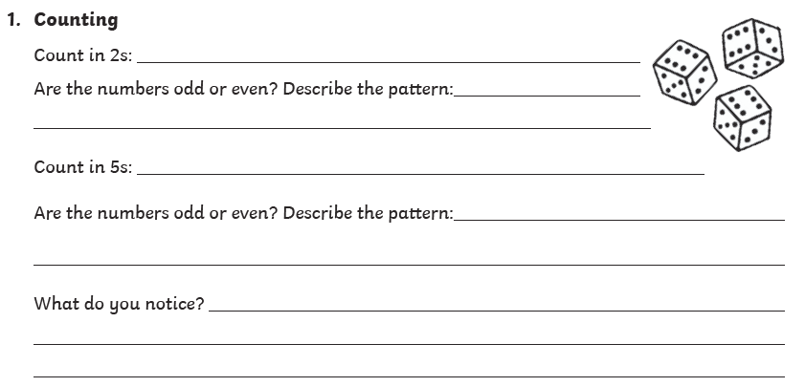
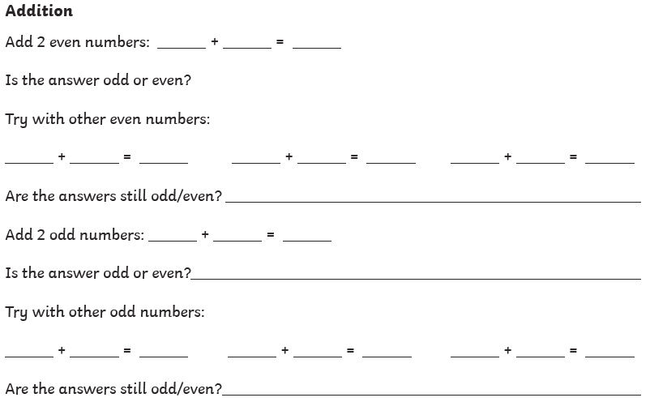

Expected
Week 7: Spelling practise: Look, say, cover, write, check.
Look | Say | Cover | Write | Check | Write | Check | Write | Check

Now choose four of the words to write in a sentence.
1. _______________________________________________________________________________________
2. _______________________________________________________________________________________
3. _______________________________________________________________________________________
4. _______________________________________________________________________________________
Expected
Week 7- Complete the 2x table’s sheet.

Remember the 2x tables are the same as doubles!
Double 6 = 12.
2 x 6 = 12

Exceeding expected
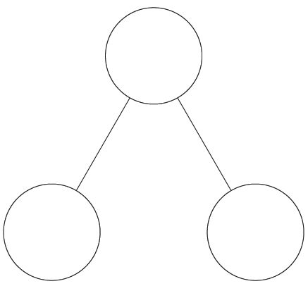
Week 7- Partition the numbers into tens and ones. The first one has been done for you.
5
60
51
73
49
65
27
12
36
95

