The Woodlands Community Primary School |  | Year 5/6 | Spring 1 2023 |  | Science-Living things and their habitats
Key Vocabulary | Habitats |  |  | Knowledge and Skills
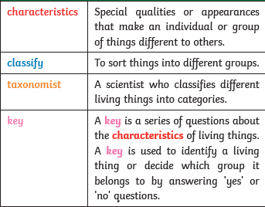  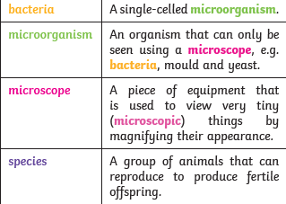 | 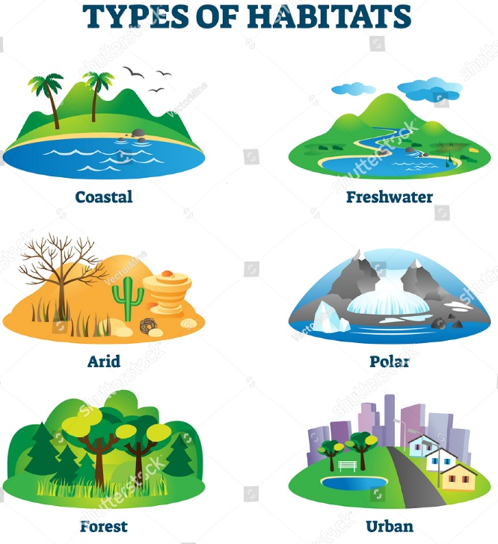 |  |  | Knowledge  I know what defines a living thing.  I know all living things are unique due to their characteristics.  I know a life cycle exists for living things to reproduce and survive.  I know how to organise my observations to help explain my understanding.  I know that classification means I need to identify characteristics unique to that living thing.  Skills  I can explain the habitats of animals to a specific country  I can use characteristics of a living thing to sort.  I can refer to images and diagrams to compare life cycles.  I can describe the life process of reproduction in some plants and animals.  I can give reasons for how I classifying plants and animals  I can use a different medium to present and explain my findings and understanding
Classification |  |  |  | Key questions
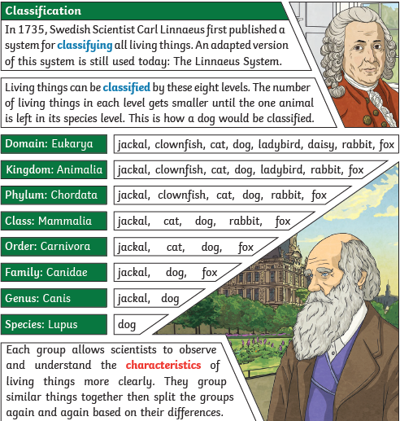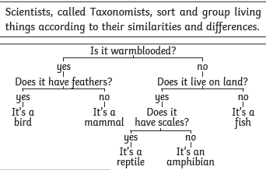 |  |  |  | What different types of habitat are there in Mexico?  What criteria can be used to classify?  What specific characteristics do different living things have?  What differences and similarities are there between the life cycles of different types of living things?

