The Woodlands Community Primary School |  | Year 1/2 | Topic – History |  | Dinosaur Planet
Key Knowledge |  | Key Knowledge and Skills
 |  | 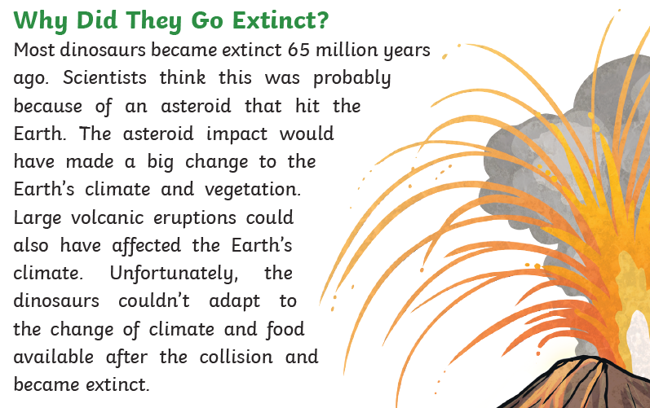  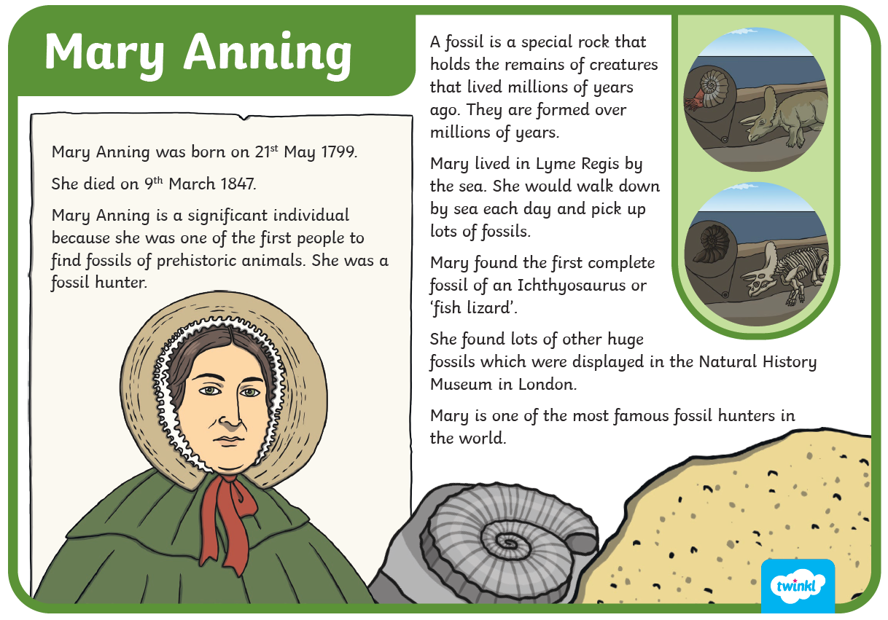 |  | Knowledge  I know events happen in chronological order  I know some significant figures from history and their impact on us today  I know that history is the study of past events  I know that some events have a worldwide impact  I know when the dinosaurs lived  I know how dinosaurs became extinct  Skills  I can describe artefacts.  I can use a range of sources to find out about events in the past.  I can ask and answer questions related to different objects.  I can recognise why people did things, why events happened and what happened as a result
Key Vocabulary |  | Key knowledge
Dinosaurs  Mary Anning  Extinct  Mary Anning  Prehistoric | Mesozoic Era  Triassic period  Jurassic period  Cretaceous period

