Home Learning Booklet
Spring 1
Year 4
This booklet belongs to

Woodlands Primary School
Homework Grid Spring 1
 | Expected | Exceeding Expected |  |  |  | Greater Depth
 | These need to be carried out every week | Maths |  | English |  | Select 2 projects from the list below to do over the half term
Week 1  11/1 | Reading at LEAST 3 times  Complete Spelling Sheet  Rule: Words with short /i/ sound spelt with ‘y’  Complete times table sheets |  |  | Conjunctions
Week 2  18/1 | Reading at LEAST 3 times  Complete Spelling Sheet  Rule: Adding the vowel suffixes –er, -ed or -ing  Complete times table sheets | Place Value |  |  |  | Design your own SCRUMDIDDLYUMPTIOUS pizza. Which toppings would be on your dream pizza? Savoury, sweet or a bit of both?  Design packaging for it with a persuading advert. Can you encourage me to buy your pizza?  Eating challenge!!  Choose 5 fruits (some you’ve not tried before) and do a taste test. Describe the taste, smell and texture. Are any fruits similar to others? Which was your favourite fruit and why?  Investigate different foods in your kitchen cupboards. Using the colour code system on the front of packages, make comparisons on the sugar and fat contents. Choose 5 foods and record your information. Which had the most sugar? Which had the most fat?  Follow a recipe to make something SCRUMDIDDLYUMPTIOUS. Take a photo of your delicious treat before you gobble it up. Yum, yum, have fun!
Week 3  25/1 | Reading at LEAST 3 times  Complete Spelling Sheet  Rule: Adding suffixes beginning with a vowel (er/ed/ing/en) to words with more than one syllable (stressed last syllable - double the final consonant)  Complete times table sheets |  |  | Inverted Commas
Week 4  1/2 | Reading at LEAST 3 times  Complete Spelling Sheet  Rule: Creating negative meaning using prefix mis-  Complete times table sheets | Addition and Subtraction
Week 5  8/2 | Reading at LEAST 3 times  Complete Spelling Sheet  Rule: Creating negative meaning using prefix dis-  Complete times table sheets | Multiplication and division
Week 6  15/2 | Reading at LEAST 3 times  Complete Spelling Sheet  Rule: Words with a /k/ sound spelt with ‘ch’  Complete times table sheets |  |  | Poetry
 | Homework will be given out every Friday. Homework will be collected every Wednesday.

Expected - Week 1 Spelling practise: Look, say, cover, write, check
Look | Say | Cover | Write | Check | Write | Check | Write | Check
myth  gym  Egypt  pyramid  mystery  hymn  system  symbol  lyric  typical |  |  | exampel |  | example |  | example
Now write the words in a sentence.
1. ____________________________________________________________________________________________________________________________________________________
2. ___________________________________________________________________________________________________________________________________________________
3. ___________________________________________________________________________________________________________________________________________________
4. ___________________________________________________________________________________________________________________________________________________
5. ___________________________________________________________________________________________________________________________________________________
6. ___________________________________________________________________________________________________________________________________________________
7. ___________________________________________________________________________________________________________________________________________________
8. ___________________________________________________________________________________________________________________________________________________
Expected - Week 1 - Multiplication
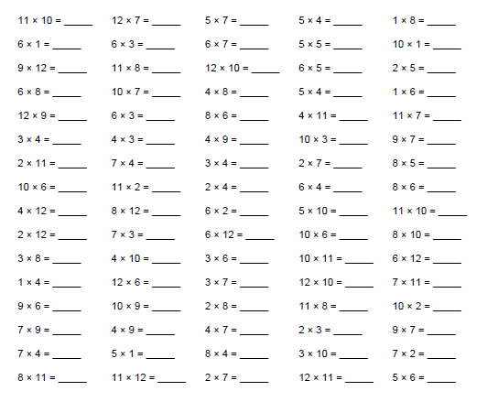

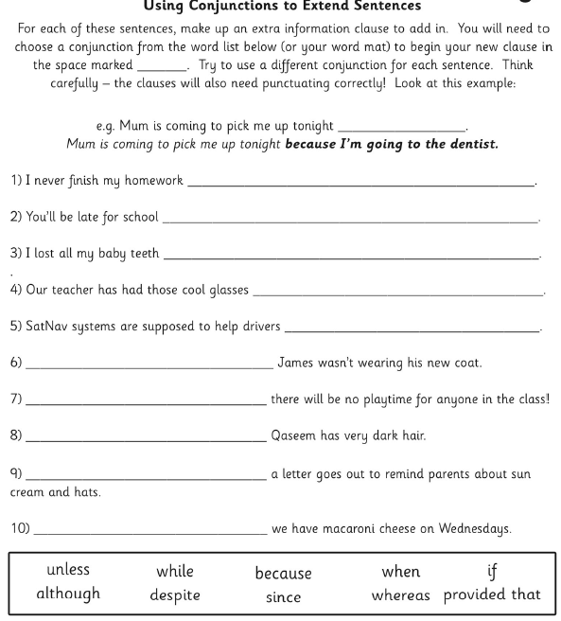
Exceeding – Week 1

Expected – Week 2 Spelling practise: Look, say, cover, write, check
Look | Say | Cover | Write | Check | Write | Check | Write | Check
example |  |  | exampel |  | example |  | example
gardener
gardening
limited
limiting
offering
offered
benefited
benefiting
focused

Now write the words in a sentence.
1. ____________________________________________________________________________________________________________________________________________________
2. ___________________________________________________________________________________________________________________________________________________
3. ___________________________________________________________________________________________________________________________________________________
4. ___________________________________________________________________________________________________________________________________________________
5. ___________________________________________________________________________________________________________________________________________________
6. ___________________________________________________________________________________________________________________________________________________
7. ___________________________________________________________________________________________________________________________________________________
8. ___________________________________________________________________________________________________________________________________________________
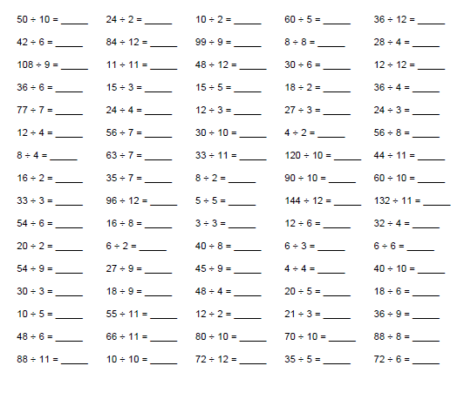
Expected Week 2 - Division

Exceeding expected – Week 2
1. Write these numbers using words.  a) 892  b) 110  c) 401  d) 33  e) 726  2. Complete these calculations.  a) 800 + 40 + 0 =  b) 100 + 60 + 1 =  c) 600 + 30 + 7 =  d) 0 + 0 + 9 = | 3. Tell the place value  Write the value of the underlined digit.  9 tens or 90  a) 6 9 2  b) 4 2  c) 9 2 4  d) 3 3 9  e) 5 7 0  f) 1 5 7  g) 6 0  h) 2 8 1

Expected - Week 3 Spelling practise: Look, say, cover, write, check
Look | Say | Cover | Write | Check | Write | Check | Write | Check
forgetting  forgotten  beginning  beginner  preferred  preferring  occurred  occurring  forbidden  committed |  |  | exampel |  | example |  | example
Now write the words in a sentence.
1. ____________________________________________________________________________________________________________________________________________________
2. ___________________________________________________________________________________________________________________________________________________
3. ___________________________________________________________________________________________________________________________________________________
4. ___________________________________________________________________________________________________________________________________________________
5. ___________________________________________________________________________________________________________________________________________________
6. ___________________________________________________________________________________________________________________________________________________
7. ___________________________________________________________________________________________________________________________________________________
8. ___________________________________________________________________________________________________________________________________________________

Expected Week 3 - Multiplication

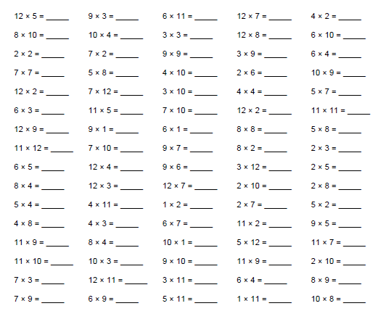

Exceeding Week 3 – Inverted Commas
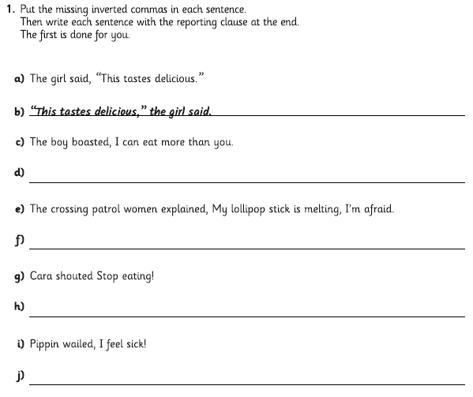
Expected Week 4 Spelling practise: Look, say, cover, write, check
Look | Say | Cover | Write | Check | Write | Check | Write | Check
misspell  mislead  mistreat  misbehave  mistrust  misprint  misuse  misplace  misheard  misread |  |  | exampel |  | example |  | example
Now write the words in a sentence.
1. ____________________________________________________________________________________________________________________________________________________
2. ___________________________________________________________________________________________________________________________________________________
3. ___________________________________________________________________________________________________________________________________________________
4. ___________________________________________________________________________________________________________________________________________________
5. ___________________________________________________________________________________________________________________________________________________
6. ___________________________________________________________________________________________________________________________________________________
7. ___________________________________________________________________________________________________________________________________________________
Expected Week 4 - Division
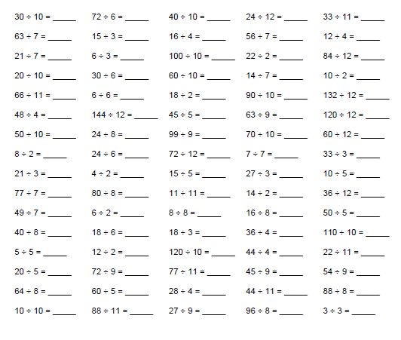

Exceeding expected – Week 4

- Willy Wonka had 325 oompa loompas working in his factory. Around Christmas time it was getting busy so he employed an additional 134 oompa loompas. However, in January he had to let 78 of them go. How many oompa loompas now work in the factory?

- A chocolate factory usually produce 550 caramel bars on a Saturday but on a Sunday production decreases and they make 125 fewer bars. How many bars are produced at the weekend in total?

- Sam is saving up to buy his mum some chocolates for her birthday. He has £3.45 in his piggy bank and his dad gave him £2.39. The chocolates cost £8.50. How much more does Sam need to save?

- Cadbury decide to launch a competition to win 350 I pads. During the first week, there were 78 winners and during the second week 53 people won. How many I pads are left to win during the rest of the competition?

- I buy a Twix for 56p and 2 mars bars that cost 49p each. How much change will I get if I pay with a five pound note?

Expected - Week 5 Spelling practise: Look, say, cover, write, check
Look | Say | Cover | Write | Check | Write | Check | Write | Check
dislike  disobey  discolour  discover  disappear  dishonest  disallow  disbelieve  disapprove  discontinue |  |  | exampel |  | example |  | example
Now write the words in a sentence.
1. ____________________________________________________________________________________________________________________________________________________
2. ___________________________________________________________________________________________________________________________________________________
3. ___________________________________________________________________________________________________________________________________________________
4. ___________________________________________________________________________________________________________________________________________________
5. ___________________________________________________________________________________________________________________________________________________
6. ___________________________________________________________________________________________________________________________________________________
7. ___________________________________________________________________________________________________________________________________________________
8. ___________________________________________________________________________________________________________________________________________________

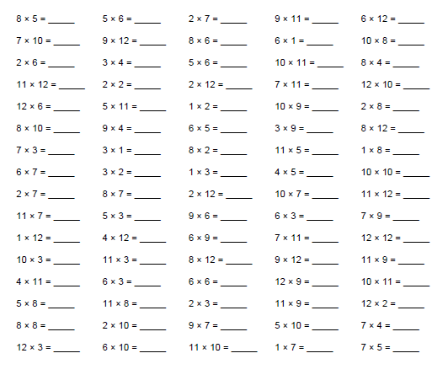
Expected Week 5 - Multiplication

Exceeding expected – Week 5
How much of each of the ingredients do I need to make 24 cakes and 40 biscuits?
Rice Krispy and peanut butter cakes
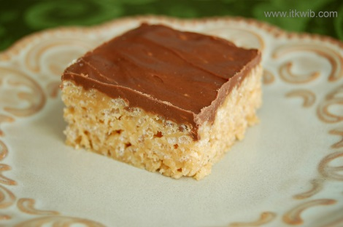
Recipe makes 12 cakes.
1 tablespoon of margarine
3 tablespoons of peanut butter
1000g of marshmallows
2000g of rice krispies
500g of chocolate
Stained glass window biscuits
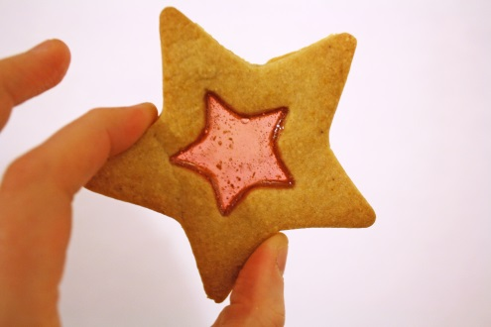
Recipe makes 20 biscuits
250g of boiled sweets
100g of butter
50g of caster sugar
200g of plain flour
1 tablespoon of milk
CHALLENGE: What if I wanted to make 48 rice krispie cakes?

Expected Week 6 Spelling practise: Look, say, cover, write, check
Look | Say | Cover | Write | Check | Write | Check | Write | Check
scheme  chorus  echo  character  ache  chaos  stomach  chemistry  orchestra  technology |  |  | exampel |  | example |  | example
Now write the words in a sentence.
1. ____________________________________________________________________________________________________________________________________________________
2. ___________________________________________________________________________________________________________________________________________________
3. ___________________________________________________________________________________________________________________________________________________
4. ___________________________________________________________________________________________________________________________________________________
5. ___________________________________________________________________________________________________________________________________________________
6. ___________________________________________________________________________________________________________________________________________________
7. ___________________________________________________________________________________________________________________________________________________
8. ___________________________________________________________________________________________________________________________________________________

Expected Week 6 - Division
