The Woodlands Community Primary School |  | Year 1/2 | Topic – DT |  |  | Dinosaur Planet
Key Vocabulary
Sewing  Needle  Thread  Stitch  Function  Design  Felt  Aesthetics  Seam | Design process:  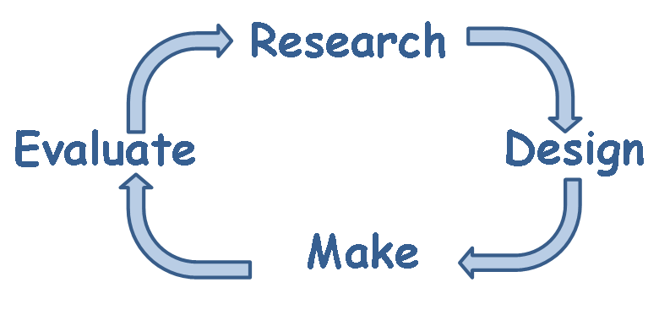  Questions to ask:  What kind of puppets are there? Finger, string, sock…  How can we attach our sock puppets’ features? Glue, sewing, staples…  How will our puppets move? String, fingers… |  |  |  | Skills:  I can design purposeful, functional, appealing products for themselves and other users based on design criteria.  I can explore using tools e.g. scissors and a hole punch safely.  I can begin to assemble, join and combine materials and components together using a variety of temporary methods e.g. glues or masking tape.  I can demonstrate how to cut, shape and join fabric to make a simple product.  I can use basic sewing techniques.  I can assemble, join and combine materials in order to make a product.  I can use correct vocabulary to name and describe tools.  Knowledge:  I know appropriate techniques to create a product.  I know how to build structures, exploring how they can be made stronger, stiffer and more stable.  I know how to, with help, measure, mark out, cut and shape a range of materials.  I know correct vocabulary for tools and materials.  I know tools can be used to manipulate media.
Key Knowledge
Techniques to put our sock puppet together:  Sewing: Glue:  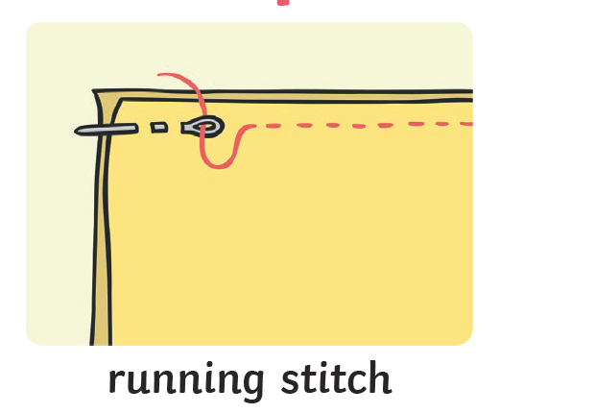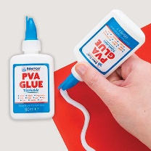  Materials to use:  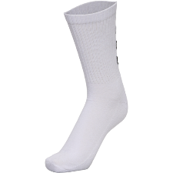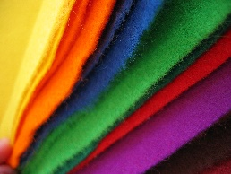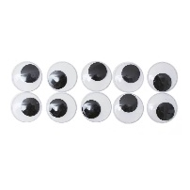  Cotton sock Felt Googly Eyes |  |  | 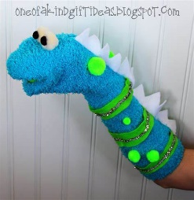  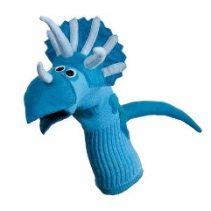  Examples: | Tools:  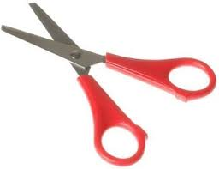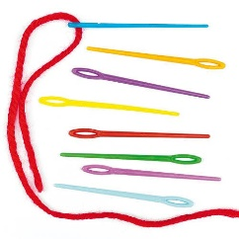  Scissors Needle and Thread  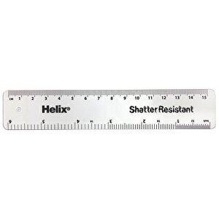Ruler

