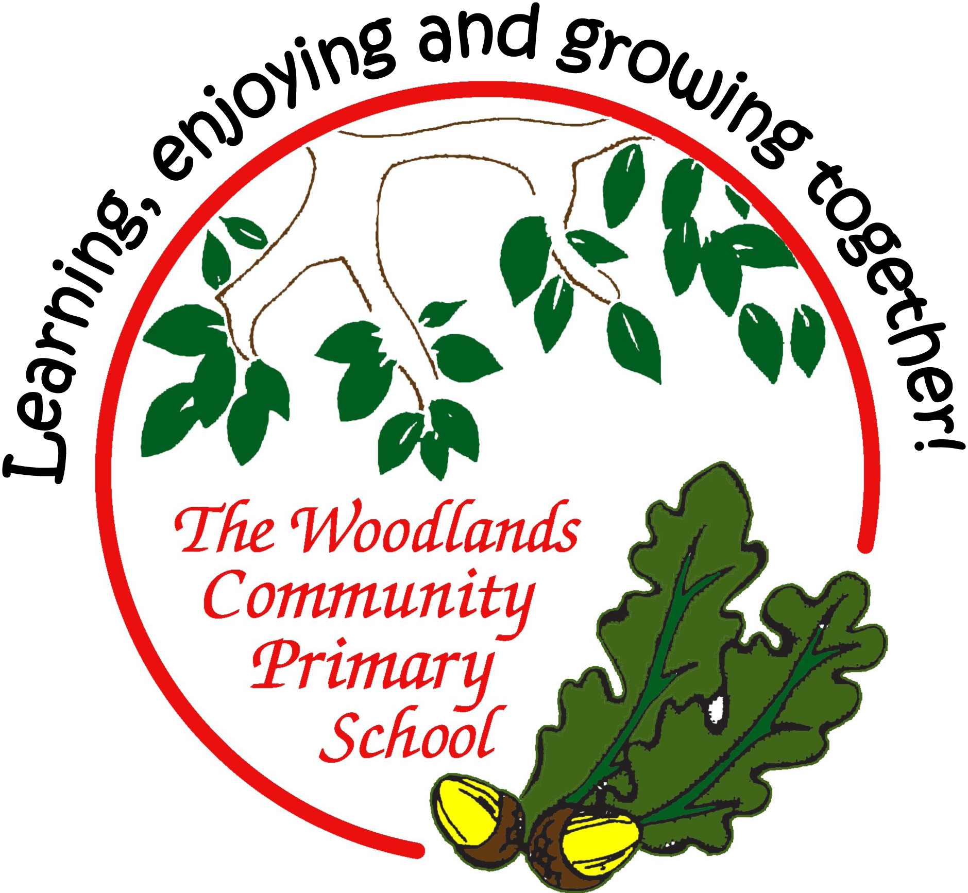

Age-related expectations

Year Six

In the tables below, you’ll find a list of end of year expectations for reading, writing and maths.

The expectations are based very closely on The national curriculum in England

Key stages 1 and 2 framework document (Department for Education, 2013). This sets out what teachers need to teach and what children are expected to learn, both for the core subjects (English, Maths and Science) and the foundation subjects. Here, we look at just English and Maths.

Sometimes, the DfE sets out expectations for each year group; sometimes for a phase (such as Years 3 and 4 or Years 5 and 6). At Woodlands Primary, we have set out all expectations for year groups – this has meant sometimes simplifying an expectation for the younger class, or sometimes referring to greater detail or amount expected for the older class in the phase. Where we think it helps, we have used our own headings to group the expectations.

Before the introduction of this curriculum, schools assessed pupils according to levels, where a typical Year 2 pupil would be expected to attain Level 2 and a Year 6 pupil to reach Level 4. Higher levels would indicate greater success. Now, there is greater importance placed on deeper learning rather than this rapid progression. This means that a pupil should not necessarily be ‘pushed’ to acquire knowledge and skills in a higher year group; instead, learning how to use and apply the learning in lots of contexts and challenges is more important.

Based on this principle, please use the expectations set out here to support your child’s learning by broadening his / her experiences and providing lots of opportunities to apply their skills and knowledge in different situations.

For example:
in reading, find and understand clues and consider the writer’s choice of language in a wider range of texts (such as magazines and comics, non-fiction books, or try out a new genre of fiction which your child doesn’t normally opt for);
in writing, try to use new vocabulary as much as possible (eg have a word of the week) and develop more formal ways to talk during your child’s Talk Time homework;
in maths, practise measuring in contexts such as cooking, shopping, DIY…

(We have, nevertheless, included examples of how you might support your child if (s)he has securely reached age-related expectations – these ideas are listed in small grey text.)

Most importantly, always remember to keep learning fun as much as possible. Some things – learning spellings and times tables, mainly – might require some effort and hard work, but the rest of your child’s learning at home can be fun, engaging and practical.

Age-related expectations: Year Six

READING

Reading words

- Can fluently read a set text appropriate for their age.

- Apply phonic knowledge and skills to read unfamiliar words.

- Apply knowledge of root words, prefixes and suffixes (see National Curriculum, Appendix 1, Y5,6 list) to read aloud (attempting pronunciation) and to understand the meaning of unfamiliar words.

- Use combined knowledge of phonemes and word derivations to pronounce words correctly (eg arachnophobia, audience)
- Read fluently, using punctuation to inform meaning.

- Apply knowledge of morphology and etymology to read and understand words.

- Read further exception words, noting the unusual correspondences between spelling and sound, and where these occur in the word.

Finding and understanding facts

- Understand books (and other texts) read independently, ensuring that the book is meaningful and discuss what has been understood.

- Summarise the main ideas drawn from a text (more than one paragraph), identifying key details that support the main ideas.

- Explain the main purpose of a text.

- Retrieve relevant information by skimming and scanning, taking notes / highlighting to record key points.
- Explore meanings of unfamiliar words and idiomatic and figurative language, eg by using meaning-seeking strategies.
- Collate and organise information / points / evidence appropriately.

- Distinguish between statements of fact and opinion.

Use a combination of skimming, scanning and text marking to find and collate information. Re-present collated information. Explain the main purpose of a text and summarise it succinctly. Explain the key features, themes and characters across a text.

Finding and understanding clues

- Draw inferences eg inferring characters' feelings, thoughts and motives from their actions.

- Develop explanations to justify inferences.

- Predict what might happen from details stated and implied from across a text.
- Raise queries about texts.

- Ask questions to extend understanding.

Draw inferences from subtle clues across a complete text. Comment on the development of themes in longer novels.

Explain how and why a text has impact on a reader. Identify how characters change during the events of a longer novel. Explain the key features, themes and characters across a text.

Organisation

- Identify, comment (with consideration of impact) and back up views on how language, structure and presentation contribute to the meaning and effectiveness of a text (eg is it clear, attractive, easy to fact-find).

- Read books (and other texts) that are structured in different ways.

- Identify and discuss the conventions of different text types.
- Recognise texts that contain features from more than one text type.

Explain the structural devices used to organise a text. Comment on the structural devices used to organise the text.

Read several texts on the same topic to find and compare information. Compare and contrast characters, themes and structure in texts by the same and different writers.

Writer’s choice

- Identify, comment (with consideration of impact) and back up views on writer’s choice of vocabulary.

- Identify, comment (with consideration of impact) and back up views on writer’s craft, including figurative language, grammatical features, text structure eg the use of short sentences to build tension.

- Explain and comment on explicit and implicit points of view.

- Identify and discuss the conventions of different text types.

Compare and contrast the language used in two different texts. Identify the grammatical features/techniques used to create mood, atmosphere, key messages, attitudes. Evaluate the impact of the grammatical features/techniques used to create mood, atmosphere, key messages, attitudes.

Identify how writers manipulate grammatical features for effect. Analyse why writers make specific vocabulary choices.

Age-related expectations: Year Six

READING continued

Readers’ opinions

- Participate in discussions about books / texts that are read to them and those they can read for themselves.

- Express a personal point of view about a text (eg about organisation, presentation, writers’ choice), giving reasons linked to evidence from texts.

- Build on others’ ideas and opinions about a text in discussion.
- Recommend books (and other texts) to peers, giving reasons for their choices.

- Present and explain the author’s viewpoint in a text.

- Present a counter-argument in response to others’ points of view.

Give a personal response to a range of literature and non-fiction texts, stating preferences and justifying them. Explain the author’s viewpoint in a text and present an alternative point of view. Explain an opinion, referring to text to justify it; Point, Evidence and Explanation (PEE). Present counter-argument in response to others’ views using evidence from text and explanation – PEE.

Context

- Compare and contrast books (and other texts): within and across texts (including by different authors who may have different views and comparison of different versions).

- Read non-fiction texts to support other curriculum areas.
- Read and discuss a range of books, including myths, legends and traditional stories, modern fiction, fiction from our literary heritage and books from other cultures and traditions.
- Become familiar with a range of books, including modern fiction, poetry, plays.

- Identify and explain the effect of the context on a text. For example, historical or geographical.

- Read for a range of purposes.

- Make connections between reading and prior knowledge and experience; explain the links.
- Raise queries about texts.

- Ask questions to extend understanding.

Compare and contrast the styles of different writers with evidence and explanation. Evaluate the styles of different writers with evidence and explanation.

Compare and contrast characters, themes and structure in texts by the same and different writers. Recognise the impact of the social, historical, cultural on the themes in a text.

Oral retelling and performance

- Read aloud and perform poems and plays, showing understanding through intonation, tone, volume and action.

- Learn poems by heart eg narrative verse, sonnet.

- Present an oral overview or summary of a text.

- Explain and discuss their understanding of what they have read, including through formal presentations and

debates, maintaining a focus on the topic and using notes where necessary.
Prepare poems and plays to read aloud and to perform, using body language, tone, pitch and volume to engage the audience.

Age-related expectations: Year Six
MATHS

Number and place value

- order and compare numbers up to 10 000 000

- read and write numbers up to 10 000 000 and determine the value of each digit
- round any whole number to a required degree of accuracy
- use negative numbers in context

- calculate intervals across zero
- solve number and practical problems that involve all of the above
Addition and subtraction, multiplication and division

- multiply numbers up to 4 digits by a two-digit whole number using formal written method

- divide numbers up to 4 digits by a two-digit whole number using formal written method
- interpret remainders as whole number remainders, fractions, or by rounding, as appropriate for the context
- divide numbers up to 4 digits by a two-digit number using the formal written method of short division where appropriate
- perform mental calculations, including with mixed operations and large numbers

- identify common factors, common multiples and prime numbers
- use their knowledge of the order of operations to carry out calculations involving the four operations
- solve addition and subtraction multi-step problems in contexts, deciding which operations and methods to use and why
- solve problems involving addition, subtraction, multiplication and division

- use estimation to check answers to calculations and determine, in the context of a problem, an appropriate degree of
accuracy
Multiply all integers, (using efficient written methods) including mixed numbers and negative numbers

Fractions (including decimals and percentages)

- use common factors to simplify fractions; use common multiples to express fractions in the same denomination
- compare and order fractions, including fractions > 1
- add and subtract fractions with different denominators and mixed numbers, using equivalent fractions
- multiply simple pairs of proper fractions, writing the answer in its simplest form eg ₄¹ × ₂¹ = ₈¹

- divide proper fractions by whole numbers eg ₃¹ ÷ 2= ¹₆

- associate a fraction with division
- calculate decimal fraction equivalents for a simple fraction [eg ³₈ =0.375]

- identify the value of each digit in numbers given to three decimal places and multiply and divide numbers by 10, 100 and 1000 giving answers up to three decimal places

- multiply one-digit numbers with up to two decimal places by whole numbers
- use written division methods in cases where the answer has up to two decimal places
- solve problems which require answers to be rounded to specified degrees of accuracy
- recall and use equivalences between simple fractions, decimals and percentages, in different contexts
Compare, order, convert between fractions, decimals and percentages in contexts related to science, history, geography

Ratio and proportion

- solve problems involving the relative sizes of two quantities where missing values can be found by using integer multiplication and division facts
- solve problems involving the calculation of percentages [eg, of measures, and such as 15% of 360] and the use of percentages for comparison
- solve problems involving similar shapes where the scale factor is known or can be found

- solve problems involving unequal sharing and grouping using knowledge of fractions and multiples
Algebra

- use simple formulae
- generate and describe linear number sequences
- express missing number problems algebraically

- find pairs of numbers that satisfy an equation with two unknowns
- enumerate possibilities of combinations of 2 variables
Move beyond squared and cubed numbers to calculate problems such as X x 10n where n is positive Use +, ≠, , ≤, ≥ correctly
Recognise an arithmetic progression, and find the nth term

Age-related expectations: Year Six
MATHS continued

Measurement

- solve problems involving the calculation and conversion of units of measure, using decimal notation up to three decimal places where appropriate

- use, read, write and convert between standard units, converting measurements of length, mass, volume and time from a smaller unit of measure to a larger unit, and vice versa, using decimal notation to up to three decimal places

- convert between miles and kilometres
- recognise that shapes with the same areas can have different perimeters and vice versa
- recognise when it is possible to use formulae for area and volume of shapes

- calculate the area of parallelograms and triangles
- calculate, estimate and compare volume of cubes and cuboids using standard units, including cubic centimetres (cm³) and
cubic metres (m³), and extending to other units [eg mm³ and km³]
Use four operations, including with decimal quantities

Crease a scaled model of a historical or geographical structure showing an acceptable degree of accuracy using known measurements Calculate costs and time involved to visit a destination in another part of the world relating to on-going learning in history or geography

Geometry: properties of shapes

- draw 2-D shapes using given dimensions and angles
- recognise, describe and build simple 3-D shapes, including making nets
- compare and classify geometric shapes based on their properties and sizes and find unknown angles in any triangles, quadrilaterals, and regular polygons

- illustrate and name parts of circles, including radius, diameter and circumference and know that the diameter is twice the radius

- recognise angles where they meet at a point, are on a straight line, or vertically opposite; find missing angles

Geometry: position and direction

- describe positions on full coordinate grid (4 quadrants)
- draw and translate simple shapes on the coordinate plane, and reflect them in the axes
Statistics

- interpret pie charts and line graphs and use these to solve problems
- construct pie charts and line graphs and use these to solve problems

- calculate and interpret the mean as an average
Collect own data on personal project and present information in formats of their choosing, charts, graphs and tables and answer specific questions related to their research

