The Woodlands Community Primary School |  | Year 1/2 | Topic – Science |  |  | Materials
Key Vocabulary
 | 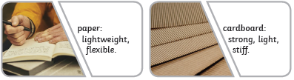  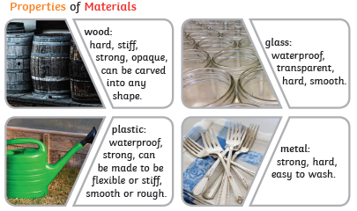 |  |  |  | Knowledge  I know that there are lots of different materials, including wood, plastic, glass, metal, water and rock.  I know that materials have different properties.  I know that the shape of some materials can be changed by squashing, bending, twisting and stretching.  Skills  I can explain the difference between an object and the material from which it is made.  I can name a variety of everyday materials, including wood, plastic, glass, metal, water and rock.  I can compare and group together materials based on their physical properties.  I can compare the suitability of everyday materials for particular uses.
Key Knowledge
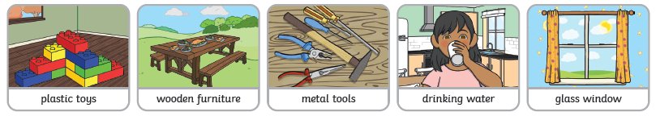 |  |  |  | 