Home Learning Booklet
Spring 1
Year 3
This booklet belongs to

Woodlands Primary School
Homework Grid Spring 1

 | Expected |  | Exceeding Expected |  |  |  | Greater Depth
 | These need to be carried out every week |  | Maths |  | English |  | Select 2 projects from the list below to do over the half term
Week 1 | Reading at LEAST 3 times  Spelling Sheet short /i/ sound spelt with ‘y’  Complete times table sheets  Homework tasks on Education City |  |  |  | Basic punctuation
Week 2 | Reading at LEAST 3 times  Spelling Sheet Adding suffixes  Complete times table sheets  Homework tasks on Education City |  | Place Value |  |  |  | Design your own SCRUMDIDDLYUMPTIOUS pizza. Which toppings would be on your dream pizza? Savoury, sweet or a bit of both?  Design packaging for it with a persuading advert. Can you encourage me to buy your pizza?  Eating challenge!!  Choose 5 fruits (some you’ve not tried before) and do a taste test. Describe the taste, smell and texture. Are any fruits similar to others? Which was your favourite fruit and why?  Investigate different foods in your kitchen cupboards. Using the colour code system on the front of packages, make comparisons on the sugar and fat contents. Choose 5 foods and record your information. Which had the most sugar? Which had the most fat?  Follow a recipe to make something SCRUMDIDDLYUMPTIOUS. Take a photo of your delicious treat before you gobble it up. Yum, yum, have fun!
Week 3 | Reading at LEAST 3 times  Spelling Sheet Adding suffixes  Complete times table sheets  Homework tasks on Education City |  |  |  | Adjectives to describe
Week 4 | Reading at LEAST 3 times  Spelling Sheet prefix mis-  Complete times table sheets  Homework tasks on Education City |  | Addition and Subtraction
Week 5 | Reading at LEAST 3 times  Spelling Sheet prefix dis-  Complete times table sheets  Homework tasks on Education City |  |  |  | Using conjunctions
Week 6 | Reading at LEAST 3 times  Spelling Sheet /k/sound spelt with ‘ch’  Complete times table sheets  Homework tasks on Education City |  | Multiplication

Homework will be given out every Friday. Homework will be collected every Wednesday.
Expected
Week 1 Spelling practise: Look, say, cover, write, check
Look | Say | Cover | Write | Check | Write | Check | Write | Check
example |  |  | exampel |  | example |  | example
myth
gym
Egypt
pyramid
mystery
hymn
system
symbol
lyric
typical
Now write the words in a sentence.
1. ____________________________________________________________________________________
2. ____________________________________________________________________________________
3. ____________________________________________________________________________________
4. ____________________________________________________________________________________
5. ____________________________________________________________________________________

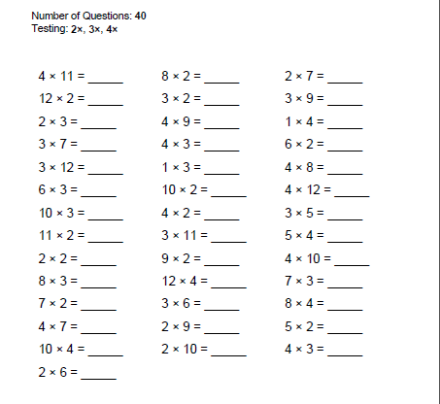
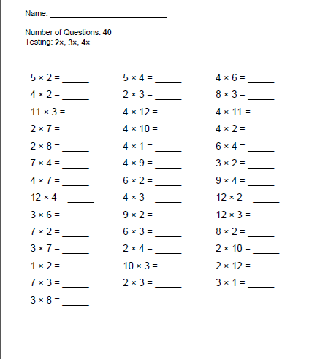
Expected - Week 1

Exceeding
Week 1
Add in the missing words and punctuation to the sentences below.
charlie is an eight year old boy who loves chocolate
his favourite chocolate bar is called a scrumdidlyumtious bar
on tuesday Charlie went to the shop after school to buy a yummy treat
the yummy treat he bought was his favourite chocolate bar
called a __________________________________________________
Now write some of your own sentences to finish this short story.

Expected Week 2 Spelling practise: Look, say, cover, write, check
Look | Say | Cover | Write | Check | Write | Check | Write | Check
Example |  |  | exampel |  | example |  | example
gardener
gardening
limited
limiting
offering
offered
benefited
benefiting
focused
focusing
Now write the words in a sentence.
1. _____________________________________________________________________________________
2. _____________________________________________________________________________________
3. _____________________________________________________________________________________
4. _____________________________________________________________________________________
5. _____________________________________________________________________________________
6. _____________________________________________________________________________________
7. _____________________________________________________________________________________

Expected
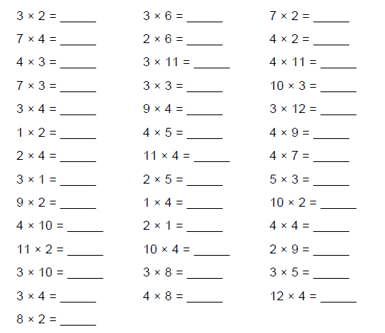
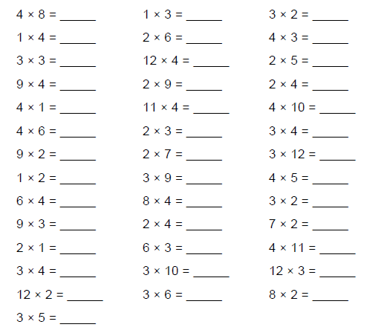
Week 2
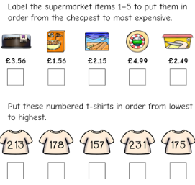
Exceeding
Week 2 - Place Value – Ordering Numbers

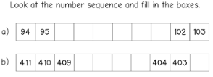

Expected - Week 3 Spelling practise: Look, say, cover, write, check
Look | Say | Cover | Write | Check | Write | Check | Write | Check
Example |  |  | exampel |  | example |  | example
forgetting
forgotten
beginning
beginner
preferred
preferring
occurred
occurring
forbidden
committed
Now write the words in a sentence.
1. _____________________________________________________________________________________
2. ____________________________________________________________________________________
3. _____________________________________________________________________________________
4. _____________________________________________________________________________________
5. _____________________________________________________________________________________
6. _____________________________________________________________________________________
7. ______________________________________________________________________________________

Expected
Week 3
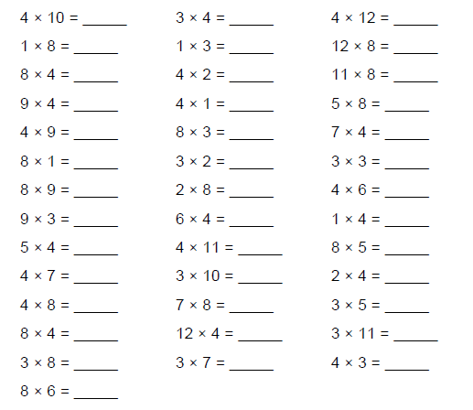
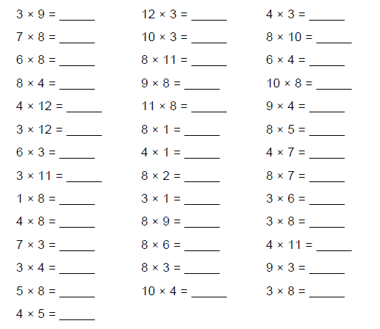

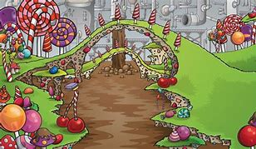
Exceeding
Week 3 Using adjectives to describe.

Look at the picture of the chocolate factory .
Imagine you are there and write some sentences to describe
your adventure.
Describe what you can see, hear, smell, taste and touch.

Expected Week 4 Spelling practise: Look, say, cover, write, check
Look | Say | Cover | Write | Check | Write | Check | Write | Check
Example |  |  | exampel |  | example |  | example
misspell
mislead
mistreat
misbehave
mistrust
misprint
misuse
misplace
misheard
misread
Now write the words in a sentence.
1. ____________________________________________________________________________________
2. ___________________________________________________________________________________
3. _____________________________________________________________________________________
4. _____________________________________________________________________________________
5. _____________________________________________________________________________________
6. _____________________________________________________________________________________
7. _____________________________________________________________________________________
Expected
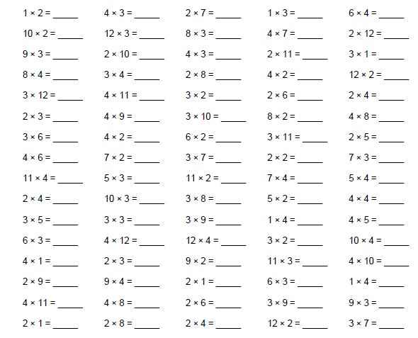
Week 4

Exceeding
Week 4 Addition and Subtraction Write the number sentence here
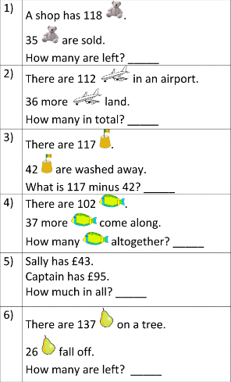

Expected - Week 5 Spelling practise: Look, say, cover, write, check

Look | Say | Cover | Write | Check | Write | Check | Write | Check
Example |  |  | exampel |  | example |  | example
dislike
disobey
discolour
discover
disappear
dishonest
disallow
disbelieve
disapprove
discontinue
Now write the words in a sentence.
1. _____________________________________________________________________________________
2. _____________________________________________________________________________________
3. _____________________________________________________________________________________
4. ______________________________________________________________________________________
5. _____________________________________________________________________________________
6. ______________________________________________________________________________________
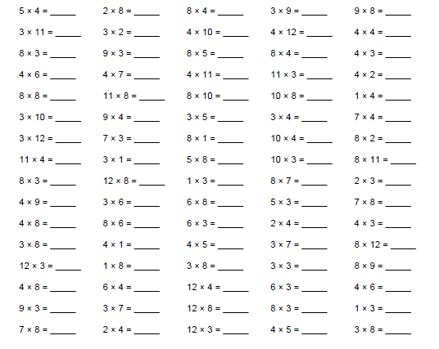
Expected
Week 5

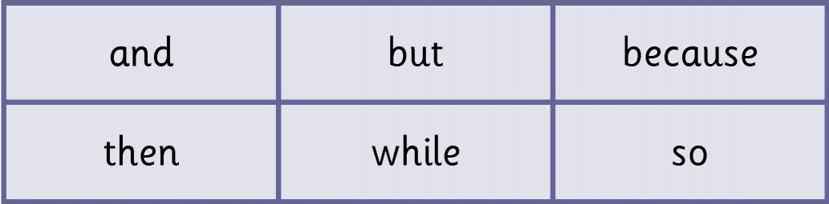
Exceeding
Week 5 - Conjunctions

Choose the correct conjunction to complete these sentences.

Charlie put on his shoes_________________________he went to the chocolate factory.
He’d hoped to go last weekend _______________________________it rained.
His friend Violet could do with him ____________________________ she had done her homework.
She worked really hard ____________________ she could go with Charlie.
They had to be quick _________________ it was close to closing time.
They managed to get there on time________________ had a fabulous day together.
Expected
Week 6 Spelling practise: Look, say, cover, write, check
Look | Say | Cover | Write | Check | Write | Check | Write | Check
Example |  |  | exampel |  | example |  | example
scheme
chorus
echo
character
ache
chaos
stomach
chemistry
orchestra
technology
Now write the words in a sentence.
1. _____________________________________________________________________________________
2. _____________________________________________________________________________________
3. _____________________________________________________________________________________
4. _____________________________________________________________________________________
5. _____________________________________________________________________________________
6. _____________________________________________________________________________________
Expected
Week 6
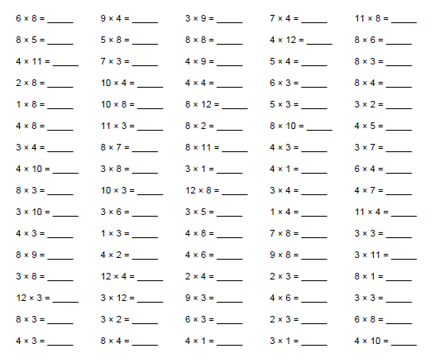

Exceeding
Week 6 Multiplication (Partition the two digit numbers to help you)
Working out space

