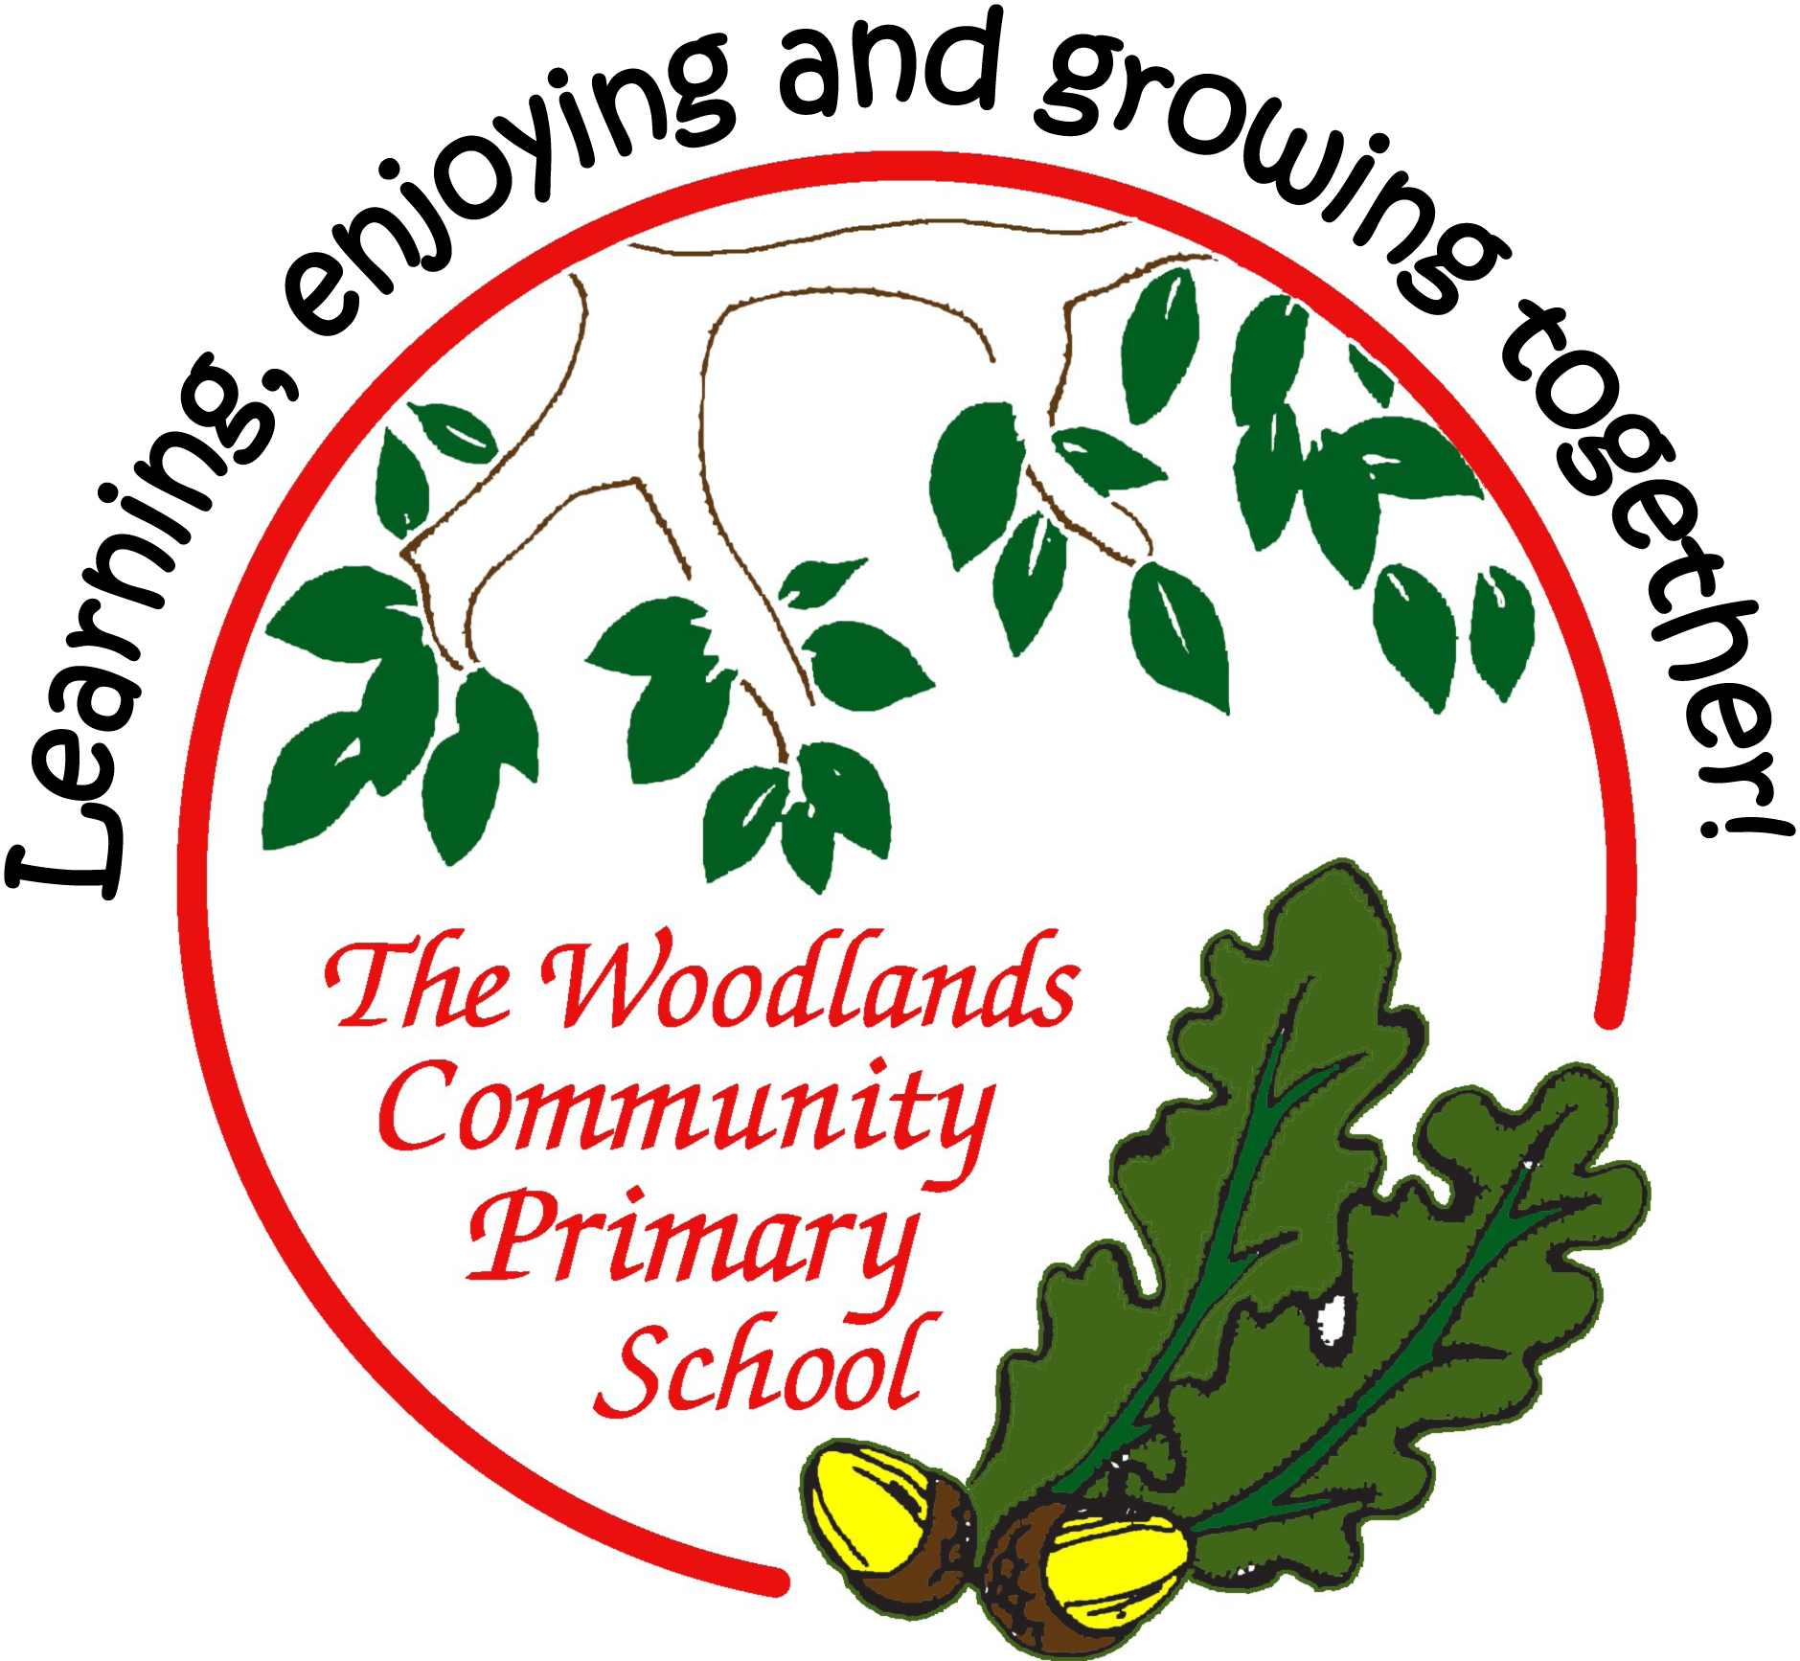

Age-related expectations

Year Two

In the tables below, you’ll find a list of end of year expectations for reading, writing and maths.

The expectations are based very closely on The national curriculum in England

Key stages 1 and 2 framework document (Department for Education, 2013). This sets out what teachers need to teach and what children are expected to learn, both for the core subjects (English, Maths and Science) and the foundation subjects. Here, we look at just English and Maths.

Sometimes, the DfE sets out expectations for each year group; sometimes for a phase (such as Years 3 and 4 or Years 5 and 6). At Woodlands Primary, we have set out all expectations for year groups – this has meant sometimes simplifying an expectation for the younger class, or sometimes referring to greater detail or amount expected for the older class in the phase. Where we think it helps, we have used our own headings to group the expectations.

Before the introduction of this curriculum, schools assessed pupils according to levels, where a typical Year 2 pupil would be expected to attain Level 2 and a Year 6 pupil to reach Level 4. Higher levels would indicate greater success. Now, there is greater importance placed on deeper learning rather than this rapid progression. This means that a pupil should not necessarily be ‘pushed’ to acquire knowledge and skills in a higher year group; instead, learning how to use and apply the learning in lots of contexts and challenges is more important.

Based on this principle, please use the expectations set out here to support your child’s learning by broadening his / her experiences and providing lots of opportunities to apply their skills and knowledge in different situations.

For example:
in reading, find and understand clues and consider the writer’s choice of language in a wider range of texts (such as magazines and comics, non-fiction books, or try out a new genre of fiction which your child doesn’t normally opt for);
in writing, try to use new vocabulary as much as possible (eg have a word of the week) and develop more formal ways to talk during your child’s Talk Time homework;
in maths, practise measuring in contexts such as cooking, shopping, DIY…

(We have, nevertheless, included examples of how you might support your child if (s)he has securely reached age-related expectations – these ideas are listed in small grey text.)

Most importantly, always remember to keep learning fun as much as possible. Some things – learning spellings and times tables, mainly – might require some effort and hard work, but the rest of your child’s learning at home can be fun, engaging and practical.

Age-related expectations: Year Two

READING

Reading words

- Apply phonic knowledge and skills to decode words by blending the sounds in words that contain the graphemes taught.

- Apply phonic knowledge and skills to decode words by recognising and reading alternative sounds for graphemes.

- Apply phonic knowledge and skills to decode words by reading accurately words of two or more syllables that contain the same grapheme-phoneme correspondences as above.

- Decode automatically and fluently: read most (93% - 95%+) words quickly and accurately when they have been frequently encountered without overt sounding and blending.

- Read words containing common suffixes.

- Read further common exception words.

- Read and notice unusual correspondence between grapheme and phoneme (eg wash, jealous).
- Read aloud books (and other texts) closely matched to their improving phonic knowledge, sounding out unfamiliar words accurately, automatically and without undue hesitation.
- Read these books (and other texts) fluently and confidently, possibly by re-reading to build up this skill.

Apply phonic knowledge confidently.

Finding and understanding facts

- Understand both the books / texts that they can read accurately and fluently and those they listen to.

- Read for meaning, checking that the text makes sense and correcting inaccurate reading.

- Locate information using contents and index.

- Recounts main themes and events by showing understanding of the main points of the text.

- Answer appropriate questions about events and characters.

- Ask appropriate questions about events and characters.
- Discuss and clarify word definitions, linking new meanings to known vocabulary.

Extract information from non-fiction texts, appropriately using contents, index, chapters, headings and glossary. Self-correct, look backwards and forwards in the text and search for meaning.

Finding and understanding clues

- Draw simple inferences from illustrations and text on the basis of events, character’s actions, speech.

- Make predictions on the basis of what has been read so far.

- Answer appropriate questions about inferred events and characters.

- Explain and discuss understanding of books, poems and other material, both those read aloud and those read independently.

- Ask appropriate questions about inferred events and characters.

Make sensible predictions about what is likely to happen in the story and to different characters. Comment on the way characters relate to one another.
Identify and comment on main characters in stories and the way they relate to one another.

Organisation

- Be aware that non-fiction books (and other texts) are structured in different ways.

- Discuss the sequence of events in books (and other texts) and how items of information are related.

Comment and begins to justify on the organisation and presentation of the text.

Writer’s choice of language

- Know and recognise simple recurring literary language in stories and poetry.

- Talk about favourite words and phrases.

- Answer and ask appropriate questions about writer’s choice.

- Make links between spellings, punctuation and grammar that has been taught.

Know how suspense and humour is built up in a story, including the development of the plot. Explain why they like particular words and phrases.

Readers’ opinions

- Develop pleasure in reading, motivation to read, vocabulary and understanding.

- Discuss books, poems and other works that are read aloud and independently, expressing opinions and listening to others’ opinions eg plot, settings, characters.

- Talk about and give an opinion on the above range of texts.

Context

- Listen and respond to (by discussing and expressing views) a wide range of poetry (including contemporary and classic), stories and non-fiction at a level beyond that at which they can read independently.

- Become increasingly familiar with a wider range of stories, fairy stories and traditional tales.

- Use prior knowledge and context and vocabulary explored to understand texts.

Talk about the context of a text and how it affects the story. Recognise similarities in the plot or characters within different stories.

Oral retelling and performance

- Use punctuation to vary pace eg pauses appropriately at full stops and commas.
- Retell orally key stories (a range, including fairy stories and traditional tales) using narrative language.

36. Begin to use punctuation to vary expression eg questions with different intonation (?), character voices (“ “).

- Increase repertoire of poems learnt by heart, appreciating these and reciting some, with appropriate intonation to make the meaning clear.

Read ahead to aid fluency and expression. Enhance meaning through expression and intonation.

Read poetry, using intonation and expression, and handle humour appropriately when needed.
Age-related expectations: Year Two
MATHS

Number and place value

- count in steps of 2, 3, and 5 from 0, forward and backward
- count in tens from any number, forward and backward
- recognise the place value of each digit in a two-digit number (tens, ones)

- compare and order numbers from 0 up to 100
- identify, represent and estimate numbers using different representations, including the number line
- use <, > and = signs correctly
- read and write numbers to at least 100 in numerals

- read and write numbers to at least 100 in words
- use place value and number facts to solve problems
Count reliably up to 1000 in 2s, 5s and 10s Count on and back in multiples of 4, 8, 25 and 0 and 100 from any given number to beyond 1000

Addition and subtraction

- solve problems with addition and subtraction:
  - using concrete objects and pictorial representations, including those involving numbers, quantities and measures

  - applying their increasing knowledge of mental and written methods

- recall and use addition and subtraction facts to 20 fluently
- derive and use related facts up to 100 eg 30+70
- know 10 more / less
- add and subtract numbers using concrete objects, pictorial representations, and mentally, including: a two-digit number and ones; a two-digit number and tens; two two-digit numbers; adding three one-digit numbers

- show that addition of two numbers can be done in any order (commutative) and subtraction cannot
- recognise and use the inverse relationship between addition and subtraction and use this to check calculations and solve
missing number problems
Apply knowledge of number up to 100 to solve one-step problems involving + and - + and - two 2-digit and numbers to 100 Use appropriate strategy to + and - across 100

Multiplication and division

- recall and use multiplication and division facts for the 2, 5 and 10 multiplication tables, including recognising odd and even numbers

- calculate and write mathematical statements for multiplication and division within the multiplication tables, using multiplication (×), division (÷) and equals (=) signs

- show that multiplication of two numbers can be done in any order (commutative) and division cannot
- recognise and use inverse

- solve problems involving multiplication and division, using materials, arrays, repeated addition, mental methods, and
multiplication and division facts, including problems in contexts
Apply knowledge of number up to 100 to solve a one-step problem involving simple x and ÷

Fractions

- recognise, find, name and write fractions ₃¹ , ₄¹ , ₄² and ₄³ of a length, shape, set of objects or quantity

- recognise equivalence of simple fractions eg ²₄ , ¹₂

Add and subtract fractions with a common denominator

Measurement

- choose and use appropriate standard units to estimate and measure length/height in any direction (m/cm); mass (kg/g); temperature (°C); capacity (litres/ml) to the neare st appropriate unit, using rulers, scales, thermometers and measuring vessels
- compare and order lengths, mass, volume/capacity and record the results using >, < and =
- recognise and use symbols for pounds (£) and pence (p); combine amounts to make a particular value
- find different combinations of coins that equal the same amounts of money

- solve simple problems in a practical context involving addition and subtraction of money of the same unit, including giving change

- compare and sequence intervals of time
- tell the time to five minutes, including quarter past/to the hour

- write the time to five minutes, including quarter past/to the hour and draw the hands on a clock face to show these times
- know the number of minutes in an hour and the number of hours in a day
Apply knowledge of addition and subtraction to pay for items, up to £10, within a problem solving context Measure, compare, add and subtract using common metric measure

Geometry: properties of shapes

- identify and describe the properties of 2-D shapes, including the number of sides and line symmetry in a vertical line
- identify and describe the properties of 3-D shapes, including the number of edges, vertices and faces
- identify 2-D shapes on the surface of 3-D shapes, [eg a circle on a cylinder and a triangle on a pyramid]

- compare and sort common 2-D and 3-D shapes and everyday objects
Geometry: position and direction

- order and arrange combinations of mathematics objects in patterns and sequences
- use mathematical vocabulary to describe position, direction and movement in a straight line
- distinguish between rotation as a turn and in terms of right angles for quarter, half and three quarter turns (clockwise and

anticlockwise)
Know about right angles and where they can be seen in the environment

Statistics

- construct simple pictograms, tally charts, block diagrams and simple tables
- interpret simple pictograms, tally charts, block diagrams and simple tables
- ask and answer simple questions by counting the number of objects in each category and sorting the categories by quantity
- ask and answer questions about totalling and comparing categorical data

