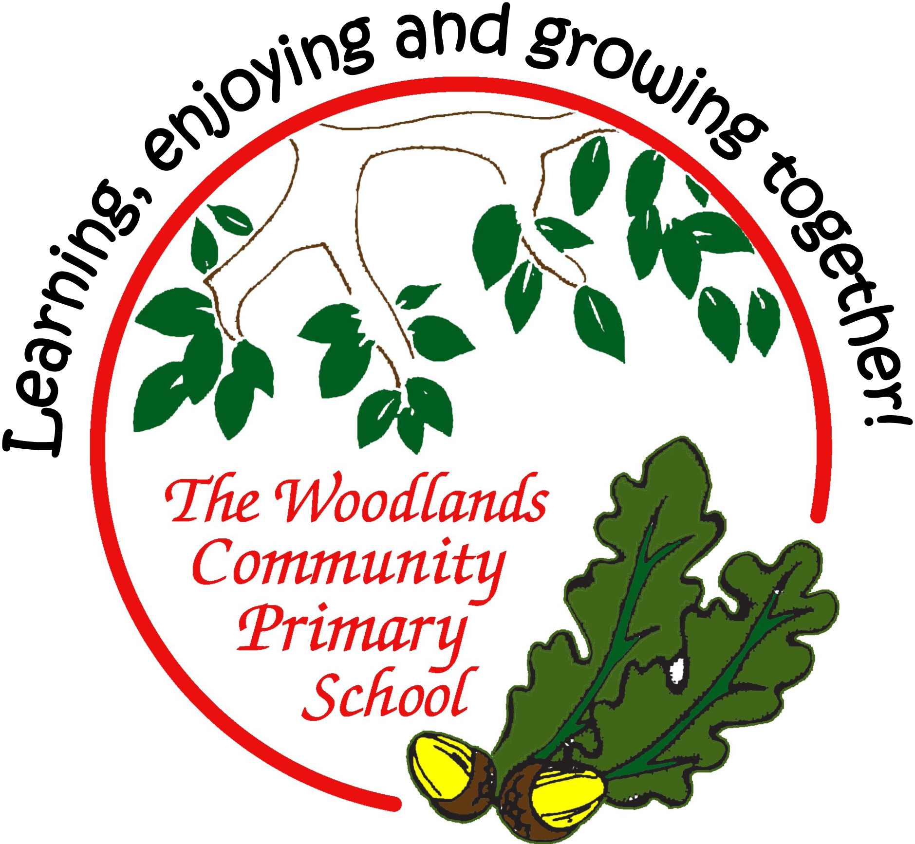

READI

Age-related expectations
Year One

In the tables below, you’ll find a list of end of year expectations for reading, writing and maths.

The expectations are based very closely on The national curriculum in England

Key stages 1 and 2 framework document (Department for Education, 2013). This sets out what teachers need to teach and what children are expected to learn, both for the core subjects (English, Maths and Science) and the foundation subjects. Here, we look at just English and Maths.

Sometimes, the DfE sets out expectations for each year group; sometimes for a phase (such as Years 3 and 4 or Years 5 and 6). At Woodlands Primary, we have set out all expectations for year groups – this has meant sometimes simplifying an expectation for the younger class, or sometimes referring to greater detail or amount expected for the older class in the phase. Where we think it helps, we have used our own headings to group the expectations.

Before the introduction of this curriculum, schools assessed pupils according to levels, where a typical Year 2 pupil would be expected to attain Level 2 and a Year 6 pupil to reach Level 4. Higher levels would indicate greater success. Now, there is greater importance placed on deeper learning rather than this rapid progression. This means that a pupil should not necessarily be ‘pushed’ to acquire knowledge and skills in a higher year group; instead, learning how to use and apply the learning in lots of contexts and challenges is more important.

Based on this principle, please use the expectations set out here to support your child’s learning by broadening his / her experiences and providing lots of opportunities to apply their skills and knowledge in different situations.

For example:
in reading, find and understand clues and consider the writer’s choice of language in a wider range of texts (such as magazines and comics, non-fiction books, or try out a new genre of fiction which your child doesn’t normally opt for);
in writing, try to use new vocabulary as much as possible (eg have a word of the week) and develop more formal ways to talk during your child’s Talk Time homework;
in maths, practise measuring in contexts such as cooking, shopping, DIY…

(We have, nevertheless, included examples of how you might support your child if (s)he has securely reached age-related expectations – these ideas are listed in small grey text.)

Most importantly, always remember to keep learning fun as much as possible. Some things – learning spellings and times tables, mainly – might require some effort and hard work, but the rest of your child’s learning at home can be fun, engaging and practical.

Age-related expectations: Year One

READING

Reading words

- Apply phonic knowledge and skills to decode words by responding speedily, matching all 40+ graphemes to their phonemes (Phase 3); where applicable, alternative sounds for graphemes (Phase 5).

- Apply phonic knowledge and skills to decode words by reading common words using phonic knowledge accurately, blending sounds in unfamiliar words based on known grapheme-phoneme correspondences.

- Read phonically decodable texts with confidence and accuracy.

- Read common exception words (‘tricky words’).

- Read words of more than one syllable which contain taught grapheme-phoneme correspondences.

- Read words containing taught grapheme-phoneme correspondences and the following endings: s, es, ing, ed, er, est.

- Read words with contractions (eg I’m, we’ll); understand apostrophe represents omitted letter(s).
- Recognise and use the repetition of words and rhymes to aid reading.

- Re-read to build up fluency.

Read accurately and confidently words of 2 or more syllables.
Read a number of signs and labels in the environment drawing from phonic knowledge when doing so.

Finding and understanding facts

- Understand both the books (and other texts) they can already read accurately and fluently and those they listen to.

- Check that the text makes sense to them as they read and correct miscues, re-reading if necessary.

- Talk about the title and the events.
- Re-tell main events.

- Use prior knowledge to understand texts.

- Discuss and clarify word definitions, linking new meanings to known vocabulary.

Aware of mistakes made because reading does not make sense. Use illustrations as an important feature in aiding reading.

Finding and understanding clues

- Make predictions based on the events in the text.

- Begin to draw inferences from the text and / or the illustrations.

- Explain what they understand about a text.

Organisation

- Understand the difference between fiction and non-fiction.

- Understand and talk about the main characteristics of the key stories known.
Growing awareness of how non-fiction texts are organised.

Writer’s choice of language

21. Identify narrative language.

Growing awareness of why writers choose particular words.

Readers’ opinions

- Develop pleasure in reading, motivation to read, vocabulary and understanding.

- Say what they like or dislike about a text.

- Talk about their responses in a group.

- Listen to others’ ideas about a text.

Tell someone about likes and dislikes related to story they have read or a story they have had read to them. Talk about favourite authors or genre of books.

Context

- Listen to and discuss a range of texts – narrative, non-fiction and poems – at a level beyond that at which they can read independently.

- Be very familiar with some key stories, including traditional and fairy tales.
- Experience poems and rhymes.

- Link what they read or hear read to their own experiences to support inference and empathy, for example.

- Use context and vocabulary provided to understand texts.

Oral retelling and performance

- Begin to use punctuation to vary pace and expression when reading aloud eg pauses at full stops, asks questions with different intonation.

- Learn some poems and rhymes by heart.

- Retell key stories orally using narrative language.
Happy to read aloud in front of other
Age-related expectations: Year One
MATHS

Number and place value

- count to and across 100, forwards and backwards, beginning with 0 or 1, or from any given number
- count, read and write numbers to 100 in numerals
- count in multiples of twos, fives and tens

- given a number, identify one more and one less
- identify and represent numbers using objects and pictorial representations including the number line, and use the language of: equal to, more than, less than (fewer), most, least
- read and write numbers from 1 to 20 in words
Count reliably well beyond 100

Count on and back in 3s from any given number to beyond 100 Say the number that is 10 more or 10 less than a number to 100 Know the signs (<); (>)

Addition and subtraction

- know by heart number bonds to 20
- represent and use number bonds and related subtraction facts within 20
- add and subtract one-digit and two-digit numbers to 20, including zero
- add and subtract more than two one-digit and two-digit numbers to 20, including zero

- read, write and interpret mathematical statements involving addition (+), subtraction (–) and equals (=) signs
- solve one-step problems that involve addition and subtraction, using concrete objects and pictorial representations, and

missing number problems such as 7 = - 9

Know the signs (+); (-); (=)

Apply knowledge of number to solve a one-step problem involving an addition, subtraction Add and subtract 1-digit and 2-digit numbers to 50, including zero

Multiplication and division

13. solve one-step problems involving multiplication and division, by calculating the answer using concrete objects, pictorial representations and arrays with the support of the teacher
Apply knowledge of number to solve a one-step problem involving simple multiplication and division

Fractions

14. recognise, find and name a half as one of two equal parts of an object, shape or quantity
- recognise, find and name a quarter as one of four equal parts of an object, shape or quantity

Measurement

- compare, describe and solve practical problems involving a full range of measures:
  - lengths and heights [eg long/short, longer/shorter, tall/short, double/half]

  - mass/weight [eg heavy/light, heavier than, lighter than]

  - capacity and volume [eg full/empty, more than, less than, half, half full, quarter]

  - time [eg quicker, slower, earlier, later]

- measure and begin to record the following:
  - lengths and heights

  - mass/weight

  - capacity and volume

  - time (hours, minutes, seconds)

- recognise and know the value of different denominations of coins and notes

- tell the time to the hour and half past the hour and draw the hands on a clock face to show these times
- sequence events in chronological order using language [eg before and after, next, first, today, yesterday, tomorrow, morning, afternoon and evening]
- recognise and use language relating to dates, including days of the week, weeks, months and years

Recognise all coins and notes and know their value Use coins to pay for items bought up to £1

Use knowledge of time to know when key periods of the day happen, eg, lunchtime, home time, etc

Geometry: properties of shapes

- recognise and name common 2-D and 3-D shapes, including:
  - 2-D shapes [eg rectangles (including squares), circles and triangles]

  - 3-D shapes [eg cuboids (including cubes), pyramids and spheres]
Recognise different 2D and 3D shapes in the environment

Geometry: position and direction

23. describe position, direction and movement, including half, quarter and three quarter turns

