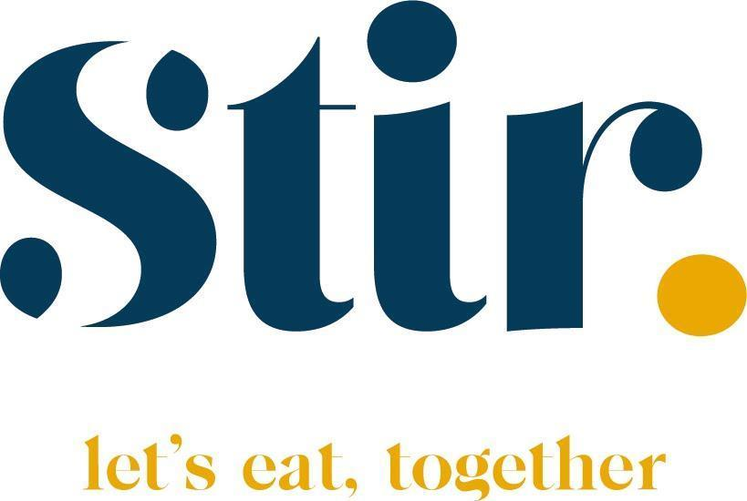
Special Diets/Allergy Form
Please send the completed form to:
Info@StirFood.co.uk

At Stir Food, we believe every child deserves to enjoy a safe, delicious, and inclusive dining experience. We are deeply committed to providing safe meals that respect both medical necessities and cultural requirements.
To ensure your child’s safety and well-being, we follow a collaborative process. Since menus change seasonally, it is essential that we work together to review these requirements regularly.

Students Details
School/Academy |  |  |  |  | Male |  | Female
Student’s Name
Student’s Class
Cultural Requirements | Halal | Kosher | Vegetarian |  | Vegan |  | Pescaterian
Does your child require texture modified meals | Yes | No | If Yes What level is Required (EG IDDSI LVL 4)
Is your Child Diabetic | Yes | No | If Yes - Please Circle  Type 1 Type 2
Please tick any allergies or intolerances your child may have. | Peanut | Milk | Crustacean |  | Soybean |  | Fish
 | Celery | Nuts | Sesame Seeds |  | Mustard |  | Lupin
 | Eggs | Molluscs | Gluten |  | Sulphites |  | *Other
 | *Other – Please state -
Does Your Child have any other medical conditions we need to be aware off. | Please state -
Does your Child Carry or need an Epipen |  |  | YES |  |  | NO
Is there student care plan in place for your child |  |  | YES |  |  | NO
Do you wish for your child to eat with us |  |  | YES |  |  | NO
Has the Allergy, Intolerance or Medical conditions been medically diagnosed? (Please provide evidence. This must be provided for ALL students) |  |  | YES |  |  | NO
The Company uses a colour coding system to identify student requirements. Please tick which applies:
RED – student has had a severe reaction/anaphylactic shock to know food
AMBER – student has an allergy or intolerance
BLUE – student excludes foods due to lifestyle choice
For students that have been identified as RED a meeting may be necessary between the Company and Parents to discuss the student’s requirements and agreed actions. Without this meeting we may not be able to cater for the student due to the unknown risk.

Parent/Guardian Details
Main contact name and
relationship
Main contact – phone number and email address
Second contact – name and relationship
Second contact - phone
number

Parent/Guardian Acceptance
Whilst we can provide meals which do not include allergens, we cannot guarantee that dishes may not contain traces of allergens, as these may be stored, prepared & cooked in the same kitchen as well as present in some ingredients from our suppliers due to production techniques.
I confirm that the information supplied is correct and will notify of any changes to the school and caterer immediately. I also understand that this information will be shared with others and displayed in the kitchen (photo & allergy).

By submitting this form, I agree that this information will be shared internally across Stir Food departments (such as the Food Team and Operations) and with Added Value Enterprises (AVE) to process your request and design your child's bespoke menu. AVE processes this health data as a Data Processor.
For more details on how we protect your information, please see our data sharing policy. A specific Privacy Notice detailing how AVE handles, secures, and retains this data is also available upon request from Stir Food and will be linked here shortly.
Name | Signed | Date

