Homework Booklet
Summer 1
Year 5
This booklet belongs to

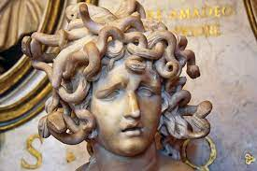

Woodlands Primary School
Homework Grid Summer 1

 | Expected |  | Exceeding Expected |  |  |  | Greater Depth
 | These need to be carried out every week |  | Maths |  | English |  | Select 2 projects from the list below to do over the half term
Week 1 | Reading at LEAST 3 times  Complete Spelling Sheet  Complete times table sheets |  | Adding and subtracting decimals
Week 2 | Reading at LEAST 3 times  Complete Spelling Sheet  Complete times table sheets |  |  |  | Subordinate clauses |  | - Create your own Greek god, for example: 3D paper mache, a drawing with labels, clay modelling  - Write an interview with a Greek god, for example: Zeus, Hermes, Hercules, Medusa  - Create a parachute to show air resistance.  - Design a new space rocket by researching air resistance.
Week 3 | Reading at LEAST 3 times  Complete Spelling Sheet  Complete times table sheets |  | Adding and subtracting fractions with different denominators
Week 4 | Reading at LEAST 3 times  Complete Spelling Sheet  Complete times table sheets |  |  |  | Active and passive voice
Week 5 | Reading at LEAST 3 times  Complete Spelling Sheet  Complete times table sheets |  | Multi-step problem solving
Homework will be given out every Friday. Homework will be collected every Wednesday.

There will be homework set on Education city weekly.

You can also access the links which are on our school website, class pages. Such as White rose maths, cgp+

Expected Week 1 Due 26.04.23 Spelling practise: Look, say, cover, write, check
Look | Say | Cover | Write | Check | Write | Check | Write | Check
example |  |  | exampel |  | example |  | example
blacken
brighten
flatten
lengthen
mistaken
straighten
shorten
thicken
tighten
toughen
Now apply 8 of those words in a sentence.
1. ____________________________________________________________________________________________________________________________________________________
2. ___________________________________________________________________________________________________________________________________________________
3. ___________________________________________________________________________________________________________________________________________________
4. ___________________________________________________________________________________________________________________________________________________
5. ___________________________________________________________________________________________________________________________________________________
6. ___________________________________________________________________________________________________________________________________________________
7. ___________________________________________________________________________________________________________________________________________________
8. ___________________________________________________________________________________________________________________________________________________

Expected - Week 1
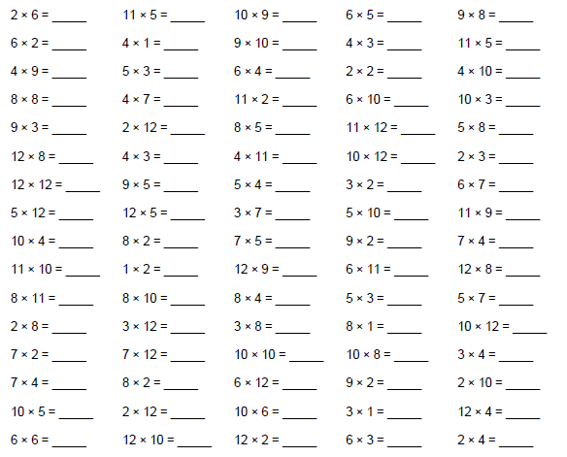
Exceeding expected- Week 1
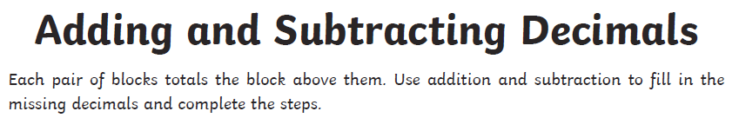

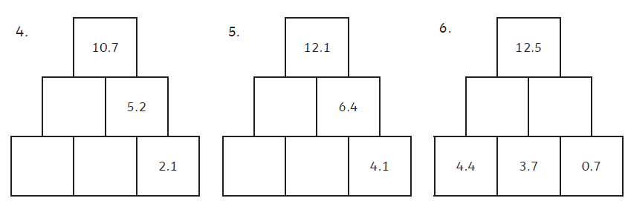
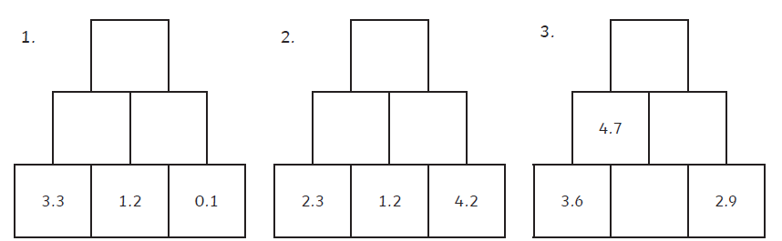
Expected - Week 2 Due 03.05.23 Spelling practise: Look, say, cover, write, check
Look | Say | Cover | Write | Check | Write | Check | Write | Check
example |  |  | exampel |  | example |  | example
though
although
dough
doughnut
through
cough
trough
rough
tough
enough
Now apply 7 of the words in a sentence.
1. ____________________________________________________________________________________________________________________________________________________
2. ___________________________________________________________________________________________________________________________________________________
3. ___________________________________________________________________________________________________________________________________________________
4. ___________________________________________________________________________________________________________________________________________________
5. ___________________________________________________________________________________________________________________________________________________
6. ___________________________________________________________________________________________________________________________________________________
7. ___________________________________________________________________________________________________________________________________________________

Expected - Week 2
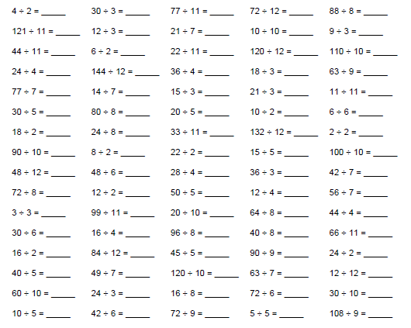
Exceeding expected- Week 2
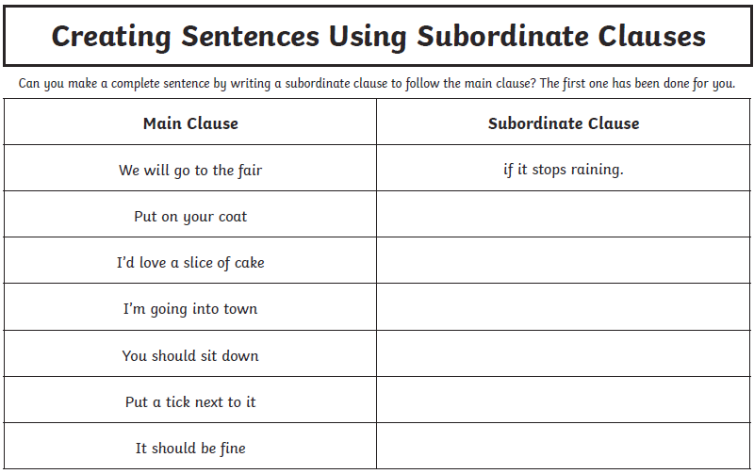

Expected - Week 3 10.05.23 Spelling practise: Look, say, cover, write, check
Look | Say | Cover | Write | Check | Write | Check | Write | Check
example |  |  | exampel |  | example |  | example
plough
bough
drought
brought
bought
wrought
thought
ought
borough
thorough

Now apply 7 of those words in a sentence.
1. ____________________________________________________________________________________________________________________________________________________
2. ___________________________________________________________________________________________________________________________________________________
3. ___________________________________________________________________________________________________________________________________________________
4. ___________________________________________________________________________________________________________________________________________________
5. ___________________________________________________________________________________________________________________________________________________
6. ___________________________________________________________________________________________________________________________________________________
7. ___________________________________________________________________________________________________________________________________________________

Expected - Week 3
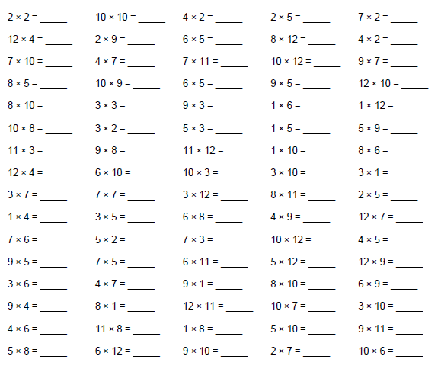

Expected - Week 3
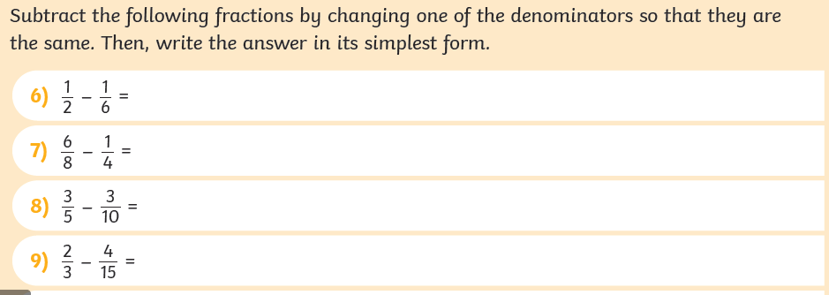
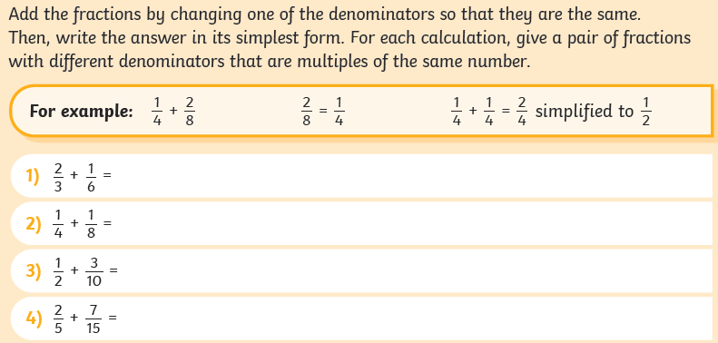
Expected - Week 4 Due 17.05.23 Spelling practise: Look, say, cover, write, check
Look | Say | Cover | Write | Check | Write | Check | Write | Check
example |  |  | exampel |  | example |  | example
yesterday
tomorrow
later
immediately
earlier
eventually
recently
previously
finally
lately

Now apply 8 of the words in a sentence.
1. ____________________________________________________________________________________________________________________________________________________
2. ___________________________________________________________________________________________________________________________________________________
3. ___________________________________________________________________________________________________________________________________________________
4. ___________________________________________________________________________________________________________________________________________________
5. ___________________________________________________________________________________________________________________________________________________
6. ___________________________________________________________________________________________________________________________________________________
7. ___________________________________________________________________________________________________________________________________________________
8. ___________________________________________________________________________________________________________________________________________________
Expected - Week 4
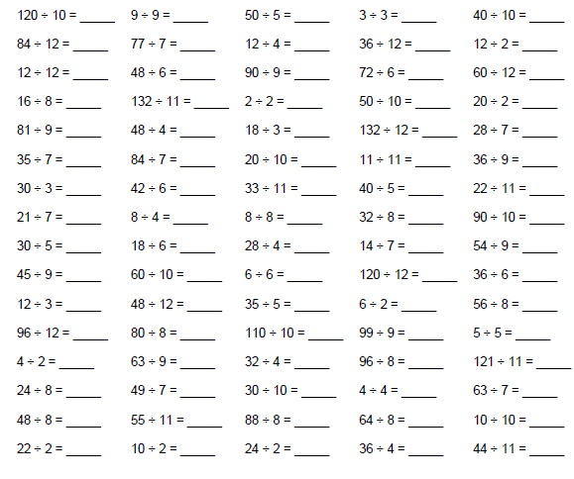
Exceeding expected – week 4
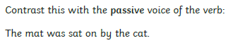

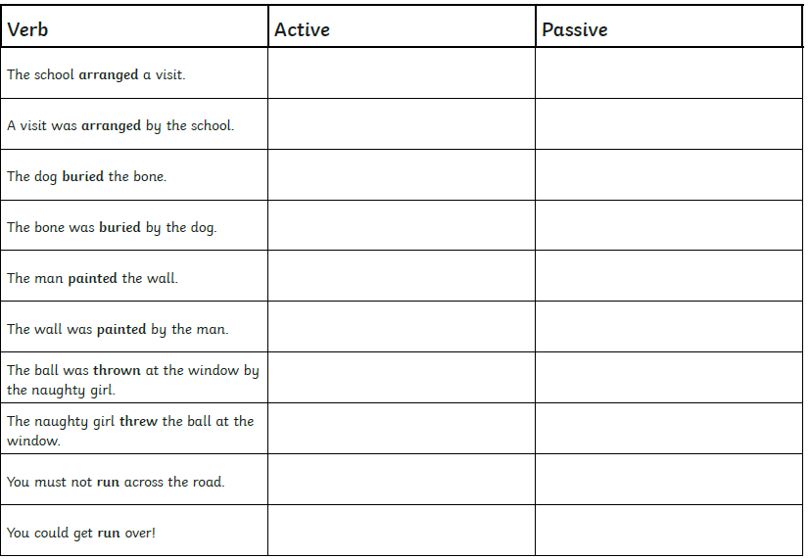
Expected - Week 5 Due 24.05.23 Spelling practise: Look, say, cover, write, check

Look | Say | Cover | Write | Check | Write | Check | Write | Check
example |  |  | exampel |  | example |  | example
nearby
everywhere
nowhere
inside
downstairs
outside
upstairs
underneath
behind
somewhere
Now write 6 of the words in a sentence.
1. ____________________________________________________________________________________________________________________________________________________
2. ___________________________________________________________________________________________________________________________________________________
3. ___________________________________________________________________________________________________________________________________________________
4. ___________________________________________________________________________________________________________________________________________________
5. ___________________________________________________________________________________________________________________________________________________
6. ___________________________________________________________________________________________________________________________________________________
Expected - Week 5

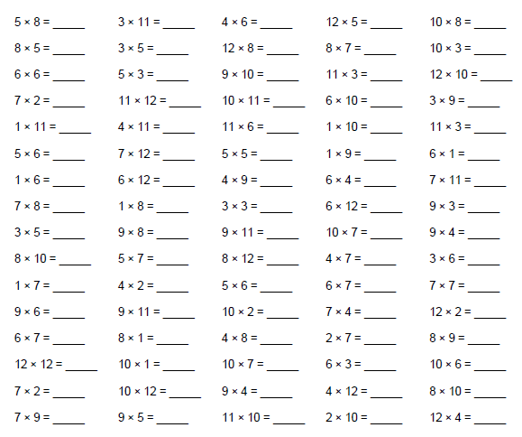
Exceeding expected – week 5
