

Home Learning Booklet

**Spring 1**

**Year 5**

This booklet belongs to



**Woodlands Primary School**

**Homework Grid Spring 1**

|  |  |  |  |  |
| --- | --- | --- | --- | --- |
|  | **Expected** | **Exceeding Expected** | | **Greater Depth** |
|  | These need to be carried out every week | **Maths** | **English** | Select 3 projects from the list below to do over the half term   * Research how the Mayans lived and compare it to our lifestyles * Create a information PowerPoint on Mexico-include transitions, images and writing * Design and make an item of clothing that would be suitable for people who lived in the Mayan civilisation!      * Create a top trumps game using facts about Mexico * Cross sitich or sewing inspired Mexican theme |
| Wk 1 | Reading at LEAST 3 times  Complete Spelling Sheet  Complete times table sheets | Adding and subtracting in powers of 10 | Verbs and Nouns |
| Wk 2 | Reading at LEAST 3 times  Complete Spelling Sheet  Complete times table sheets | Adding and subtracting fractions | Expanded noun phrases |
| Wk 3 | Reading at LEAST 3 times  Complete Spelling Sheet  Complete times table sheets | Mental maths | Reading comprehension-skim and scan skills |
| Wk 4 | Reading at LEAST 3 times  Complete Spelling Sheet  Complete times table sheets | Column addition | Synonyms |
| Wk 5 | Reading at LEAST 3 times  Complete Spelling Sheet  Complete times table sheets | Rounding numbers | Modal verbs |
| Wk 6 | Reading at LEAST 3 times  Complete Spelling Sheet  Complete times table sheets | Prime numbers | Commas in use |
| Wk 7 | Consolidation activities mixed variety and levels of achievement | | |
|  | **Homework will be given out every Friday. Homework will be collected every Wednesday.**  **EACH WEEK THERE IS HOMEWORK ALSO SET ON EDUCATION CITY** | | |

**Expected: Due 11.01.23 Week 1 Spelling practise:** Look, say, cover, write, check

|  |  |  |  |  |  |  |  |  |
| --- | --- | --- | --- | --- | --- | --- | --- | --- |
| **Look** | **Say** | **Cover** | **Write** | **Check** | **Write** | **Check** | **Write** | **Check** |
| example |  |  | *exampel* | 🗶 | *example* | ✓ | *example* | ✓ |
| community |  |  |  |  |  |  |  |  |
| curiosity |  |  |  |  |  |  |  |  |
| ability |  |  |  |  |  |  |  |  |
| visibility |  |  |  |  |  |  |  |  |
| captivity |  |  |  |  |  |  |  |  |
| activity |  |  |  |  |  |  |  |  |
| eternity |  |  |  |  |  |  |  |  |
| flexibility |  |  |  |  |  |  |  |  |
| possibility |  |  |  |  |  |  |  |  |
| sensitivity |  |  |  |  |  |  |  |  |

Now apply six of those words in a sentence.

1. ____________________________________________________________________________________________________________________________________________________

2. ___________________________________________________________________________________________________________________________________________________

3. ___________________________________________________________________________________________________________________________________________________

4. ___________________________________________________________________________________________________________________________________________________

5. ­___________________________________________________________________________________________________________________________________________________

6. ___________________________________________________________________________________________________________________________________________________

**Expected -** **Week 1**

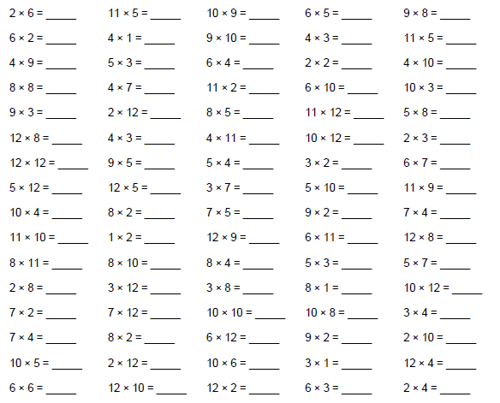

**Exceeding expected- Week 1**

A game where children add and subtract in powers of 10.

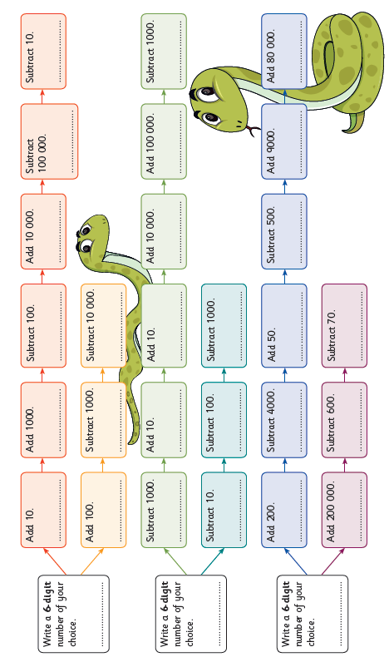

**Exceeding expected week 1**

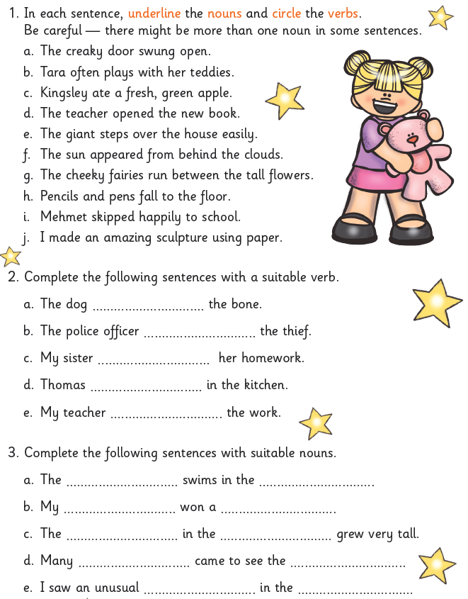

**Now write 2 sentences of your own and colour code the verbs and nouns.**

1. ______________________________________________________________________

______________________________________________________________________

2. ______________________________________________________________________

______________________________________________________________________

**Expected – Due 18.01.23 Week 2 Spelling practise:** Look, say, cover, write, check

|  |  |  |  |  |  |  |  |  |
| --- | --- | --- | --- | --- | --- | --- | --- | --- |
| **Look** | **Say** | **Cover** | **Write** | **Check** | **Write** | **Check** | **Write** | **Check** |
| example |  |  | *exampel* | 🗶 | *example* | ✓ | *example* | ✓ |
| happiness |  |  |  |  |  |  |  |  |
| hardness |  |  |  |  |  |  |  |  |
| madness |  |  |  |  |  |  |  |  |
| nastiness |  |  |  |  |  |  |  |  |
| silliness |  |  |  |  |  |  |  |  |
| tidiness |  |  |  |  |  |  |  |  |
| childishness |  |  |  |  |  |  |  |  |
| willingness |  |  |  |  |  |  |  |  |
| carelessness |  |  |  |  |  |  |  |  |
| foolishness |  |  |  |  |  |  |  |  |

Now write the words in a sentence.

1. ____________________________________________________________________________________________________________________________________________________

2. ___________________________________________________________________________________________________________________________________________________

3. ___________________________________________________________________________________________________________________________________________________

4. ___________________________________________________________________________________________________________________________________________________

5. ­___________________________________________________________________________________________________________________________________________________

6. ___________________________________________________________________________________________________________________________________________________

7. ___________________________________________________________________________________________________________________________________________________

8. ___________________________________________________________________________________________________________________________________________________

**Expected** - **Week 2**

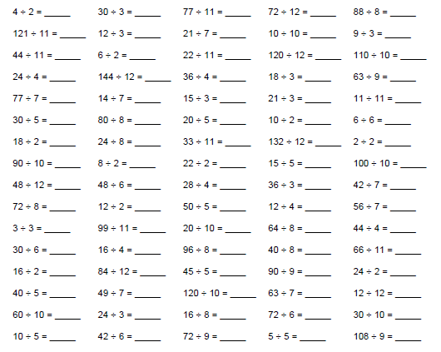

**Exceeding expected- Week** **2**

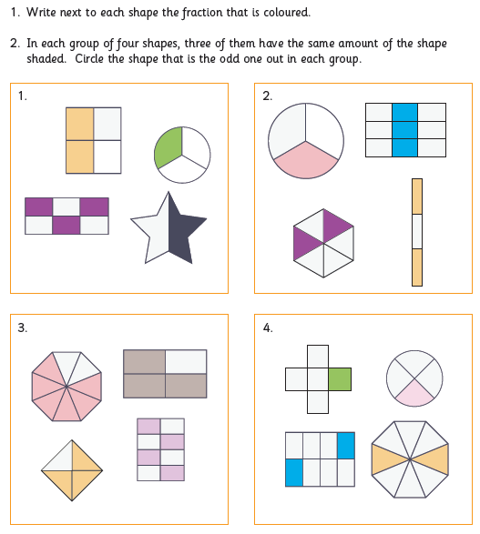

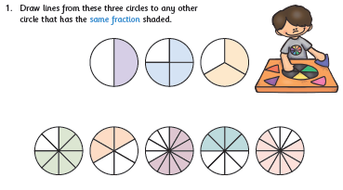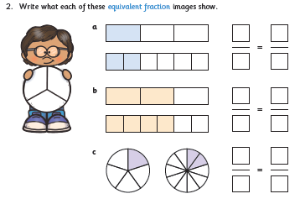

**Exceeding expected week 2:**

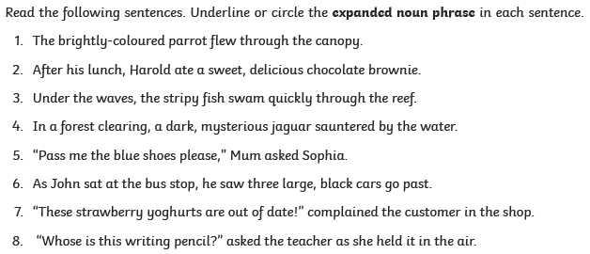

**Expected – Due 25.01.23 Week 3 Spelling practise:** Look, say, cover, write, check

|  |  |  |  |  |  |  |  |  |
| --- | --- | --- | --- | --- | --- | --- | --- | --- |
| **Look** | **Say** | **Cover** | **Write** | **Check** | **Write** | **Check** | **Write** | **Check** |
| example |  |  | *exampel* | 🗶 | *example* | ✓ | *example* | ✓ |
| membership |  |  |  |  |  |  |  |  |
| ownership |  |  |  |  |  |  |  |  |
| partnership |  |  |  |  |  |  |  |  |
| dictatorship |  |  |  |  |  |  |  |  |
| championship |  |  |  |  |  |  |  |  |
| craftsmanship |  |  |  |  |  |  |  |  |
| fellowship |  |  |  |  |  |  |  |  |
| apprenticeship |  |  |  |  |  |  |  |  |
| citizenship |  |  |  |  |  |  |  |  |
| sponsorship |  |  |  |  |  |  |  |  |

**Now write the words in a sentence.**

1. ____________________________________________________________________________________________________________________________________________________

2. ___________________________________________________________________________________________________________________________________________________

3. ___________________________________________________________________________________________________________________________________________________

4. ___________________________________________________________________________________________________________________________________________________

5. ­___________________________________________________________________________________________________________________________________________________

6. ___________________________________________________________________________________________________________________________________________________

**Expected - Week 3**

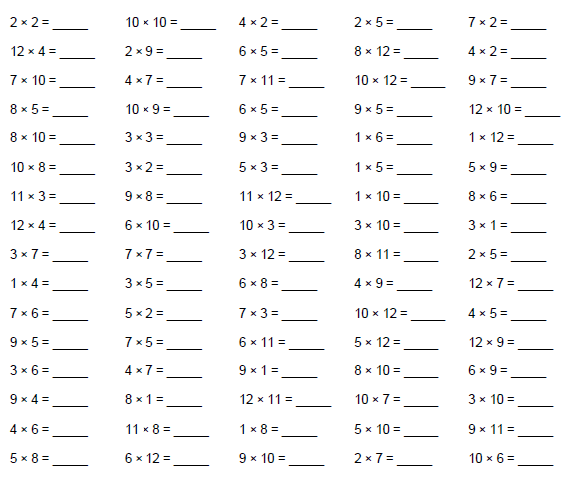

**Exceeding expected – week 3**

Match the words to the closest synonym Highlight the words you have matched in the text

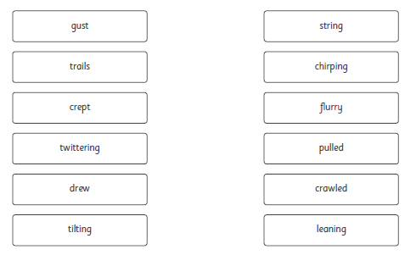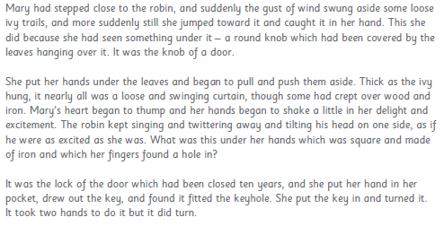



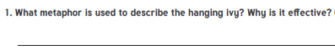

**Exceeding expected week 3:**

Using mental methods – no working out.

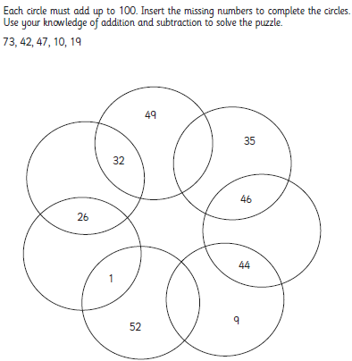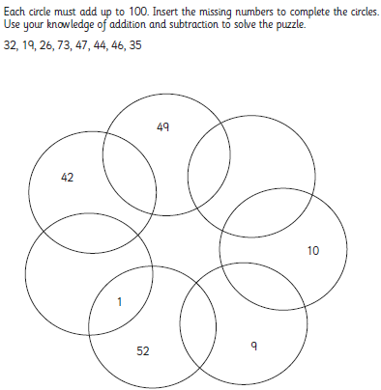

**Expected – Due 01.02.23 Week 4 Spelling practise:** Look, say, cover, write, check

|  |  |  |  |  |  |  |  |  |
| --- | --- | --- | --- | --- | --- | --- | --- | --- |
| **Look** | **Say** | **Cover** | **Write** | **Check** | **Write** | **Check** | **Write** | **Check** |
| example |  |  | *exampel* | 🗶 | *example* | ✓ | *example* | ✓ |
| stationary |  |  |  |  |  |  |  |  |
| stationery |  |  |  |  |  |  |  |  |
| steal |  |  |  |  |  |  |  |  |
| steel |  |  |  |  |  |  |  |  |
| wary |  |  |  |  |  |  |  |  |
| weary |  |  |  |  |  |  |  |  |
| who’s |  |  |  |  |  |  |  |  |
| whose |  |  |  |  |  |  |  |  |
| fate |  |  |  |  |  |  |  |  |
| fete |  |  |  |  |  |  |  |  |

Now write the words in a sentence.

1. ____________________________________________________________________________________________________________________________________________________

2. ___________________________________________________________________________________________________________________________________________________

3. ___________________________________________________________________________________________________________________________________________________

4. ___________________________________________________________________________________________________________________________________________________

5. ­___________________________________________________________________________________________________________________________________________________

6. ___________________________________________________________________________________________________________________________________________________

**Expected - Week 4**

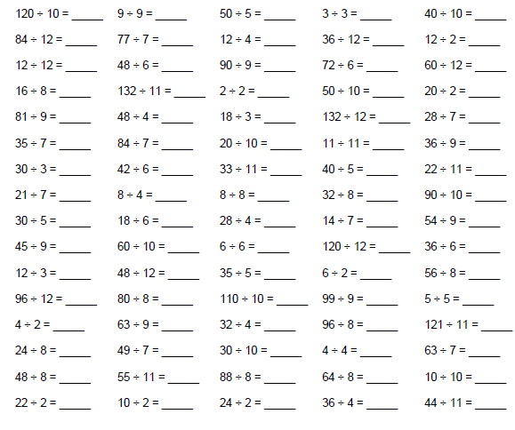

**Exceeding expected – week 4**

Answer the following problems and show your working using column method.

Mrs Mansfield has £1.48 in her purse but she loses 49p, how much does she now have?

The bus to town costs £1.15, with the money left in her purse can she afford to go to town?

Miss Bennett has £12.68 more than Mrs Mansfield (her original amount) How much does

Miss Bennet have in total? She is then gets £780 for her birthday, and £1980 from her car

Sale, how much does she now have?

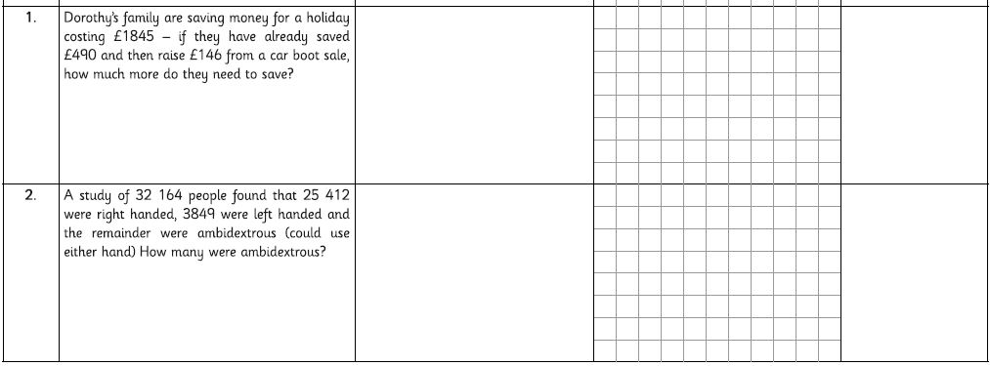If Mrs Ball had £100.98 and Miss Volante had £20.21 could they afford to a £122 puppy if

They combined their money?

**Exceeding expected week 4:**

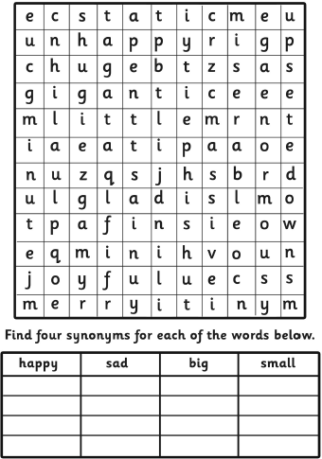

**Expected – Due 08.02.23 Week 5 Spelling practise:** Look, say, cover, write, check

|  |  |  |  |  |  |  |  |  |
| --- | --- | --- | --- | --- | --- | --- | --- | --- |
| **Look** | **Say** | **Cover** | **Write** | **Check** | **Write** | **Check** | **Write** | **Check** |
| example |  |  | *exampel* | 🗶 | *example* | ✓ | *example* | ✓ |
| alter |  |  |  |  |  |  |  |  |
| altar |  |  |  |  |  |  |  |  |
| ascent |  |  |  |  |  |  |  |  |
| assent |  |  |  |  |  |  |  |  |
| bridal |  |  |  |  |  |  |  |  |
| bridle |  |  |  |  |  |  |  |  |
| cereal |  |  |  |  |  |  |  |  |
| serial |  |  |  |  |  |  |  |  |
| compliment |  |  |  |  |  |  |  |  |
| complement |  |  |  |  |  |  |  |  |

**Now write the words in a sentence.**

1. ____________________________________________________________________________________________________________________________________________________

2. ___________________________________________________________________________________________________________________________________________________

3. ___________________________________________________________________________________________________________________________________________________

4. ___________________________________________________________________________________________________________________________________________________

5. ­___________________________________________________________________________________________________________________________________________________

**Expected** - **Week 5**

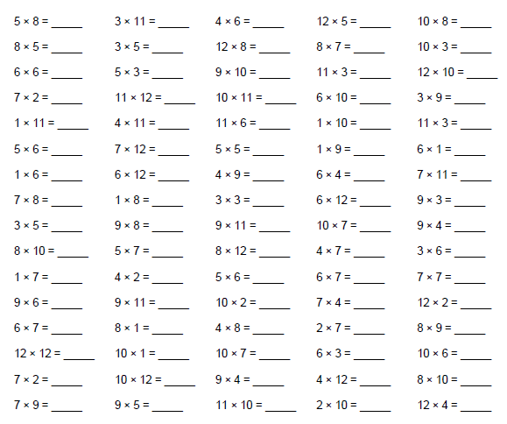

**Exceeding expected – week 5**

Round the numbers below to the nearest 10, 100, 1000 or 10, 000. Think carefully about the value of the digit.

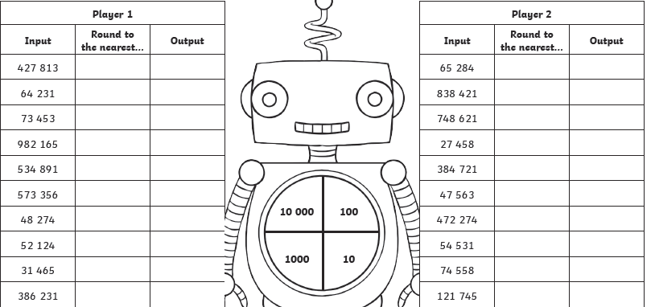

Exceeding expected week 5:

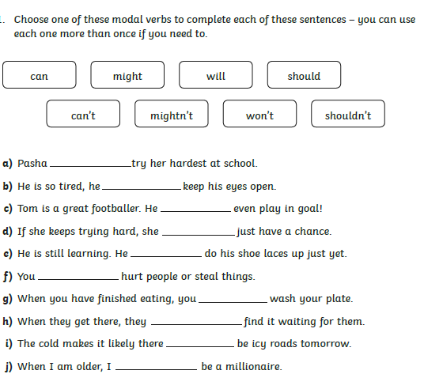

**Expected – Due 15.02.23 Week 6 Spelling practise:** Look, say, cover, write, check

|  |  |  |  |  |  |  |  |  |
| --- | --- | --- | --- | --- | --- | --- | --- | --- |
| **Look** | **Say** | **Cover** | **Write** | **Check** | **Write** | **Check** | **Write** | **Check** |
| example |  |  | *exampel* | 🗶 | *example* | ✓ | *example* | ✓ |
| principal |  |  |  |  |  |  |  |  |
| principle |  |  |  |  |  |  |  |  |
| profit |  |  |  |  |  |  |  |  |
| prophet |  |  |  |  |  |  |  |  |
| descent |  |  |  |  |  |  |  |  |
| dissent |  |  |  |  |  |  |  |  |
| desert |  |  |  |  |  |  |  |  |
| dessert |  |  |  |  |  |  |  |  |
| draft |  |  |  |  |  |  |  |  |
| draught |  |  |  |  |  |  |  |  |

**Now write the words in a sentence.**

1. ____________________________________________________________________________________________________________________________________________________

2. ___________________________________________________________________________________________________________________________________________________

3. ___________________________________________________________________________________________________________________________________________________

4. ___________________________________________________________________________________________________________________________________________________

5. ­___________________________________________________________________________________________________________________________________________________

6. ___________________________________________________________________________________________________________________________________________________

**Expected - Week 6**

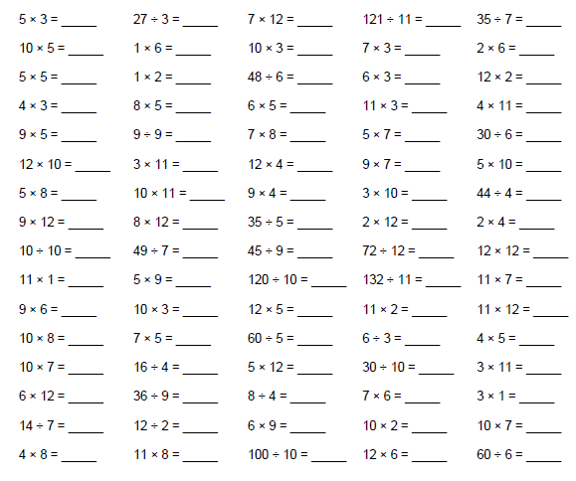

**Exceeding expected – week 6**

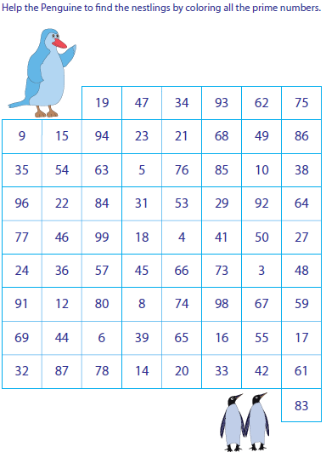

Helpful Hint

A prime number can only be divided by itself and 1.

**Exceeding expected week 6:**

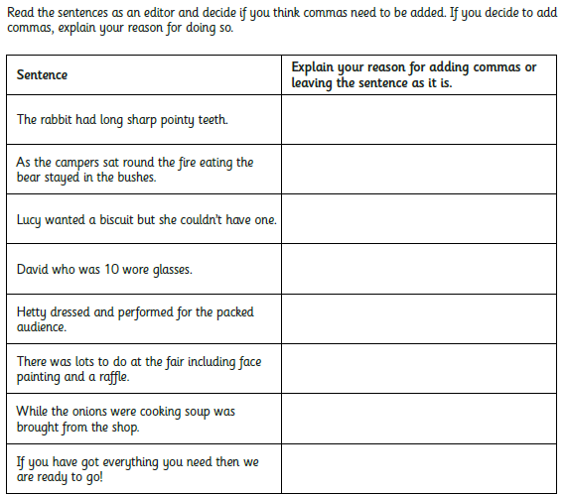

**Week 7:**

**Consolidation of learning:**

**Visit this link for support**

**https://www.youtube.com/watch?v=hIVL38Is5Ac**

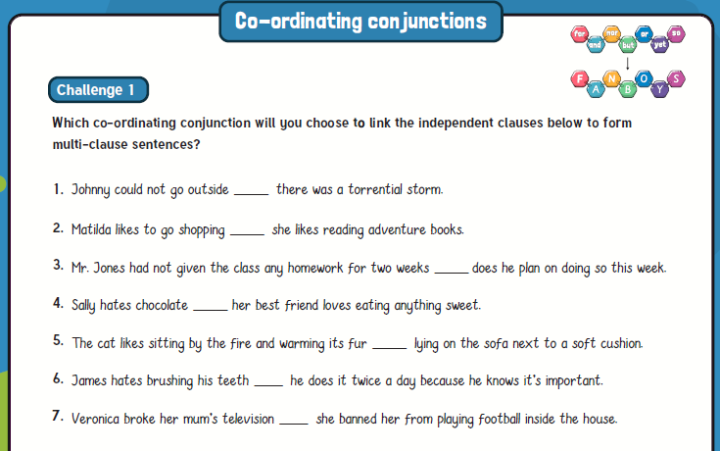

**Week 7:**

**Pygmy gecko**

The pygmy gecko is a species of tiny lizard that grows to just 24mm long: that’s about the length of a small paper clip!  They live amongst the dead leaves on the floor of the Amazon, the vast tropical rainforest that covers a large part of South America. The pygmy gecko eats tiny arthropods (creatures with an exoskeleton instead of a spine) such as springtails and mites. Thanks to the pygmy gecko’s small size, the way it moves, and its superhydrophobic (water-repellent) skin, this tiny lizard can walk on water!

In this clip we see how the pygmy gecko’s water-repellent skin helps it to survive in its dangerous rainforest habitat.

**Activity:**

What would you do if your skin could repel water? Imagine that for one day you had hydrophobic skin like a pygmy gecko, and write a diary entry describing all the things you did. Try to include the following details:

* Talk about the important events that happened to you throughout the day;
* Describe the places you visited;
* Describe the people you saw (this might be your family, your friends or your neighbours);
* Talk about your feelings;
* Remember to write in the past tense.

Once you have finished, why not read it out loud to someone at home?

**Week 7:**



**Week 7:**



**Please see Miss Bennett for extra or additional homework if required.**

**Please tell your teacher if there is something particular you need support with.**