Homework Booklet
Summer 1
Year 6
This booklet belongs to

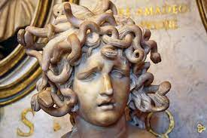

Woodlands Primary School
Homework Grid Summer 1

 | Expected |  | Exceeding Expected |  |  |  | Greater Depth
 | These need to be carried out every week |  | Maths |  | English |  | Select 2 projects from the list below to do over the half term
Week 1 | Reading at LEAST 3 times  Complete Spelling Sheet  Complete times table sheets |  | Prime, square and cube numbers
Week 2 | Reading at LEAST 3 times  Complete Spelling Sheet  Complete times table sheets |  |  |  | Parenthesis - using brackets, dashes and commas to add extra information into a sentence |  | - Create your own Greek god, for example: 3D paper mache, a drawing with labels, clay modelling  - Write an interview with a Greek god, for example: Zeus, Hermes, Hercules, Medusa  - Create a parachute to show air resistance.  - Design a new space rocket by researching air resistance.
Week 3 | Reading at LEAST 3 times  Complete Spelling Sheet  Complete times table sheets |  | Ratio and proportion
Week 4 | Reading at LEAST 3 times  Complete Spelling Sheet  Complete times table sheets |  |  |  | Using semi-colons to separate 2 main clauses
Week 5 | Reading at LEAST 3 times  Complete Spelling Sheet  Complete times table sheets |  | Fractions to decimals
Homework will be given out every Friday. Homework will be collected every Wednesday.

There will be homework set on Education city weekly.

You can also access the links which are on our school website, class pages. Such as White rose maths, cgp+

Expected Week 1 Due 26.04.23 Spelling practise: Look, say, cover, write, check
Look | Say | Cover | Write | Check | Write | Check | Write | Check
example |  |  | exampel |  | example |  | example
foreign
apparent
appreciate
persuade
individual
language
sufficient
determined
explanation
pronunciation
Now apply 6 of those words in a sentence.
1. ____________________________________________________________________________________________________________________________________________________
2. ___________________________________________________________________________________________________________________________________________________
3. ___________________________________________________________________________________________________________________________________________________
4. ___________________________________________________________________________________________________________________________________________________
5. ___________________________________________________________________________________________________________________________________________________
6. ___________________________________________________________________________________________________________________________________________________

Expected - Week 1
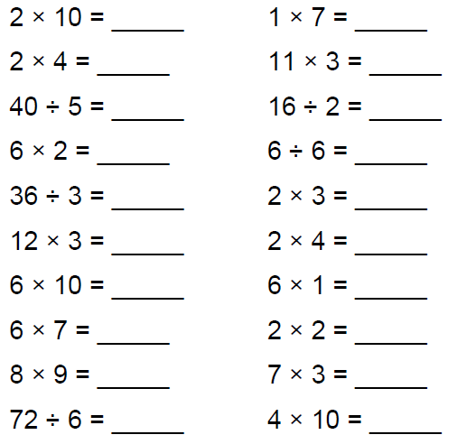
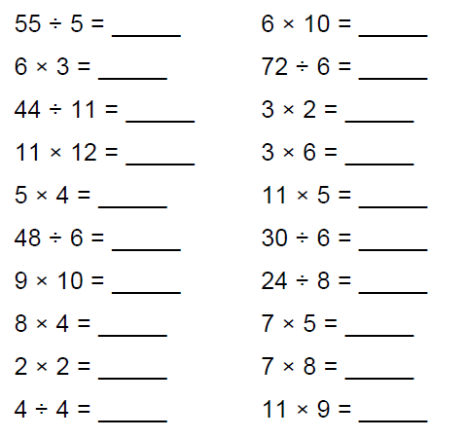

Exceeding expected- Week 1
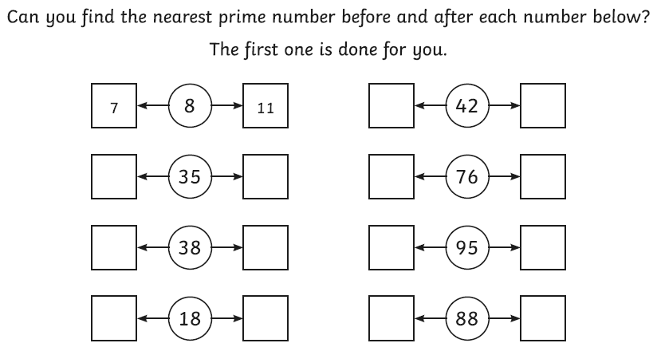
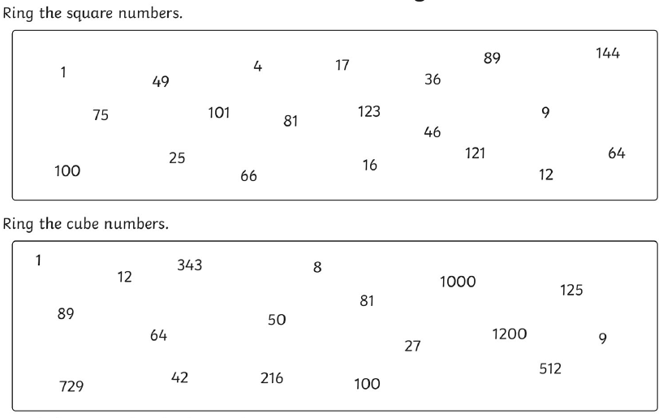

Expected - Week 2 Due 03.05.23 Spelling practise: Look, say, cover, write, check
Look | Say | Cover | Write | Check | Write | Check | Write | Check
example |  |  | exampel |  | example |  | example
programme
telegram
hologram
diagram
grammar
grammatical
parallelogram
monogram
programmer
programme
Now apply 6 of the words in a sentence.
1. ____________________________________________________________________________________________________________________________________________________
2. ___________________________________________________________________________________________________________________________________________________
3. ___________________________________________________________________________________________________________________________________________________
4. ___________________________________________________________________________________________________________________________________________________
5. ___________________________________________________________________________________________________________________________________________________
6. ___________________________________________________________________________________________________________________________________________________

Expected - Week 2
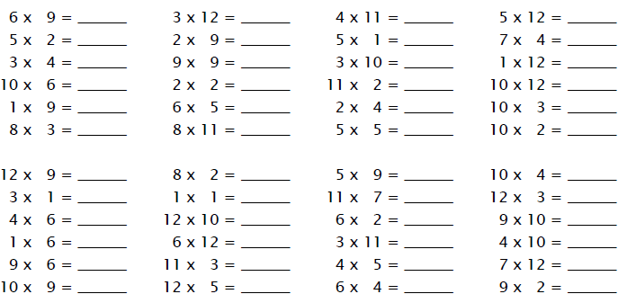

Exceeding expected- Week 2

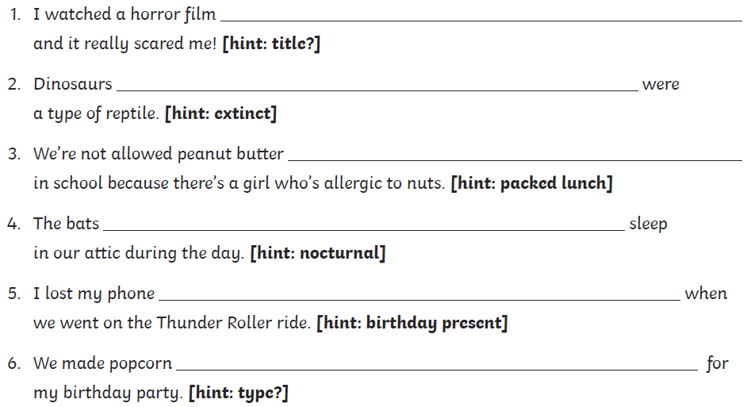

Expected - Week 3 10.05.23 Spelling practise: Look, say, cover, write, check
Look | Say | Cover | Write | Check | Write | Check | Write | Check
example |  |  | exampel |  | example |  | example
challenge
damage
broadcast
benefit
charge
function
influence
interest
object
protest

Now apply 7 of those words in a sentence.
1. ____________________________________________________________________________________________________________________________________________________
2. ___________________________________________________________________________________________________________________________________________________
3. ___________________________________________________________________________________________________________________________________________________
4. ___________________________________________________________________________________________________________________________________________________
5. ___________________________________________________________________________________________________________________________________________________
6. ___________________________________________________________________________________________________________________________________________________
7. ___________________________________________________________________________________________________________________________________________________

Expected - Week 3
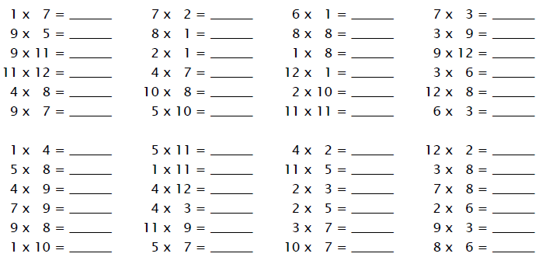

Expected - Week 3
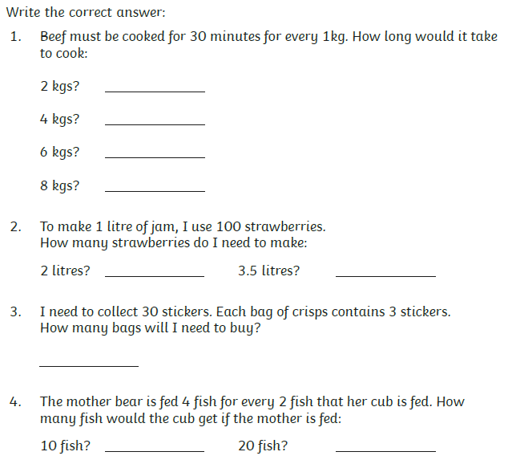
Expected - Week 4 Due 17.05.23 Spelling practise: Look, say, cover, write, check
Look | Say | Cover | Write | Check | Write | Check | Write | Check
example |  |  | exampel |  | example |  | example
produce
present
reason
silence
support
transport
surprise
scratch
freeze
balance

Now apply 8 of the words in a sentence.
1. ____________________________________________________________________________________________________________________________________________________
2. ___________________________________________________________________________________________________________________________________________________
3. ___________________________________________________________________________________________________________________________________________________
4. ___________________________________________________________________________________________________________________________________________________
5. ___________________________________________________________________________________________________________________________________________________
6. ___________________________________________________________________________________________________________________________________________________
7. ___________________________________________________________________________________________________________________________________________________
8. ___________________________________________________________________________________________________________________________________________________
Expected - Week 4

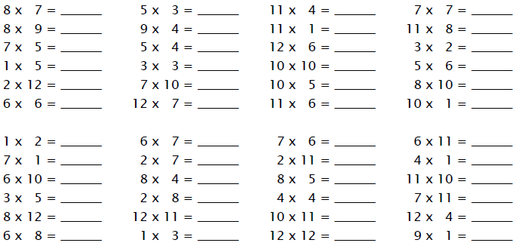
Exceeding expected – week 4

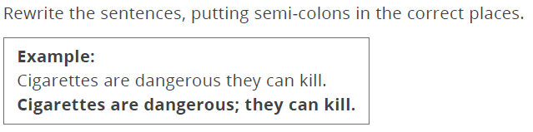

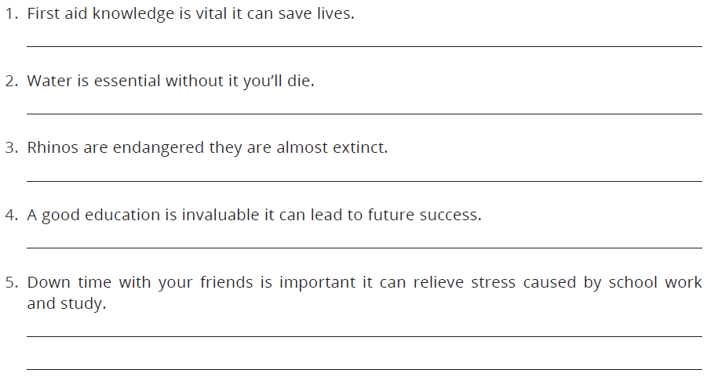

Expected - Week 5 Due 24.05.23 Spelling practise: Look, say, cover, write, check
Look | Say | Cover | Write | Check | Write | Check | Write | Check
example |  |  | exampel |  | example |  | example
shoulder
smoulder
mould
poultry
soul
shallow
window
blown
know
thrown
Now write 6 of the words in a sentence.
1. ____________________________________________________________________________________________________________________________________________________
2. ___________________________________________________________________________________________________________________________________________________
3. ___________________________________________________________________________________________________________________________________________________
4. ___________________________________________________________________________________________________________________________________________________
5. ___________________________________________________________________________________________________________________________________________________
6. ___________________________________________________________________________________________________________________________________________________
Expected - Week 5

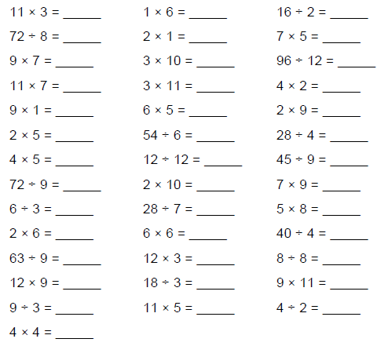
Exceeding expected – week 5
