

Home Learning Booklet

**Spring 2**

**Year 2**

This booklet belongs to

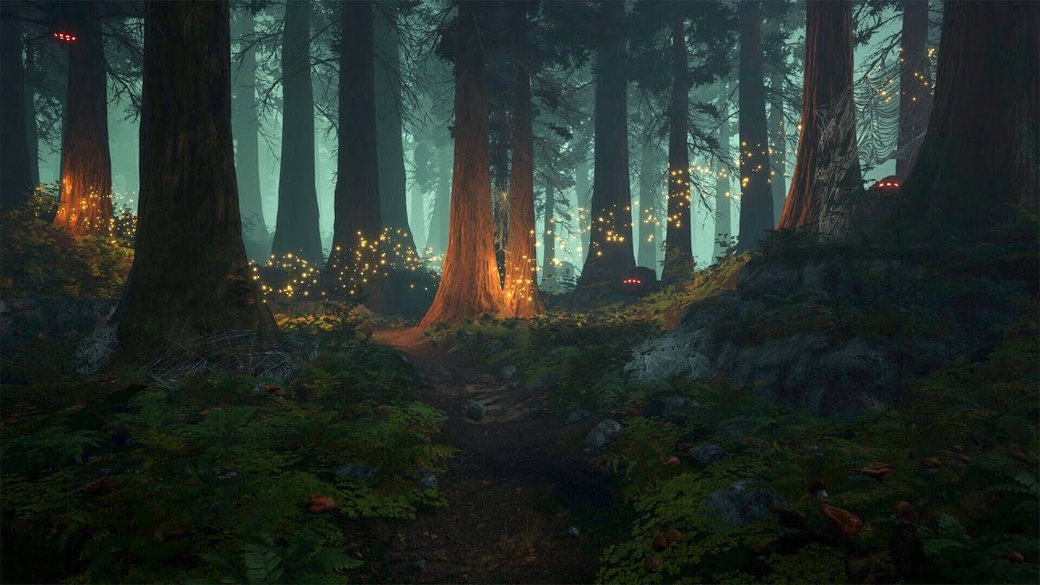

**Woodlands Primary School**

**Homework Grid Spring 2**

|  |  |  |  |  |  |  |  |
| --- | --- | --- | --- | --- | --- | --- | --- |
|  | **Expected** | | **Exceeding Expected** | | | | **Greater Depth** |
|  | These need to be carried out every week | | **Maths** | | **English** | | Select 2 projects from the list below to do over the half term |
| Week 1 | Reading at LEAST 3 times  Practise spellings from last half term  Complete 5 x times tables sheet |  | Education City – Calculation Station |  | Can I explore the homophone to, too and two?  (See inside booklet) |  |
| Week 2 | Reading at LEAST 3 times  Complete Spelling Sheet  Complete 5 ÷ times tables sheet |  | Can I explore position and direction?  (See inside booklet) |  |  |  | * Create a bug hotel. Use small logs, large sticks and pieces of rotting wood. Pile them up in a damp, shady area of your garden, then stuff some dead leaves in the nooks and crannies to make it cosy. * Grow some vegetables such as tomatoes, cucumbers etc. * Go on a nature walk and collect parts of plants to use on a woodland piece of art. * Go on a woodland walk and take pictures of your adventure. |
| Week 3 | Reading at LEAST 3 times  Complete Spelling Sheet  Complete 5 x times tables sheet |  | Education City – Carnival Capers |  | Can I explore expanded noun phrases?  (See inside booklet) |  |
| Week 4 | Reading at LEAST 3 times  Complete Spelling Sheet  Complete 5 ÷ times tables sheet |  | Can I explore position and direction?  (See inside booklet) |  | Education City – Football Contractions |  |
| Week 5 | Reading at LEAST 3 times  Complete Spelling Sheet  Complete 5 x times tables sheet |  | Education City – Mirage Madness |  | Can I explore verbs?  (See inside booklet) |  |

**Expected**

**Week 1: Spelling practise:** Look, say, cover, write, check

|  |  |  |  |  |  |  |  |  |
| --- | --- | --- | --- | --- | --- | --- | --- | --- |
| **Look** | **Say** | **Cover** | **Write** | **Check** | **Write** | **Check** | **Write** | **Check** |
| other |  |  |  | 🗶 |  | ✓ |  | ✓ |
| mother |  |  |  |  |  |  |  |  |
| brother |  |  |  |  |  |  |  |  |
| nothing |  |  |  |  |  |  |  |  |
| Monday |  |  |  |  |  |  |  |  |
| money |  |  |  |  |  |  |  |  |
| cover |  |  |  |  |  |  |  |  |
| honey |  |  |  |  |  |  |  |  |
| discover |  |  |  |  |  |  |  |  |
| wonder |  |  |  |  |  |  |  |  |

Now choose two of the words to write in a sentence.

1. _______________________________________________________________________________________

2. _______________________________________________________________________________________

**Expected**

**Week 1** 5x Times tables

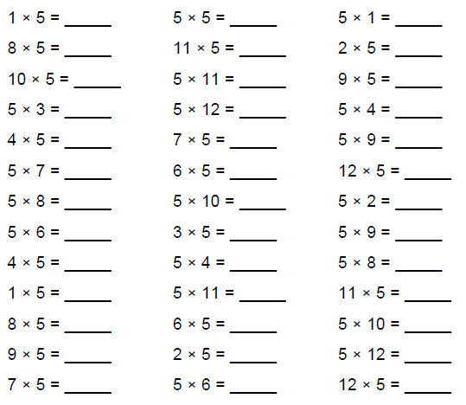



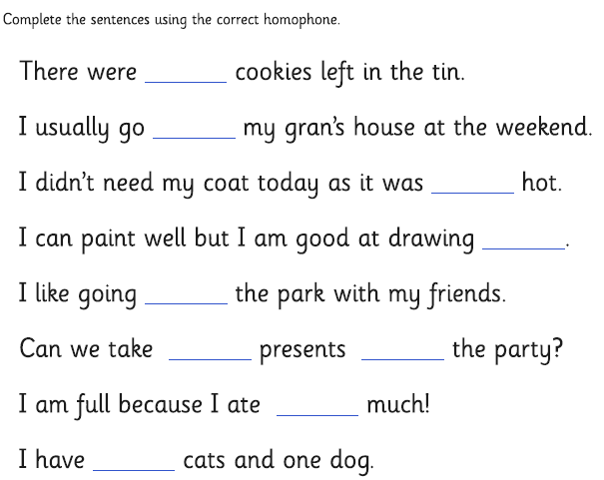**Exceeding expected**

THTH

**Week 1-** Exploring the Homophone: **two, too** and **to**.

The words **to**, **too, and two** are homophones: they sound alike but have different meanings**. To** is a preposition when it comes before a noun. **Too** is an adverb meaning "excessively" or "also." .**Two** is a number.

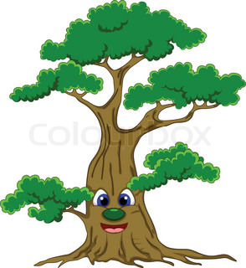

**Exceeding expected**

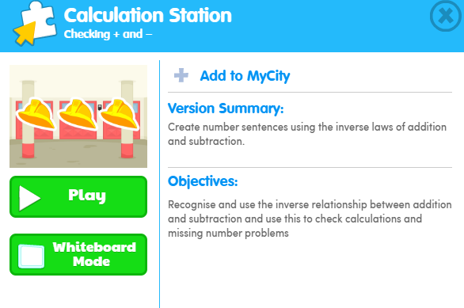

What score did you get?

___________

**Expected**

**Week 2: Spelling practise:** Look, say, cover, write, check

|  |  |  |  |  |  |  |  |  |
| --- | --- | --- | --- | --- | --- | --- | --- | --- |
| **Look** | **Say** | **Cover** | **Write** | **Check** | **Write** | **Check** | **Write** | **Check** |
| key |  |  |  | 🗶 |  | ✓ |  | ✓ |
| donkey |  |  |  |  |  |  |  |  |
| monkey |  |  |  |  |  |  |  |  |
| chimney |  |  |  |  |  |  |  |  |
| valley |  |  |  |  |  |  |  |  |
| trolley |  |  |  |  |  |  |  |  |
| turkey |  |  |  |  |  |  |  |  |
| hockey |  |  |  |  |  |  |  |  |
| parsley |  |  |  |  |  |  |  |  |
| journey |  |  |  |  |  |  |  |  |

Now choose two of the words to write in a sentence.

1. _______________________________________________________________________________________

2. _______________________________________________________________________________________

**Expected**

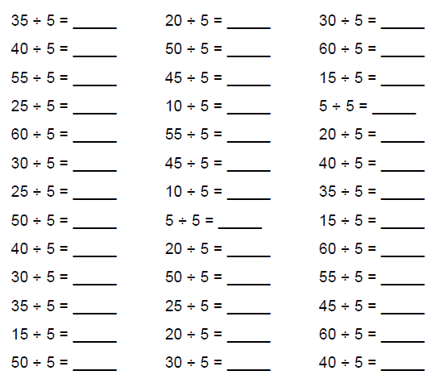**Week 2** Complete the 5÷ table’s sheet.

Count in fives to help you solve the problems**.**

[](http://www.google.co.uk/url?sa=i&rct=j&q=&esrc=s&source=images&cd=&cad=rja&uact=8&ved=2ahUKEwjm0Neqi4zZAhWCKVAKHfrwBzwQjRx6BAgAEAY&url=http://laoblogger.com/fall-flower-pot-clipart.html&psig=AOvVaw0HB2zQlSaFixMAycDXasDS&ust=1517827795469262)

**Exceeding expected**

**Week 2-** Answer the questions based on position and direction.

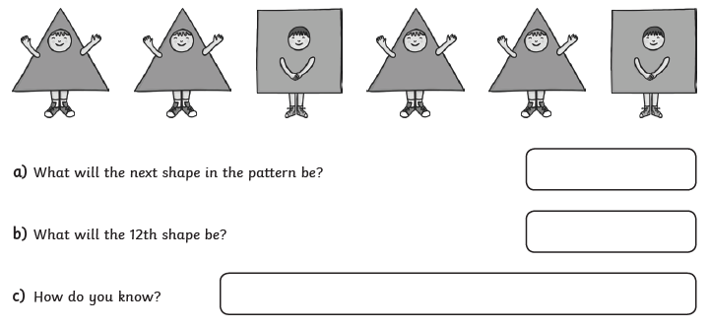

don’t

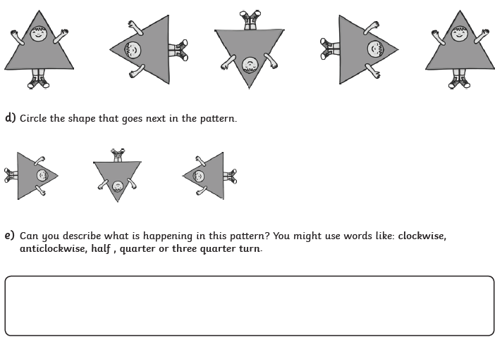

**Expected**

**Week 3: Spelling practise:** Look, say, cover, write, check

|  |  |  |  |  |  |  |  |  |
| --- | --- | --- | --- | --- | --- | --- | --- | --- |
| **Look** | **Say** | **Cover** | **Write** | **Check** | **Write** | **Check** | **Write** | **Check** |
| want |  |  |  | 🗶 |  | ✓ |  | ✓ |
| watch |  |  |  |  |  |  |  |  |
| wander |  |  |  |  |  |  |  |  |
| quantity |  |  |  |  |  |  |  |  |
| squash |  |  |  |  |  |  |  |  |
| quality |  |  |  |  |  |  |  |  |
| squabble |  |  |  |  |  |  |  |  |
| squad |  |  |  |  |  |  |  |  |
| quad |  |  |  |  |  |  |  |  |
| quarrel |  |  |  |  |  |  |  |  |

Now choose two of the words to write in a sentence.

1. _______________________________________________________________________________________

2. _______________________________________________________________________________________

**Expected**

**Week 3**-. Complete the 5x times tables.

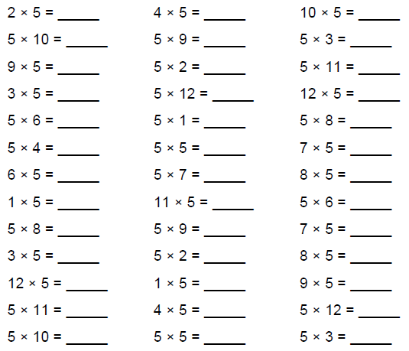

Count in fives to help you solve the problems**.**



**Exceeding expected**

**Week 3**

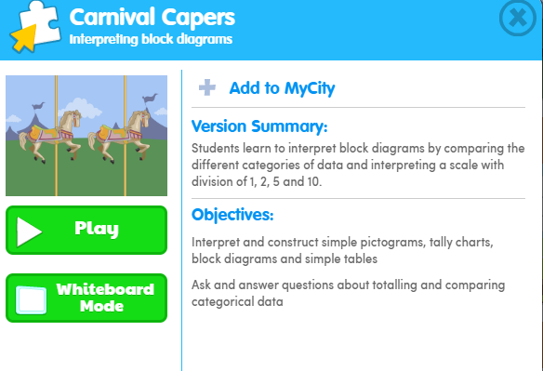

What score did you get?

___________

**Exceeding expected**

**Week 3-** Complete the questions about expanded noun phrases.

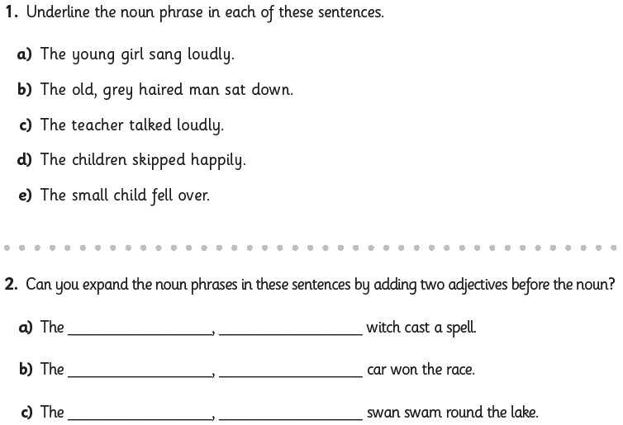

An expanded noun phrase is a noun phrase with extra details added.

Adjectives can be added to add more information:

[](http://www.google.co.uk/url?sa=i&rct=j&q=&esrc=s&source=images&cd=&cad=rja&uact=8&ved=2ahUKEwjq7Kq8mIzZAhWSGuwKHXTXCuoQjRx6BAgAEAY&url=http://www.how-to-draw-cartoons-online.com/plants-vs.-zombies.html&psig=AOvVaw2AmsWixJlj3SLJh-1sCvoy&ust=1517831329740089)

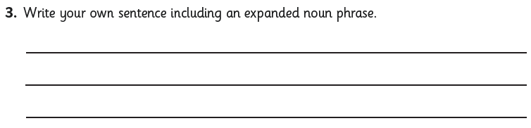

**Expected**

**Week 4: Spelling practise:** Look, say, cover, write, check

|  |  |  |  |  |  |  |  |  |
| --- | --- | --- | --- | --- | --- | --- | --- | --- |
| **Look** | **Say** | **Cover** | **Write** | **Check** | **Write** | **Check** | **Write** | **Check** |
| word |  |  |  | 🗶 |  | ✓ |  | ✓ |
| work |  |  |  |  |  |  |  |  |
| worm |  |  |  |  |  |  |  |  |
| world |  |  |  |  |  |  |  |  |
| worth |  |  |  |  |  |  |  |  |
| worst |  |  |  |  |  |  |  |  |
| war |  |  |  |  |  |  |  |  |
| warm |  |  |  |  |  |  |  |  |
| towards |  |  |  |  |  |  |  |  |
| ward |  |  |  |  |  |  |  |  |

Now choose two of the words to write in a sentence.

1. _______________________________________________________________________________________

2. _______________________________________________________________________________________

**Expected**

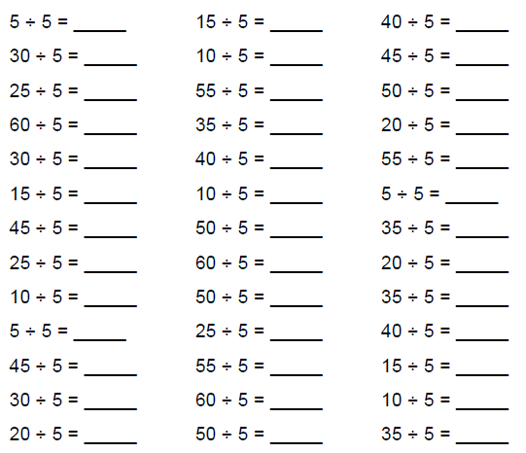**Week 4-** Complete the 5÷ time’s tables.

0+10=10

10+0=10

Count in fives to help you solve the problems**.**

10-0=10

[](http://www.google.co.uk/url?sa=i&rct=j&q=&esrc=s&source=images&cd=&cad=rja&uact=8&ved=2ahUKEwjm0Neqi4zZAhWCKVAKHfrwBzwQjRx6BAgAEAY&url=http://laoblogger.com/fall-flower-pot-clipart.html&psig=AOvVaw0HB2zQlSaFixMAycDXasDS&ust=1517827795469262)

**Exceeding expected**

**Week 4**

What score did you get?

___________

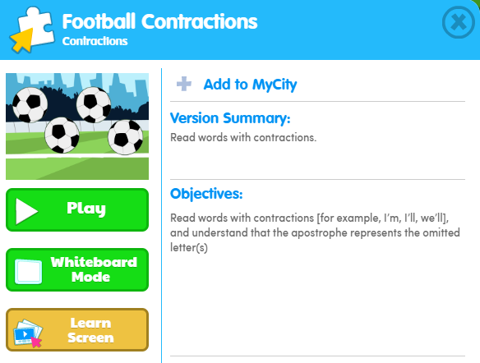

**Exceeding expected**

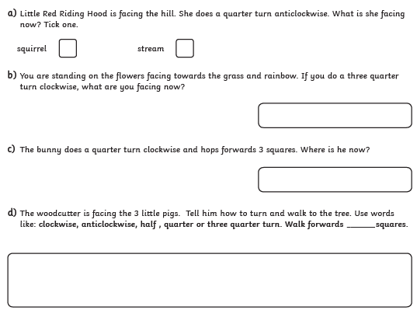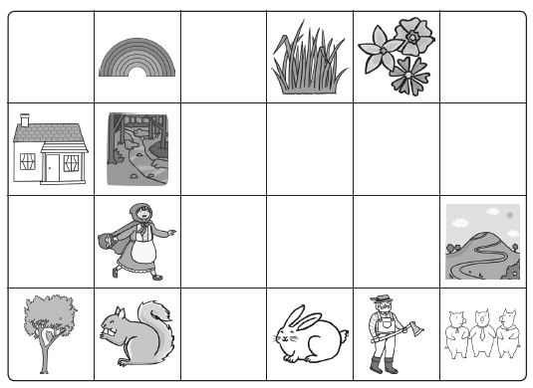**Week 4** - Answer the questions based on position and direction.

**Expected**

**Week 5: Spelling practise:** Look, say, cover, write, check

|  |  |  |  |  |  |  |  |  |
| --- | --- | --- | --- | --- | --- | --- | --- | --- |
| **Look** | **Say** | **Cover** | **Write** | **Check** | **Write** | **Check** | **Write** | **Check** |
| television |  |  |  | 🗶 |  | ✓ |  | ✓ |
| treasure |  |  |  |  |  |  |  |  |
| usual |  |  |  |  |  |  |  |  |
| division |  |  |  |  |  |  |  |  |
| vision |  |  |  |  |  |  |  |  |
| pleasure |  |  |  |  |  |  |  |  |
| measure |  |  |  |  |  |  |  |  |
| occasion |  |  |  |  |  |  |  |  |
| usually |  |  |  |  |  |  |  |  |
| leisure |  |  |  |  |  |  |  |  |

Now choose two of the words to write in a sentence.

1. _______________________________________________________________________________________

2. _______________________________________________________________________________________

**Expected** **Week 5-** Complete the 5x times tables.



Count in fives to help you solve the problems**.**



**Exceeding Expected**

**Week 5-**

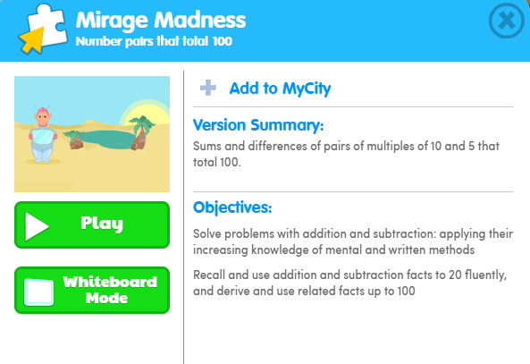

What score did you get?

___________

**Exceeding Expected**

**Week 5-** Complete the questions based on verbs.

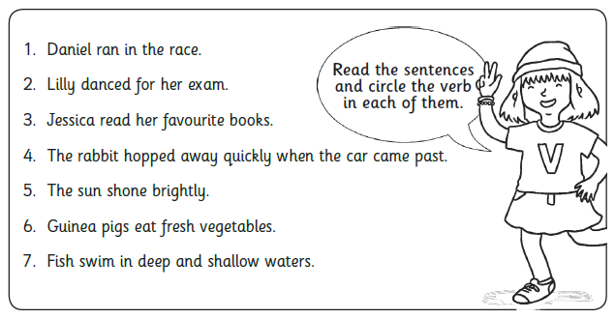

A verb is a "doing" word. A verb can express:

**A physical action** (e.g., to swim, to write, to climb).

**A mental action** (e.g., to think, to guess, to consider).

**A state of being** (e.g., to be, to exist, to appear).

