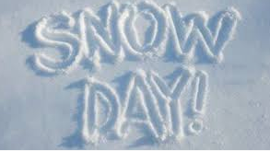
Good morning Oak,
Here are some ideas for you to do on your snow day!
Our Science topic is Seasonal Changes so why not look outside and write or draw a list of all the clues that show it is winter. E.g. no leaves on the trees, snow on the ground…
In maths we have been learning about place value. If you go outside in the snow can you make these teens numbers using sticks to show the tens and snowballs to show the ones. If you don’t have access to an outside area, you could draw these instead.
e.g. 15 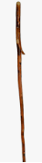
12
13
14
17
18
In English we have been learning about nouns. Can you sort these into common and proper nouns?
