The Woodlands Community Primary School | Year 1/2 | Topic – History |  | Towers, Tunnels and Turrets
Key Vocabulary | Key Knowledge and Skills
Landmark  Map  Route  Plot  Coordinate  Field sketch  . | 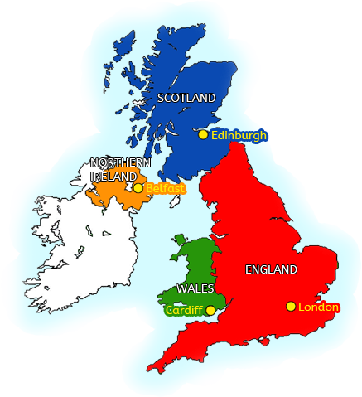 |  | Knowledge  I know compass directions.  I know directional language.  I know what a key is – map.  I know that a map represents an area.  I know the four capital cities of the UK.  Skills  I can use simple field sketches.  I can create a simple map.  I can plan a route.  I can use geographical language to describe a feature or location e.g hill/local/a road/coastline/Woods.  I can use maps at a range of scales.  I can draw information from a map.
 | Key knowledge
Plotting on a Map
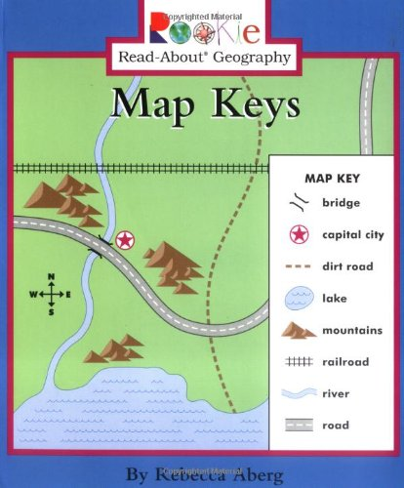
*A Key – using symbols

*Position and Directional Language: Compass – North, South, East and West

*Capital Cities of the UK: London, Edinburgh, Cardiff and Belfast

