Home Learning Booklet
Autumn 1
Year 1
This booklet belongs to

Woodlands Primary School
Homework Grid Autumn 1 (Bright lights, big cities)
Please return your homework to school on Monday for marking. Booklets will be returned on Tuesday.
 | Expected |  | Exceeding Expected |  |  |  | Greater Depth
 | These need to be carried out every week |  | Maths |  | English |  | Select 2 projects from the list below to do over the half term  - Make a pictogram to show the different vehicles you see while you are out and about with your family.  - Take your favourite teddy on a visit to a city near you. Write a simple diary about teddy’s day out, including what you saw and how you felt.  - Build a real or fantasy city using Lego, blocks or 3D junk material from home.  - Create a 2D shape picture of a city skyline. Label the shape names.  - Search the web and find images of different cities around the world. Present your findings as you wish, you could include facts, images and captions.  - Draw a map of a city and direct a toy or figure using words such as forward, backwards, left, right etc. Write your directions alongside your map.  - Create your own city song to the tune of ‘The wheels on the bus’. Your song should start with ‘I went to the city and I saw…’.
Week 1 | - Read three times a week minimum and record in red reading diary.  - Practise weekly spellings. (See in booklet)  - Practise number bonds to 5 (See in booklet) |  |  |  | Spell the words by selecting the correct phase three digraph.  Apply the words into a sentence.  (See in booklet)
Week 2 | - Read three times a week minimum and record in red reading diary.  - Practise weekly spellings. (See in booklet)  - Practise number bonds to 5 (See in booklet) |  |  |  | Spell the words by selecting the correct phase four blend.  Apply the words into a sentence.  (See in booklet)
Week 3 | - Read three times a week minimum and record in red reading diary.  - Practise weekly spellings. (See in booklet)  - Practise number bonds to 10 (See in booklet) |  |  |  | Re-write the sentences adding the missing capital letters and full stops.  (See in booklet)
Week 4 | - Read three times a week minimum and record in red reading diary.  - Practise weekly spellings. (See in booklet)  - Practise number bonds to 10 (See in booklet) |  |  |  | Write your own sentences using the pictures to help you. Don’t forget your capital letters and full stops.  (See in booklet)
Week 5 | - Read three times a week minimum and record in red reading diary.  - Practise weekly spellings. (See in booklet)  - Practise number bonds to 10 (See in booklet) |  | Naming 2D shapes  Write the correct name of the 2D shapes underneath the picture. (See in booklet)
Week 6 | - Read three times a week minimum and record in red reading diary.  - Practise weekly spellings. (See in booklet)  - Practise number bonds to 10 (See in booklet) |  | Naming 3D shapes  Write the correct name of the 3D shapes underneath the picture. (See in booklet)
Week 7 | - Read three times a week minimum and record in red reading diary.  - Practise weekly spellings. (See in booklet)  - Practise number bonds to 10 (See in booklet) |  | Repeated patterns  Continue the repeated pattern.
Week 8 | - Read three times a week minimum and record in red reading diary.  - Practise the spellings that you found tricky during this half term.  - Practise number bonds to 10 (See in booklet) |  | Repeated patterns  Continue the repeated pattern.

Expected
Week 1: Spelling practise: Look, say, cover, write, check.
Look | Say | Cover | Write | Check | Write | Check | Write | Check
off
puff
sniff
miss
hiss
less
if
us
bus
yes
Now choose two of the words to write in a sentence.
1. _______________________________________________________________________________________
2. _______________________________________________________________________________________
Expected
Week 1- Number bonds to 5.
Add the missing number to make the robot total 5.
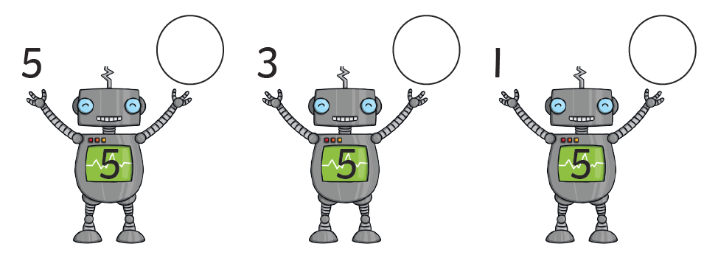

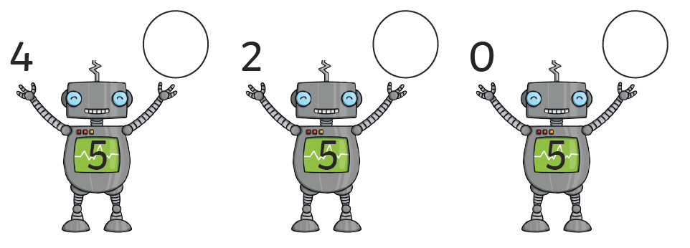

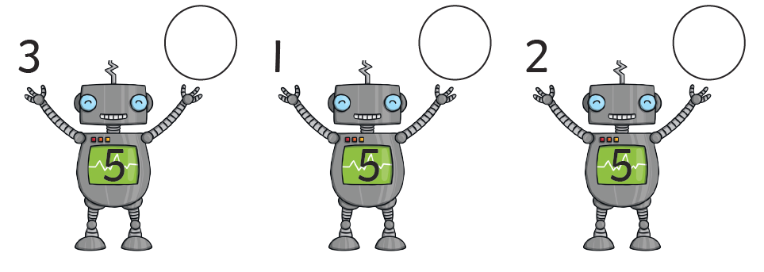

Exceeding expected
Week 1- Spell the words by selecting the correct Phase Three digraph.
oo oi ai ee oa

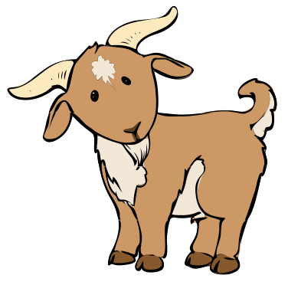

Choose three words from above and apply them into sentences.
D
Don’t forget to start your sentences with a capital letter and end in a full stop.

Expected
Week 2: Spelling practise: Look, say, cover, write, check.
Look | Say | Cover | Write | Check | Write | Check | Write | Check
well
pull
full
wall
buzz
fizz
back
stick
flick
pal

Now choose two of the words to write in a sentence.
1. _______________________________________________________________________________________
2. _______________________________________________________________________________________
Expected
Week 2- Number bonds to 5.
Complete the missing number sentences to total 5.

3 + = 5 4 + 1 =

5 + = 5 + 2 = 5

+ 1 = 5 0 + 5 =

+ 3 = 5 4 + = 5

Exceeding expected
Week 2- Spell the words by selecting the correct Phase Four blend.

st nt nd dr sp
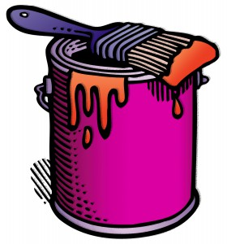

Choose three words from above and apply them into sentences.
D
Don’t forget to start your sentences with a capital letter and end in a full stop.

Expected
Week 3: Spelling practise: Look, say, cover, write, check.
Look | Say | Cover | Write | Check | Write | Check | Write | Check
hunting
hunted
hunter
buzzing
buzzed
buzzer
jumping
jumped
jumper
cracker

Now choose two of the words to write in a sentence.
1. _______________________________________________________________________________________
2. _______________________________________________________________________________________
Expected
Week 3- Number bonds to 10.
Draw the missing dinosaurs to make them total ten.
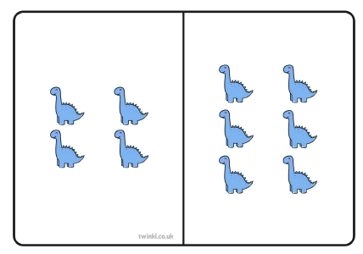
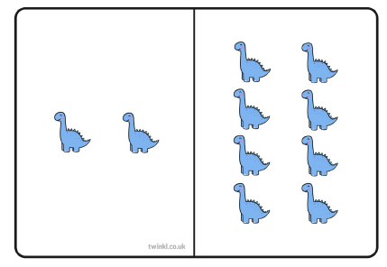
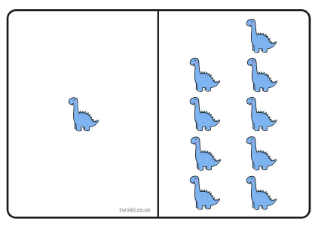

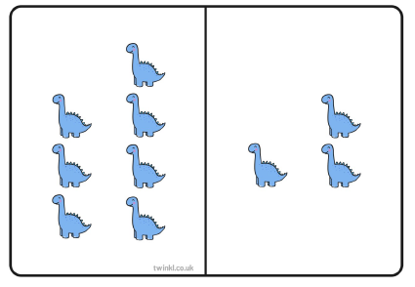
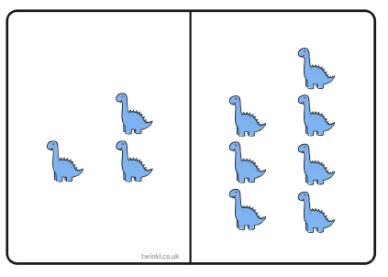
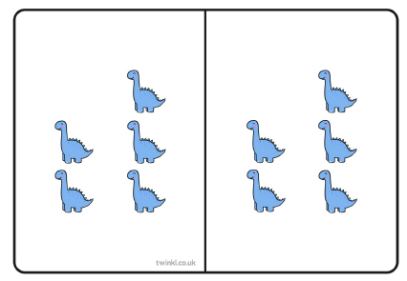

Exceeding expected
Week 3- Re-write the sentences by adding the missing capital letters and full stops.

the dog jumped over the fence

some pigs have pink tails

this cake is very yummy

the party starts at one o clock

Expected
Week 4: Spelling practise: Look, say, cover, write, check.
Look | Say | Cover | Write | Check | Write | Check | Write | Check
bank
think
honk
sunk
wink
bunk
sing
string
hang
long

Now choose two of the words to write in a sentence.
1. _______________________________________________________________________________________
2. _______________________________________________________________________________________
Expected
Week 4- Number bonds to 10.
Add the missing number to make the robot total 10.
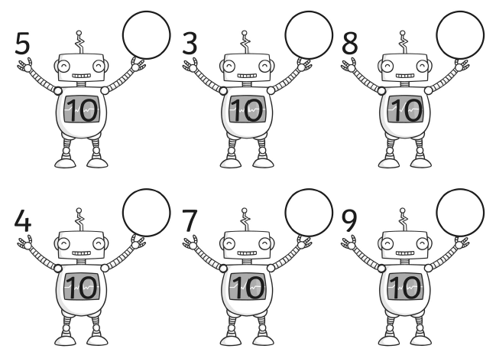

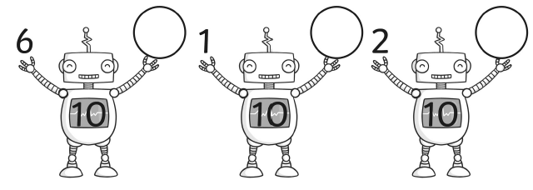

Exceeding expected
Don’t forget to start your sentences with a capital letter and end in a full stop.
D
Week 4- Write your own sentences using the pictures and word bank to help you.
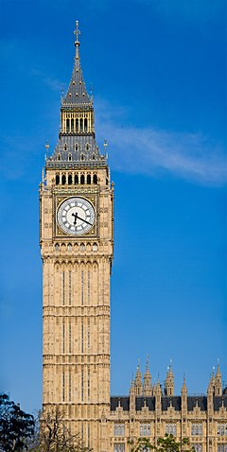

Word bank
Big Ben
London Eye
Buckingham Palace

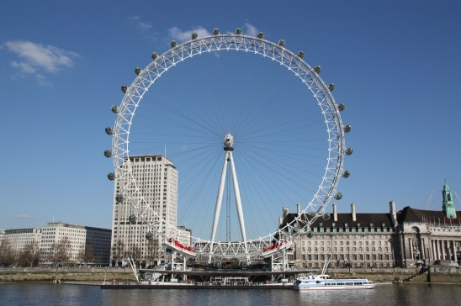

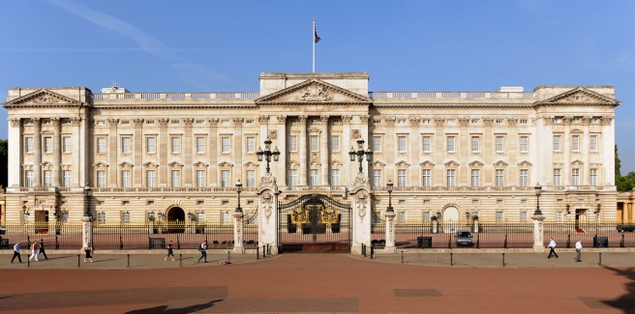

Expected
Week 5: Spelling practise: Look, say, cover, write, check.
Look | Say | Cover | Write | Check | Write | Check | Write | Check
chip
chick
catch
fetch
kitchen
notch
hutch
rich
much
such

Now choose two of the words to write in a sentence.
1. _______________________________________________________________________________________
2. _______________________________________________________________________________________
Expected
Week 5- Number bonds to 10.
Write the matching number on the snowball to make the total ten.
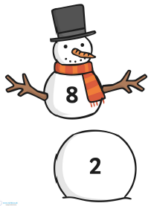
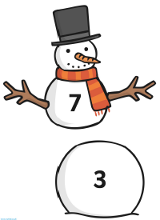
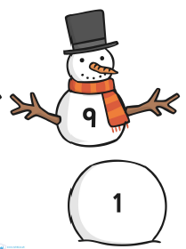

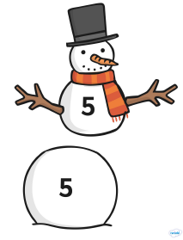
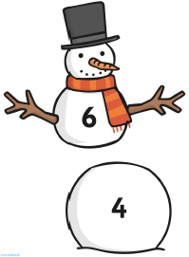
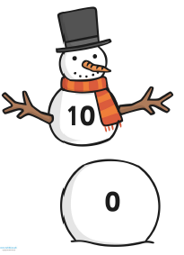

Exceeding expected
Week 5- Use the word bank to write the correct name of the 2D shape under the picture.

Word bank

Triangle Hexagon Rectangle

Circle Pentagon Square

Expected
Week 6: Spelling practise: Look, say, cover, write, check.
Look | Say | Cover | Write | Check | Write | Check | Write | Check
van
vet
visit
have
live
give
love
glove
above
nerve

Now choose two of the words to write in a sentence.
1. _______________________________________________________________________________________
2. _______________________________________________________________________________________
Expected
Week 6- Number bonds to 10.
Complete the bar models to make the total of ten.
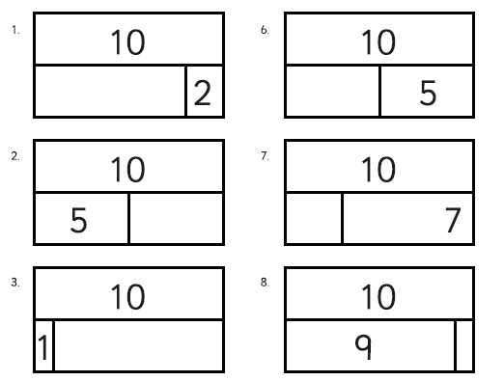

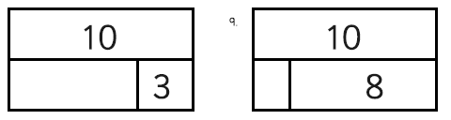

Exceeding expected
Week 6- Use the word bank to write the correct name of the 3D shape under the picture.
Cube Cylinder Sphere Square- based pyramid Cuboid Cone
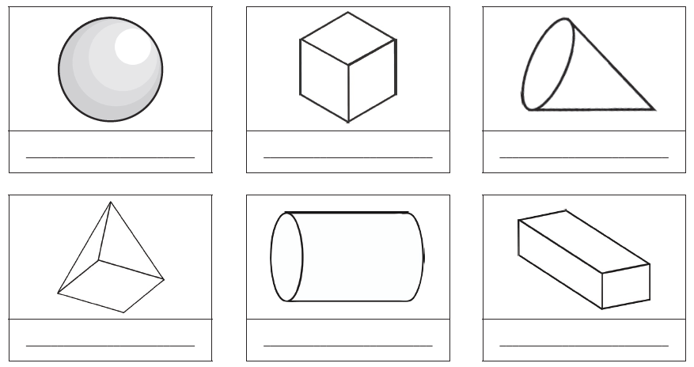
Expected
Week 7: Spelling practise: Look, say, cover, write, check.
Look | Say | Cover | Write | Check | Write | Check | Write | Check

Now choose four of the words to write in a sentence.
1. _______________________________________________________________________________________
2. _______________________________________________________________________________________
3. _______________________________________________________________________________________
4. _______________________________________________________________________________________
Expected
Week 7- Number bonds to 10.
Complete the missing number sentences to total 10.

3 + = 10 4 + 6 =

5 + = 10 + 2 = 10

+ 1 = 10 8 + 2 =

+ 3 = 10 7 + = 10

Exceeding expected
Week 7- Continue the repeated pattern.
