Home Learning Booklet
Summer 1
Year 1
This booklet belongs to

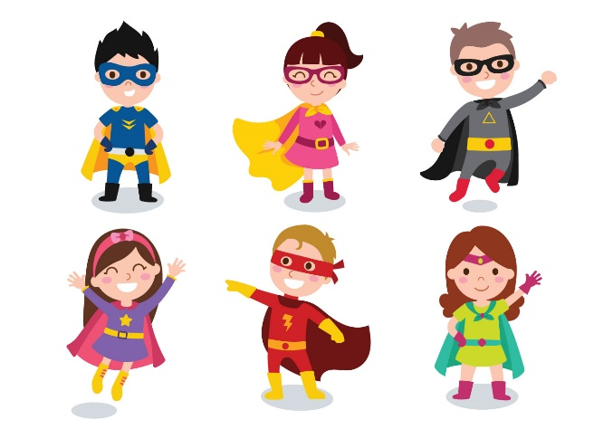

Woodlands Primary School
Homework Grid Summer 1

 | Expected |  | Exceeding Expected |  |  |  | Greater Depth
 | These need to be carried out every week |  | Maths |  | English |  | Select 2 projects from the list below to do over the half term
Week 1 | Reading at LEAST 3 times  Revisit all spellings from last term  Addition within 20 – colour the answer |  | Counting in 2s – write the answer on the socks
Week 2 | Reading at LEAST 3 times  Complete Spelling Sheet  Complete number bonds sheet  to 20 |  | Education City |  | High frequency word wordsearch |  | - Design your own superhero.  - Design a superhero cape and mask.  - Write a superhero story.  - Create a superhero shield.  - Superhero rock painting.  - Interview a real life superhero and record their answers.
Week 3 | Reading at LEAST 3 times  Complete Spelling Sheet  Complete number bonds sheet  to 20 |  | Partitioning numbers
Week 4 | Reading at LEAST 3 times  Complete Spelling Sheet  Part whole models. |  |  |  | Writing months of the year.  Education City
Week 5 | Reading at LEAST 3 times  Complete Spelling Sheet  Subtraction within 20 using a numberline. |  | Multiplication |  | Education City
Week 6 | Reading at LEAST 3 times  Complete Spelling Sheet  Sharing Equally |  |  |  | Doubles to 20

Expected
Week 1: Spelling practise: Look, say, cover, write, check
Look | Say | Cover | Write | Check | Write | Check | Write | Check
now
how
brown
down
town
out
about
mouth
sound
you

Now choose two of the words to write in a sentence.
1. _______________________________________________________________________________________
2. _______________________________________________________________________________________
Expected
Week 1 Addition within 20

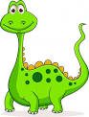
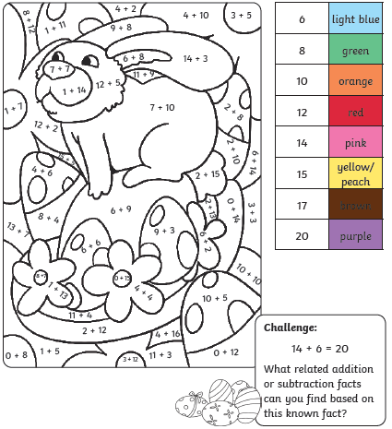
Remember that number bonds to 20 are two numbers that add together to make 20!

Exceeding Expected
Week 1- Counting in 2s
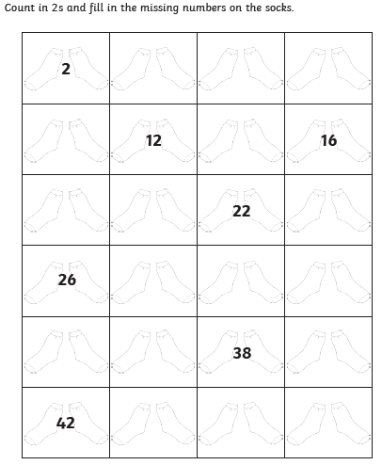

Expected
Week 2: Spelling practise: Look, say, cover, write, check
Look | Say | Cover | Write | Check | Write | Check | Write | Check
very
happy
funny
party
family
dizzy
smelly
silly
jolly
sunny

Now choose two of the words to write in a sentence.
1. _______________________________________________________________________________________
2. _______________________________________________________________________________________
Expected
Week 2 Number bonds to 20.
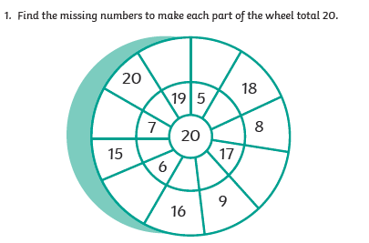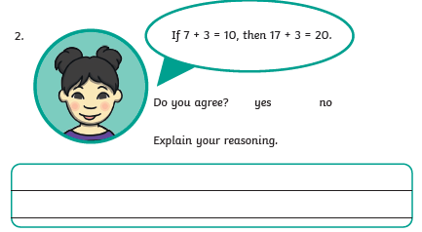

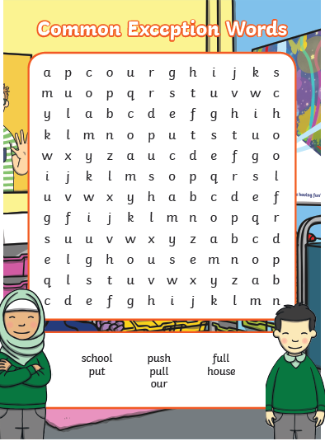
Exceeding Expected Week 2- High Frequency Words (Spelling)

Exceeding expected
Week 2 – Education City
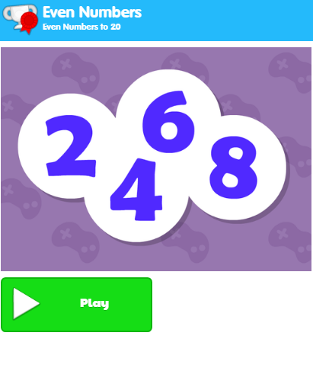
What score did you get?
___________

Expected
Week 3: Spelling practise: Look, say, cover, write, check
Look | Say | Cover | Write | Check | Write | Check | Write | Check
for
short
born
horse
morning
more
score
before
wore
shore

Now choose two of the words to write in a sentence.
1. _______________________________________________________________________________________
2. _______________________________________________________________________________________

Expected
Week 3- Addition and Subtraction within 20
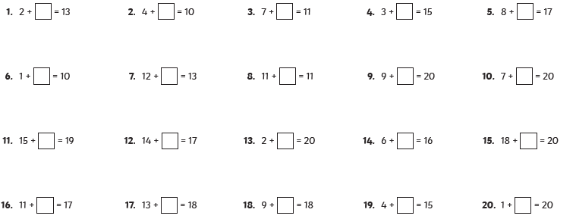

Exceeding Expected
Week 3- Partitioning numbers
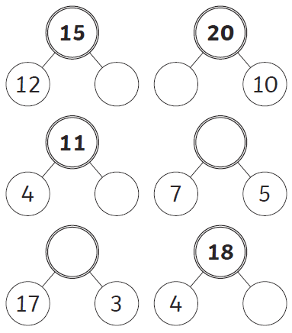
Expected
Week 4: Spelling practise: Look, say, cover, write, check
Look | Say | Cover | Write | Check | Write | Check | Write | Check
saw
draw
yawn
crawl
claw
author
August
dinosaur
astronaut
your

Now choose two of the words to write in a sentence.
1. _______________________________________________________________________________________
2. _______________________________________________________________________________________

Expected
Week 4- Part whole models
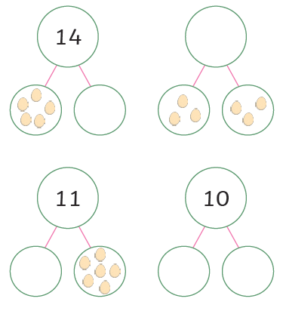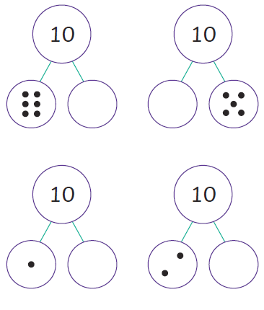

Exceeding Expected
Week 4- Months of the Year
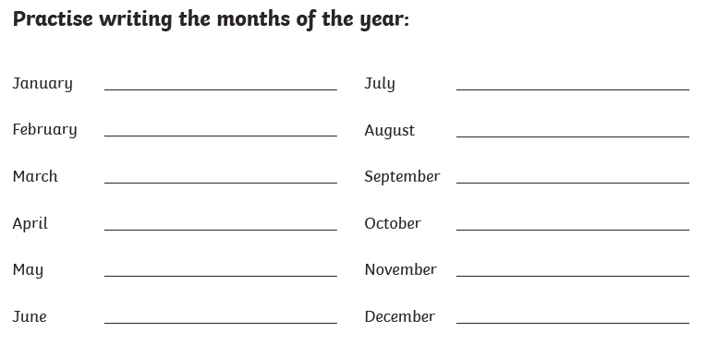

Exceeding expected
Week 4 Reading comprehension

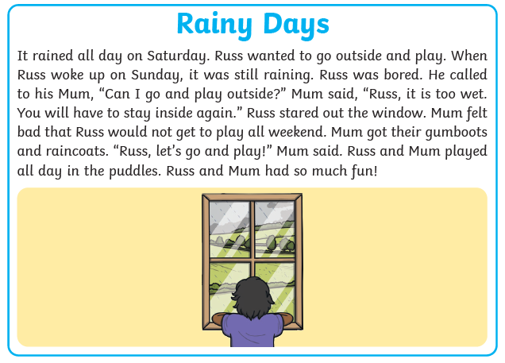
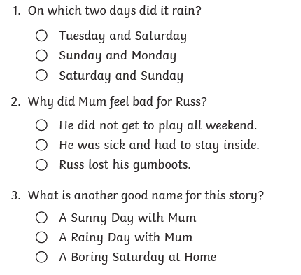

Expected
Week 5: Spelling practise: Look, say, cover, write, check
Look | Say | Cover | Write | Check | Write | Check | Write | Check
air
fair
pair
hair
chair
bare
dare
care
share
scared

Now choose two of the words to write in a sentence.
1. _______________________________________________________________________________________
2. _______________________________________________________________________________________
Expected
Week 5 Subtraction with numberlines.
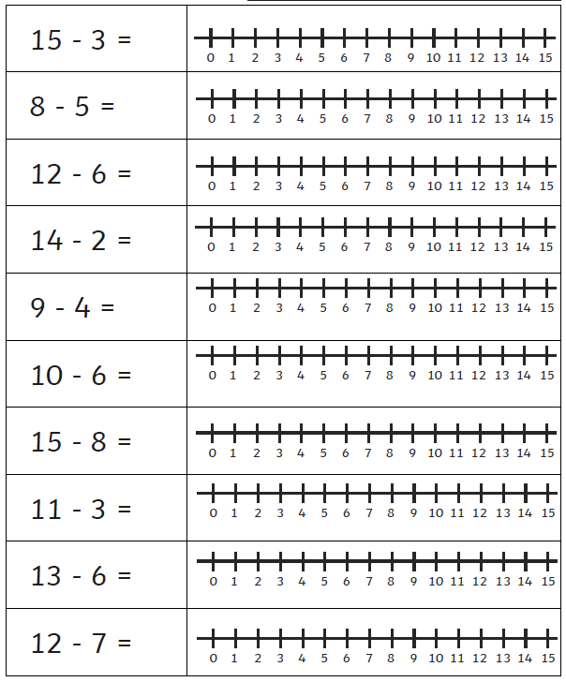

Exceeding Expected
Week 5- Multiplication
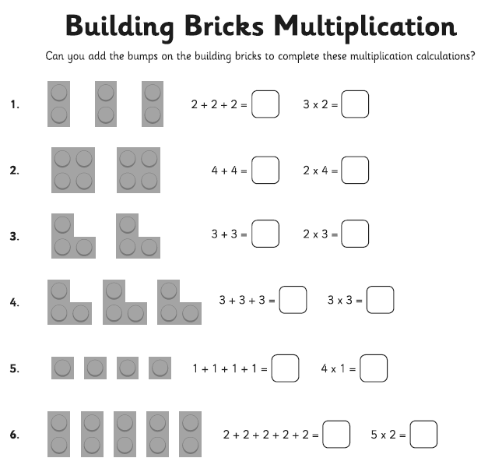
Exceeding Expected
Week 5
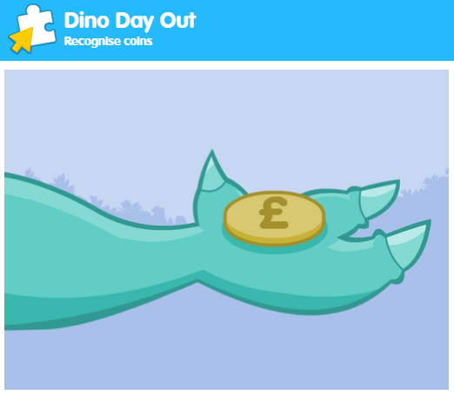
What score did you get?
___________

Expected
Week 6: Spelling practise: Look, say, cover, write, check
Look | Say | Cover | Write | Check | Write | Check | Write | Check
dear
hear
beard
near
year
clear
fear
bear
wear
pear

Now choose two of the words to write in a sentence.
1. _______________________________________________________________________________________
2. _______________________________________________________________________________________

Expected
Week 6 Sharing equally
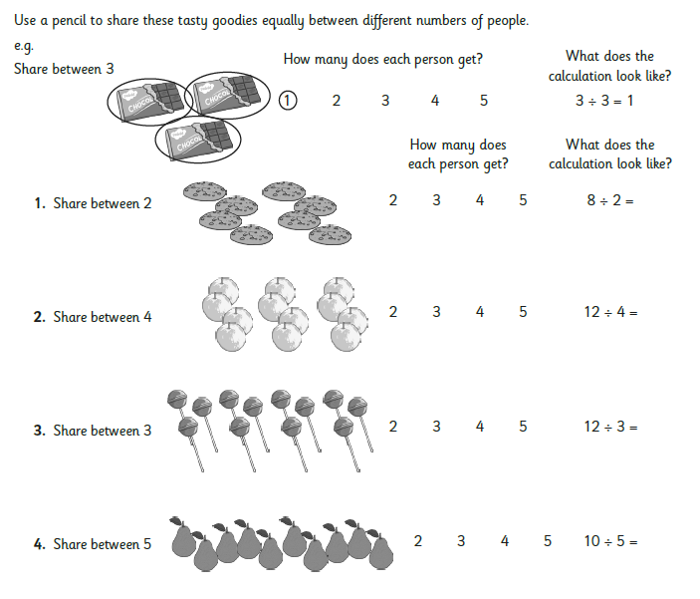

Exceeding Expected
Week 6- Doubles to 20
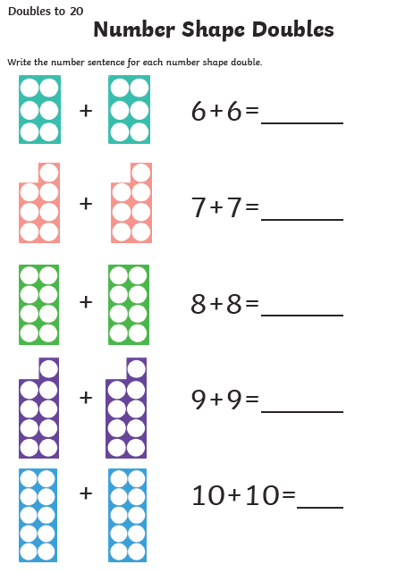
Exceeding Expected
Week 5
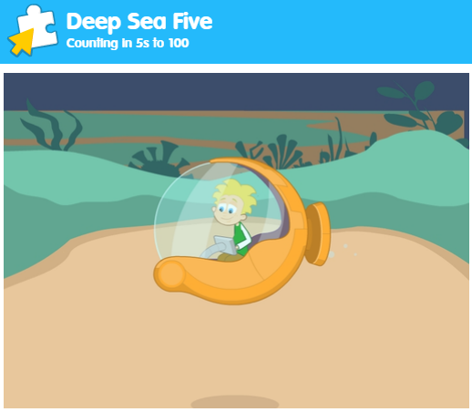
What score did you get?
___________

