Home Learning Booklet
Spring 1
Year 2
This booklet belongs to

Woodlands Primary School
Homework Grid Spring 1

 | Expected |  | Exceeding Expected |  |  |  | Greater Depth
 | These need to be carried out every week |  | Maths |  | English |  | Select 2 projects from the list below to do over the half term
Week 1 | Reading at LEAST 3 times  Practise spellings from last half term  Complete 10 x times tables sheet |  | Adding 2 2-digit numbers (not crossing 10)
Week 2 | Reading at LEAST 3 times  Complete Spelling Sheet  Complete 10 ÷ times tables sheet |  |  |  | Reading comprehension- Through thick and fin (Education City) |  | - Create a 3D model of a dinosaur using junk materials.  - Research how the dinosaurs lived and what happened to the dinosaurs.  - Visit a dinosaur themed place and take photographs, Can you create a scrap book of your day.  - Create a dance moving like a dinosaur and send it to me using your e-schools login.  - Design and make an item of clothing that would be suitable for a dinosaur! Oh no it better not be pants… we all know dinosaurs love pants!!!
Week 3 | Reading at LEAST 3 times  Complete Spelling Sheet  Complete 10 x times tables sheet |  | Multiples of 10
Week 4 | Reading at LEAST 3 times  Complete Spelling Sheet  Complete 10 ÷ times tables sheet |  |  |  | Reading comprehension- Read the passage of text and answer the questions based on what you have read.
Week 5 | Reading at LEAST 3 times  Complete Spelling Sheet  Complete 10 x times tables sheet |  | Snakes on the brain (Education City)
Week 6 | Reading at LEAST 3 times  Complete Spelling Sheet  Complete 10 ÷ times tables sheet |  |  |  | Reading comprehension- Read the passage of text and answer the questions based on what you have read.
Week 7 | Reading at LEAST 3 times  Complete Spelling Sheet  Complete 10 x times tables sheet |  | Solving division problems

Expected
Week 1: Spelling practise: Look, say, cover, write, check
Look | Say | Cover | Write | Check | Write | Check | Write | Check
copier
copied
happier
happiest
cried
replied
tried
dried
driest
funnier

Now choose two of the words to write in a sentence.
1. _______________________________________________________________________________________
2. _______________________________________________________________________________________
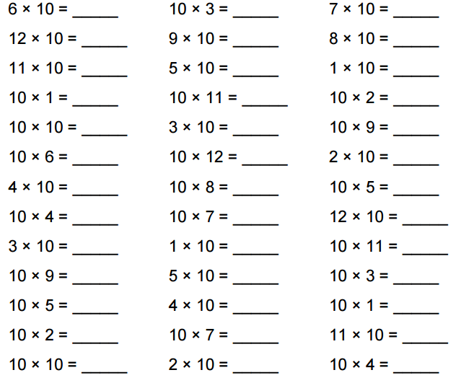
Expected
Week 1 10x Times tables

Exceeding expected
Week 1- Adding 2 2-digit numbers (not crossing 10)
Draw base 10 to help you.
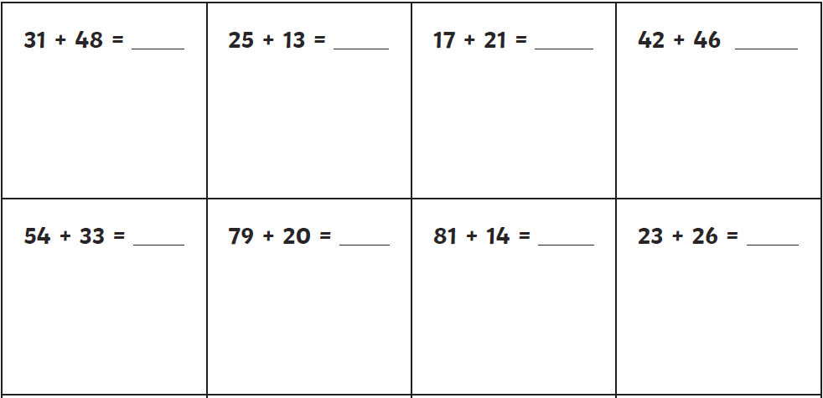

Expected
Week 2: Spelling practise: Look, say, cover, write, check
Look | Say | Cover | Write | Check | Write | Check | Write | Check
copying
crying
replying
marrying
carrying
flying
trying
drying
skiing
taxiing

Now choose two of the words to write in a sentence.
1. _______________________________________________________________________________________
2. _______________________________________________________________________________________

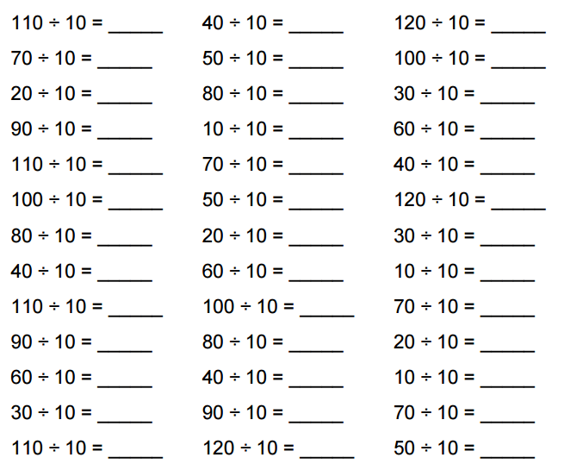
Expected
Week 2 10÷ Times tables

Exceeding expected
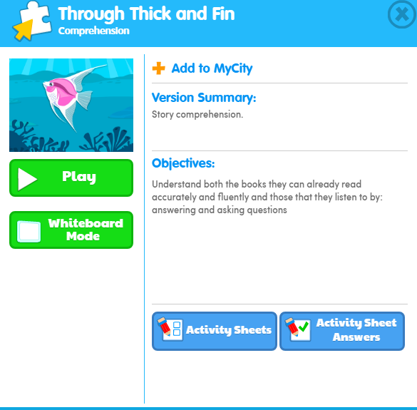
Week 2 Reading comprehension – Listen/read the story and answer the questions.
What score did you get?
___________

Expected
Week 3: Spelling practise: Look, say, cover, write, check
Look | Say | Cover | Write | Check | Write | Check | Write | Check
hiking
hiked
hiker
nicer
nicest
shiny
being
shining
scary
scaring

Now choose two of the words to write in a sentence.
1. _______________________________________________________________________________________
2. _______________________________________________________________________________________

Expected
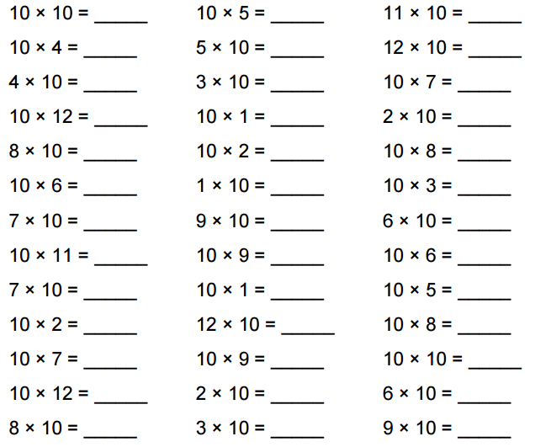
Week 3 10x Times tables

Exceeding expected
Week 3- Multiples of 10
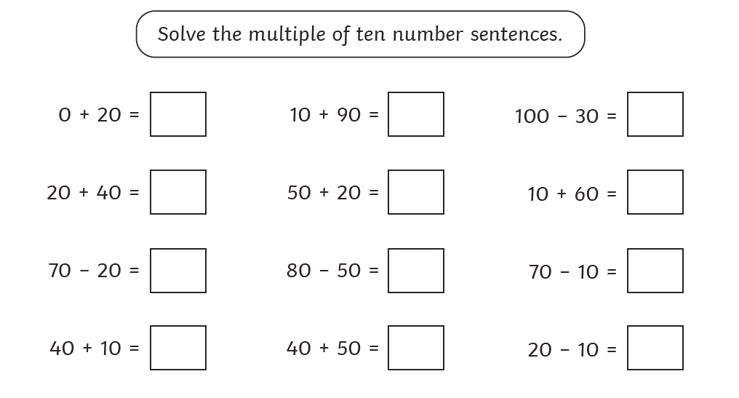

Expected
Week 4: Spelling practise: Look, say, cover, write, check
Look | Say | Cover | Write | Check | Write | Check | Write | Check
patting
patted
humming
hummed
dropping
dropped
sadder
saddest
runner
runny

Now choose two of the words to write in a sentence.
1. _______________________________________________________________________________________
2. _______________________________________________________________________________________
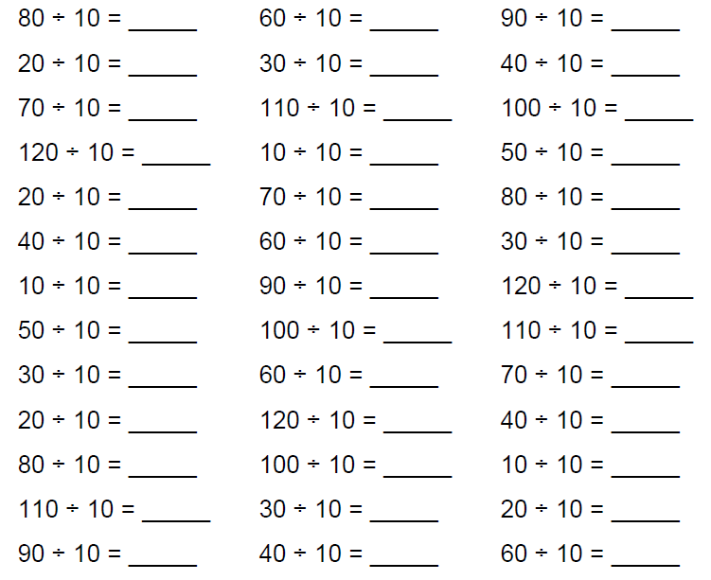
Expected
Week 4 10÷ Times tables

Exceeding expected
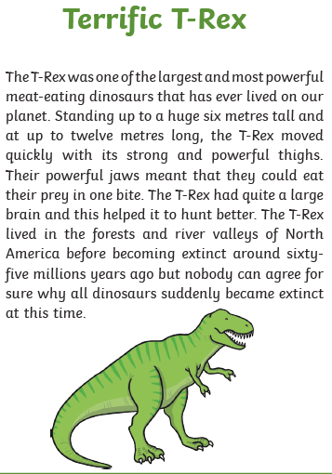
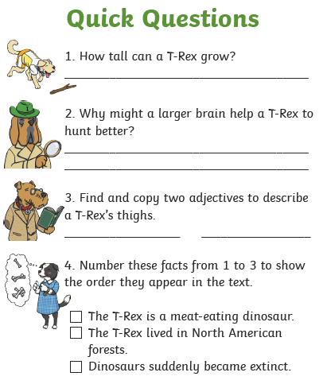
Week 4 Reading comprehension

Expected
Week 5: Spelling practise: Look, say, cover, write, check
Look | Say | Cover | Write | Check | Write | Check | Write | Check
all
ball
call
walk
talk
always
small
wall
fall
altogether

Now choose two of the words to write in a sentence.
1. _______________________________________________________________________________________
2. _______________________________________________________________________________________
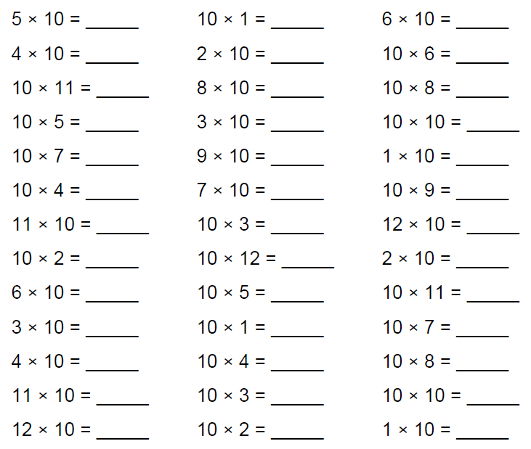
Expected
Week 5 10x Times tables

Exceeding expected
Week 5

What score did you get?
___________

Expected
Week 6: Spelling practise: Look, say, cover, write, check
Look | Say | Cover | Write | Check | Write | Check | Write | Check
fast
last
father
class
grass
pass
plant
path
bath
people

Now choose two of the words to write in a sentence.
1. _______________________________________________________________________________________
2. _______________________________________________________________________________________

Expected
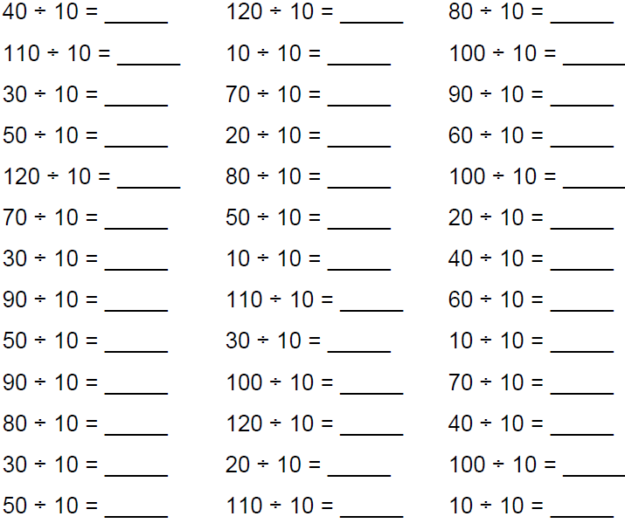
Week 6 10÷ Times tables

Exceeding expected
Week 6 Reading comprehension
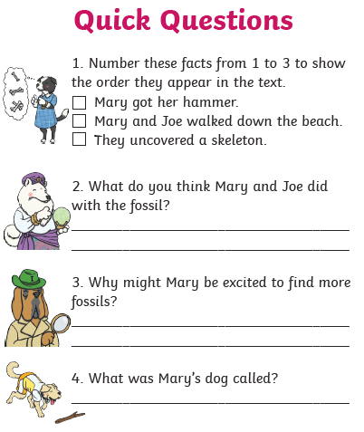
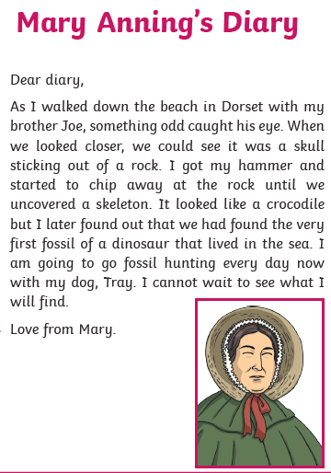

Expected
Week 7: Spelling practise: Look, say, cover, write, check
Look | Say | Cover | Write | Check | Write | Check | Write | Check

Now choose four of the words to write in a sentence.
1. _______________________________________________________________________________________
2. _______________________________________________________________________________________
3. _______________________________________________________________________________________
4. _______________________________________________________________________________________
Expected
Week 7 10x Times tables

Exceeding expected
Week 7

