Home Learning Booklet
Autumn 2
Year 1
This booklet belongs to

Woodlands Primary School
Homework Grid Autumn 2

 | Expected |  | Exceeding Expected |  |  |  | Greater Depth
 | These need to be carried out every week |  | Maths |  | English |  | Select 2 projects from the list below to do over the half term
Week 1 | Reading at LEAST 3 times  Revisit all spellings from last term  Complete number bonds sheet to 10 |  | Children to order the days of the week in the correct order.  Children to start with Sunday.
Week 2 | Reading at LEAST 3 times  Complete Spelling Sheet  Complete number bonds sheet  to 10 |  |  |  | Children to write the alphabet in the correct order (Lower and upper case). Ensuring all letters are formed correctly. |  | - Create a 3D model castle using junk materials.  - Research a famous knight, king or queen. You can present you findings how you wish.  - Visit a castle and take photographs of your trip. Present your findings in a creative way.  - Research your ‘family name’ coat of arms. Recreate it using a range of materials.  - Follow a medieval recipe and write a set of instructions to match.  - Create a timeline for the oldest castles in the UK. Present your findings.  - Design and make an item of medieval clothing.
Week 3 | Reading at LEAST 3 times  Complete Spelling Sheet  Complete number bonds sheet  to 20 |  | Telling the time- o’clock  Children to write the time and draw the hands on the clock.
Week 4 | Reading at LEAST 3 times  Complete Spelling Sheet  Complete number bonds sheet to 20 |  |  |  | Children to unscramble the letters to spell the days of the week correctly.
Week 5 | Reading at LEAST 3 times  Complete Spelling Sheet  Complete number bonds sheet  to 20 |  | Telling the time- half past.  Children to write the time and draw the hands on the clock.
Week 6 | Reading at LEAST 3 times  Complete Spelling Sheet- Revisit any gaps from the last 5 weeks.  Complete number bonds sheet  to 20 |  |  |  | Common exception words- Read and apply the correct common exception word to the sentence.
Week 7 | Reading at LEAST 3 times  Complete Spelling Sheet- Revisit any gaps from the last 5 weeks.  Complete number bonds sheet  to 20 |  | Answer the questions based on the months of the yar.

Expected
Week 1: Spelling practise: Look, say, cover, write, check
Look | Say | Cover | Write | Check | Write | Check | Write | Check
rain
wait
train
paid
afraid
oil
join
coin
point
soil

Now choose two of the words to write in a sentence.
1. _______________________________________________________________________________________
2. _______________________________________________________________________________________
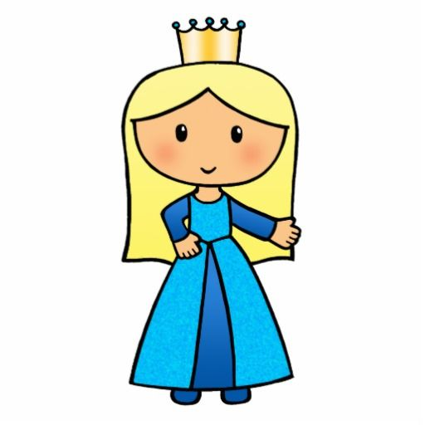
Expected

Remember that number bonds are two numbers that equal ten.
E.g.: 5+5=10
6+4=10
Week 1 Number bonds to 10.
10
6
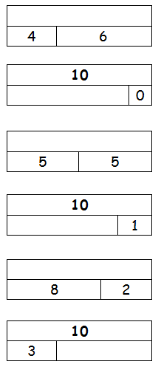

10
2

10
5

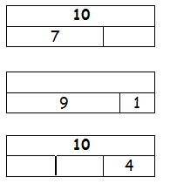

10
9

0 | 10

10
8

Exceeding Expected
Week 1- Ordering the days of the week by writing.
Tuesday
Sunday
Sunday

Wednesday
Friday
Saturday

Monday
Thursday

Remember to spell the days of the week correctly and start each day with a capital letter!

Expected
Week 2: Spelling practise: Look, say, cover, write, check
Look | Say | Cover | Write | Check | Write | Check | Write | Check
play
way
stay
today
says
boy
toy
enjoy
annoy
royal

Now choose two of the words to write in a sentence.
1. _______________________________________________________________________________________
2. _______________________________________________________________________________________
Expected
Week 2 Number bonds to 10.
6 + = 10
+ 3 = 10
3 + 7 = hh
1 + = 10
+ 4 = 10
4 + 6 = hh
4 + = 10
+ 8 = 10
1 + 9 = hh
10 + = 10
+ 9 = 10
0 + 10 = hh

5 + = 10
+ 6 = 10

Remember that number bonds are two numbers that equal ten.
E.g.: 5+5=10
6+4=10
9 + 1 = hh
7 + = 10
+ 0 = 10
8 + 2 = hh
6 + = 10
+ 7 = 10
5 + 5 = hh
2 + = 10
+ 10 = 10
3 + 7 = hh

Exceeding Expected
Week 2- Writing the alphabet in the correct order in lower and upper case letters.

lower case

UPPER CASE

Remember to form all your letters the correct way around, sitting them neatly on the line.

Expected
Week 3: Spelling practise: Look, say, cover, write, check
Look | Say | Cover | Write | Check | Write | Check | Write | Check
goal
coach
own
snow
grow
toe
goes
go
no
so

Now choose two of the words to write in a sentence.
1. _______________________________________________________________________________________
2. _______________________________________________________________________________________

Expected
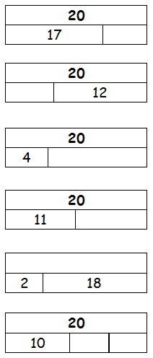
Week 3-Number bonds to 20
20
16
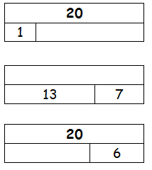

20
2

20
15

Number bonds to 20 are easy if you know your number bonds to 10! Carry one column of ten over to make one number 2 digit.
E.g.: 12+8=20 0r 2 + 18=20
20
19

0 | 20

20
8

Exceeding Expected
Week 3- Telling and writing the time to the nearest hour (o’clock).
Write the correct time underneath the clocks.
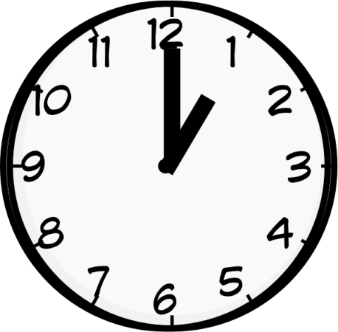
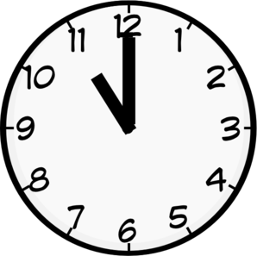
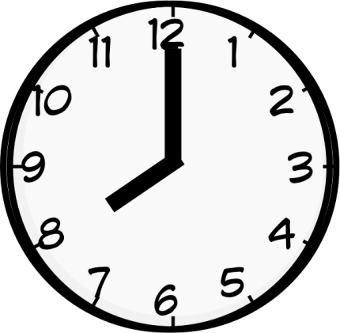
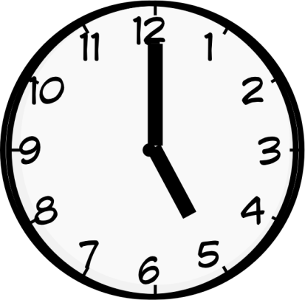

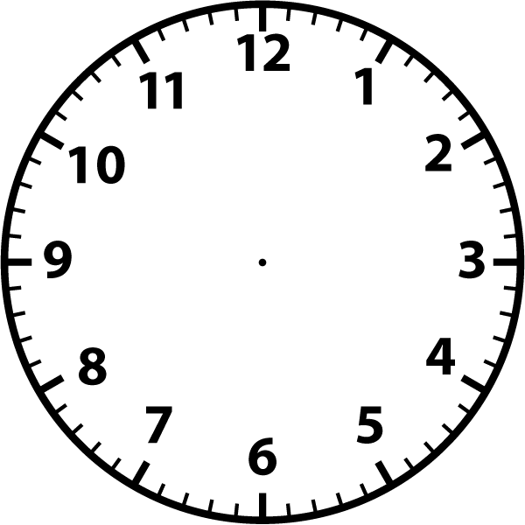
Draw the hands on the clocks to show the correct time.

12 o’clock 2 o’clock 4 o’clock 10 o’clock
Expected
Week 4: Spelling practise: Look, say, cover, write, check
Look | Say | Cover | Write | Check | Write | Check | Write | Check
me
she
we
be
he
see
tree
green
meet
week

Now choose two of the words to write in a sentence.
1. _______________________________________________________________________________________
2. _______________________________________________________________________________________

Expected
Week 4-Number bonds to 20
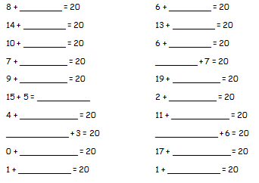

Number bonds to 20 are easy if you know your number bonds to 10! Carry one column of ten over to make one number 2 digit.
E.g.: 12+8=20 0r 2 + 18=20

Exceeding Expected
Week 4- Unscramble the letters to spell the days of the week correctly.

y d a n S u
n M d y a o
s u d a T e y
s n d W d e e y a
y d h r a u s T
a d i r F y
S d t r a u y a

Remember to start each day with a capital letter and keep your handwriting sat neatly on the line.

Expected
Week 5: Spelling practise: Look, say, cover, write, check
Look | Say | Cover | Write | Check | Write | Check | Write | Check
sea
dream
meat
each
scream
read
head
bread
meant
instead

Now choose two of the words to write in a sentence.
1. _______________________________________________________________________________________
2. _______________________________________________________________________________________

Expected

Number bonds to 20 are easy if you know your number bonds to 10! Carry one column of ten over to make one number 2 digit.
E.g.: 12+8=20 0r 2 + 18=20
Week 5 Number bonds to 20.

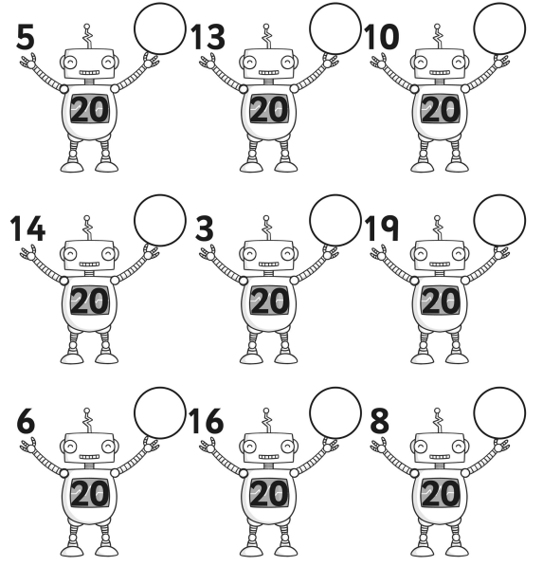
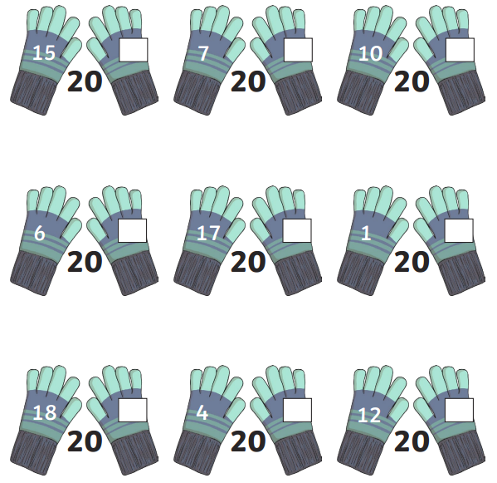

Exceeding Expected
Week 5- Telling and writing the time to the nearest half hour (half past).
Match the clock to the correct time.
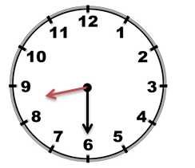
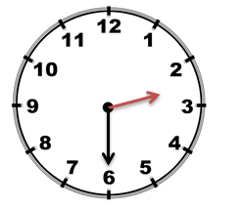

Half past 2 Half past 8 Half past 4 Half past 10

Write the correct time to match the clock

Expected
Week 6: Spelling practise: Look, say, cover, write, check
Look | Say | Cover | Write | Check | Write | Check | Write | Check
lie
tie
pie
cried
tried
dried
chief
field
thief
shield

Now choose two of the words to write in a sentence.
1. _______________________________________________________________________________________
2. _______________________________________________________________________________________

Expected
Week 6 Number bonds to 20.
6 + = 20
+ 13 = 20
3 + 17 = hh
1 + = 20
+ 4 = 20
14 + 6 = hh
4 + = 20
+ 18 = 20
11 + 9 = hh
10 + = 20
+ 9 = 20
10 + 10 = hh

15 + = 20
+ 16 = 20
19 + 1 = hh
7 + = 20
+ 10 = 20

Remember that number bonds are two numbers that equal ten.
E.g.: 5+5=10
6+4=10
8 + 12 = hh
6 + = 20
+ 17 = 20
15 + 5 = hh
2 + = 20
+ 10 = 20
13 + 7 = hh

Exceeding Expected
Week 6- Common exception words- Read and apply the correct common exception word to the sentence.
where were was there people some come you school

Some like to play football.
over here please.

Remember to read the sentence back to check that it makes sense.

There some children dancing on the stage.
At we learn to count and read.
I very happy when I won the race.
are you going?
How are feeling?
Can I have sweets please?
was a brown dog in the classroom.

Expected
Week 7: Spelling practise: Look, say, cover, write, check
Look | Say | Cover | Write | Check | Write | Check | Write | Check

Now choose four of the words to write in a sentence.
1. _______________________________________________________________________________________
2. _______________________________________________________________________________________
3. _______________________________________________________________________________________
4. _______________________________________________________________________________________

Expected
Week 7-Number bonds to 20

Number bonds to 20 are easy if you know your number bonds to 10! Carry one column of ten over to make one number 2 digit.
E.g.: 12+8=20 0r 2 + 18=20

Exceeding Expected
Week 7- Answering questions based on the months of the year.
