The Woodlands Community Primary School |  | Year 5/6 | Spring 1 2023 |  | PSHE- Keeping safe
Key Vocabulary | Key Questions |  |  | Knowledge and Skills
Online safety- Being safe online means individuals are protecting themselves and others from online harms and risks  legal privacy- the protection of personal or private information from misuse or unauthorized disclosure  sharing online-sharing information online platforms  emotional needs  Inappropriate- not suitable or proper in the circumstances.  age restrictions- an age under or over which something can or cannot be done  permission- the action of officially allowing someone to do a particular thing  alcohol- any organic compound whose molecule contains one or more hydroxyl groups attached to a carbon atom.  supply non-medical produce-  items used for therapeutic or diagnostic purposes essential for patient care | Are emotional needs equally Important as physical needs?  What might happen if someone’s emotional needs are not met?  Can having a mobile phone be both negative and positive?  How can someone keep themselves safe when using a mobile phone?  Is young people’s use of alcohol increasing or decreasing?  Why do we all need physical and emotional needs met? |  |  | Knowledge:  I know the laws regarding the use of drugs and alcohol in the UK  I know what is meant by legal and illegal  I know what is meant by viral social media  I know how to protect myself online  Skills:  I can explain why emotional needs are as important as physical needs and what might happen if a person doesn’t get their emotional needs met.  I can explain some ways of making sure that I keep myself safe when using a mobile phone, including safety around sharing personal information or images, and that there are laws relating to this.  I can explain why some people believe that more young people drink alcohol than actually do (misperceive the norm).  I can express my emotions, thoughts, feeling and opinions in a respectful manner.
SCARF |  |  |  | Where to go for support
S-Safety C- Caring A-Achievement R-Resilience F-Friendships  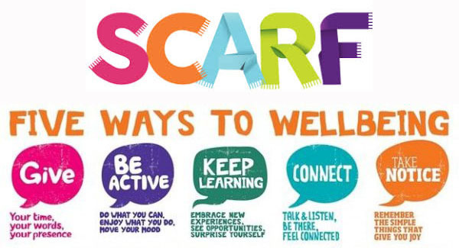 |  |  |  | Drink Aware  0300 123 1110  Narcotics Anonymous  0300 999 1212  Frank- provides information about drugs and alcohol  0300 123 6600 82111 frank@talktofrank.com  Young minds-Parents Helpline  0808 802 5544  NSPCC-  help@nspcc.org.uk. 0808 800 5000 under 18 call-0800 1111  Parent wise  https://parentwise.campaign.gov.uk/  Staffordshire support  https://www.staffordshireconnects.info/kb5/staffordshire/directory/results.page?familychannel=3-5
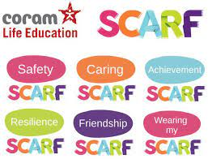
Knowledge  I know the laws regarding the use of drugs and alcohol in the UK  I know what is meant by legal and illegal  I know what is meant by viral social media  I know how to protect myself online | Skills  I can explain why emotional needs are as important as physical needs and  what might happen if a person doesn’t get their emotional needs met.  I can explain some ways of making sure that I keep myself safe when using a mobile phone, including safety around sharing personal information or images, and that there are laws relating to this.  I can explain why some people believe that more young people drink alcohol than actually do (misperceive the norm).  I can express my emotions, thoughts, feeling and opinions in a respectful manner.

