Home Learning Booklet
Summer 1
Year 2
This booklet belongs to

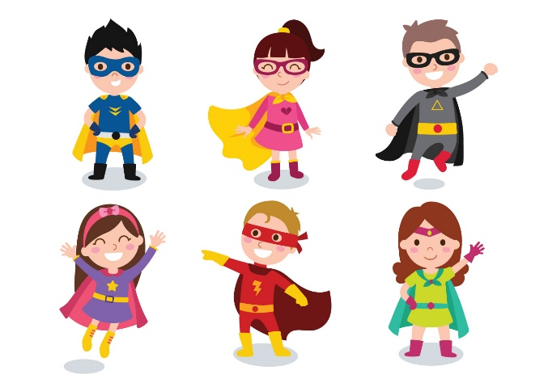

Woodlands Primary School
Homework Grid Summer 1

 | Expected |  | Exceeding Expected |  |  |  | Greater Depth
 | These need to be carried out every week |  | Maths |  | English |  | Select 2 projects from the list below to do over the half term
Week 1 | Reading at LEAST 3 times  Revisit all spellings from last term  Naming 3-D shapes |  | Writing the time under each clock. |  | Education City
Week 2 | Reading at LEAST 3 times  Complete Spelling Sheet  Adding two 2-digit numbers |  |  |  | Correcting Sentences |  | - Design your own superhero.  - Design a superhero cape and mask.  - Write a superhero story.  - Create a superhero shield.  - Superhero rock painting.  - Interview a real life  superhero and record their answers.
Week 3 | Reading at LEAST 3 times  Complete Spelling Sheet  Rhyming Words |  | Column Subtraction
Week 4 | Reading at LEAST 3 times  Complete Spelling Sheet  Multiples of 10 calculations |  | Education City |  | Using conjunctions
Week 5 | Reading at LEAST 3 times  Complete Spelling Sheet  Using Verbs |  | Multiplication Challenge
Week 6 | Reading at LEAST 3 times  Complete Spelling Sheet  Division facts |  | Education City |  | Education City

Expected
Week 1: Spelling practise: Look, say, cover, write, check
Look | Say | Cover | Write | Check | Write | Check | Write | Check
enjoyment
sadness
careful
playful
plainness
argument
merriment
happiness
plentiful
cheerful

Now choose two of the words to write in a sentence.
1. _______________________________________________________________________________________
2. _______________________________________________________________________________________
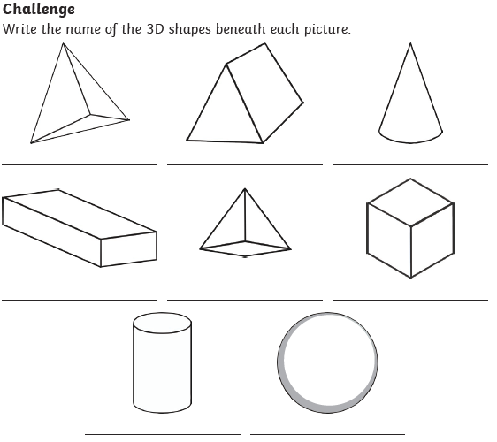
Expected
Week 1

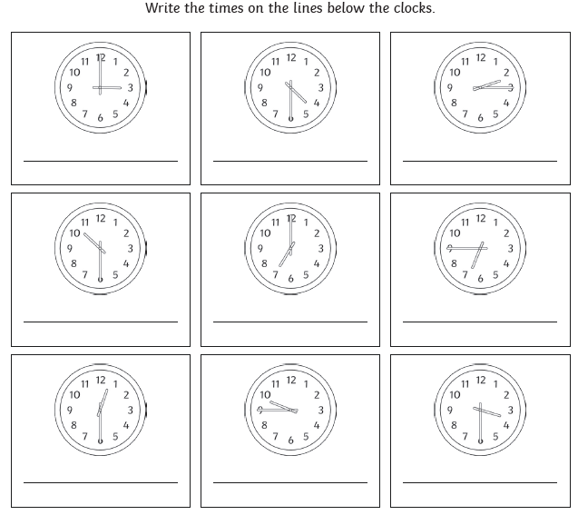
Exceeding Expected
Week 1-

Exceeding Expected
Week 1- Education City

What score did you get?
___________
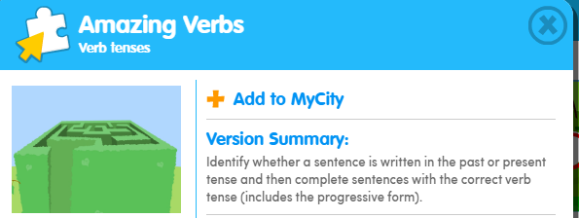

Expected
Week 2: Spelling practise: Look, say, cover, write, check
Look | Say | Cover | Write | Check | Write | Check | Write | Check
badly
hopeless
penniless
happily
lovely
joyless
slowly
quickly
careless
fearless

Now choose two of the words to write in a sentence.
1. _______________________________________________________________________________________
2. _______________________________________________________________________________________
Expected
Week 2

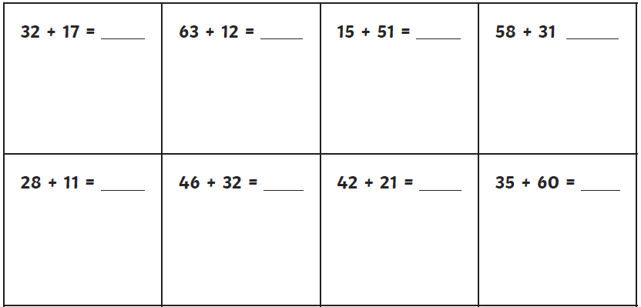

Exceeding Expected Week 2

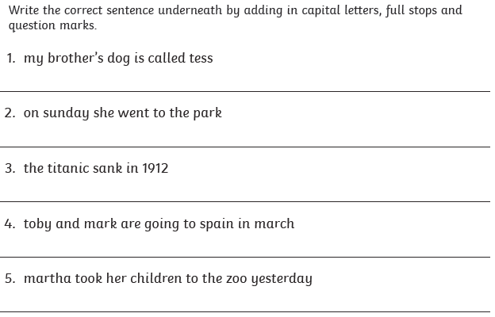
Expected
Week 3: Spelling practise: Look, say, cover, write, check
Look | Say | Cover | Write | Check | Write | Check | Write | Check
station
fiction
motion
national
section
addition
subtraction
potion
option
introduction

Now choose two of the words to write in a sentence.
1. _______________________________________________________________________________________
2. _______________________________________________________________________________________

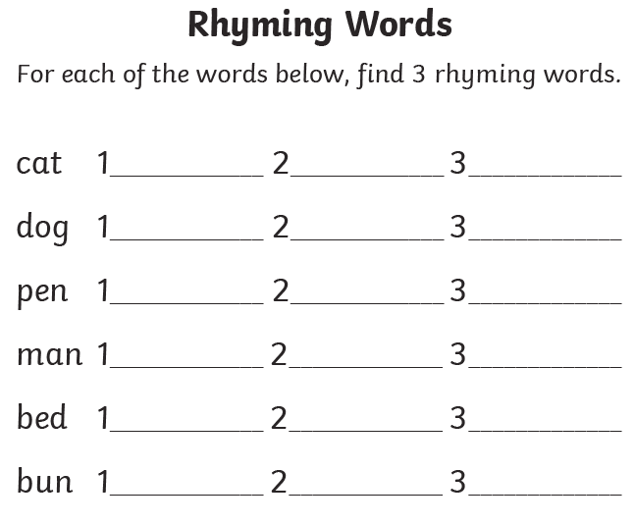
Expected
Week 3-

Exceeding Expected
Week 3-
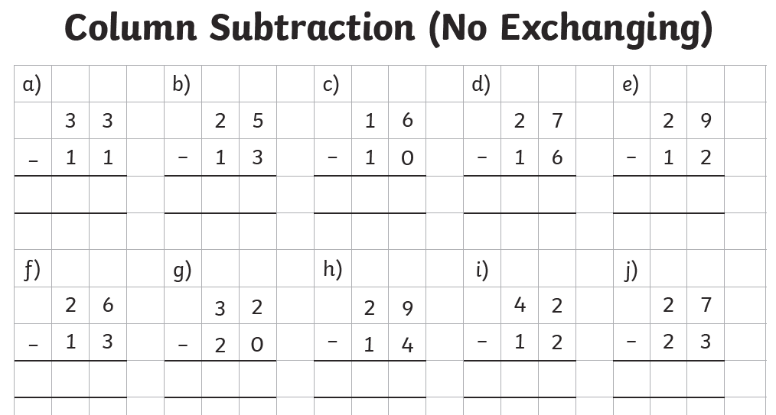

Expected
Week 4: Spelling practise: Look, say, cover, write, check
Look | Say | Cover | Write | Check | Write | Check | Write | Check
can’t
didn’t
hasn’t
couldn’t
it’s
wouldn’t
shouldn’t
wasn’t
Mr
Mrs

Now choose two of the words to write in a sentence.
1. _______________________________________________________________________________________
2. _______________________________________________________________________________________

Expected
Week 4-

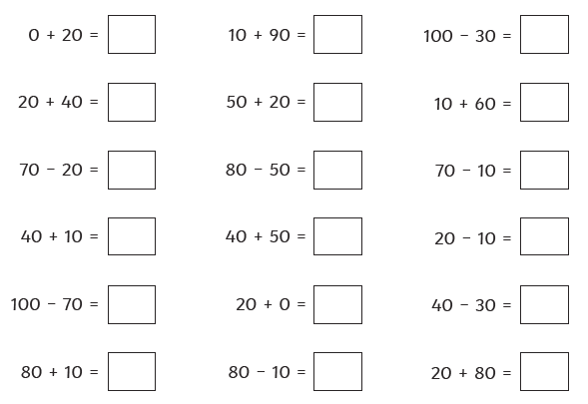

Exceeding Expected
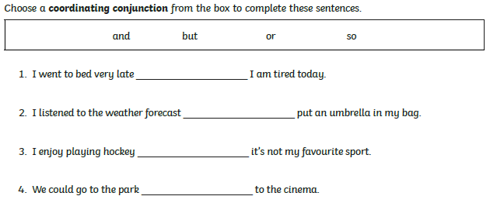
Week 4-

Exceeding Expected
Week 4 – Education City
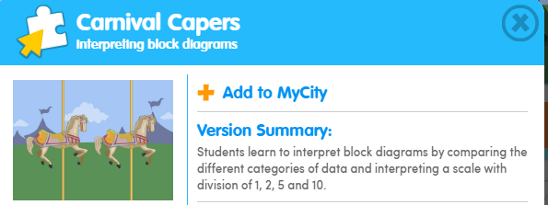
What score did you get?
___________

Expected
Week 5: Spelling practise: Look, say, cover, write, check
Look | Say | Cover | Write | Check | Write | Check | Write | Check
Megan’s
Ravi’s
the girl’s
the child’s
the man’s
the woman’s
the school’s
a dog’s
a teacher’s
a postman’s

Now choose two of the words to write in a sentence.
1. _______________________________________________________________________________________
2. _______________________________________________________________________________________
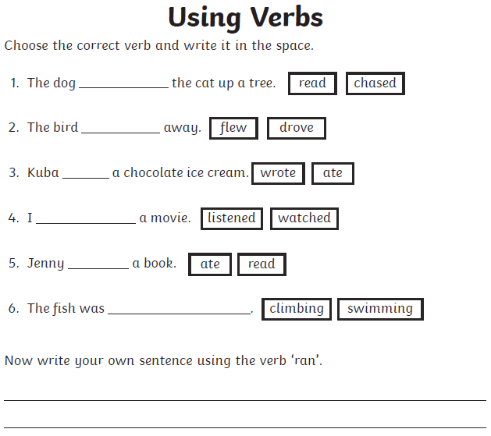
Expected - Week 5
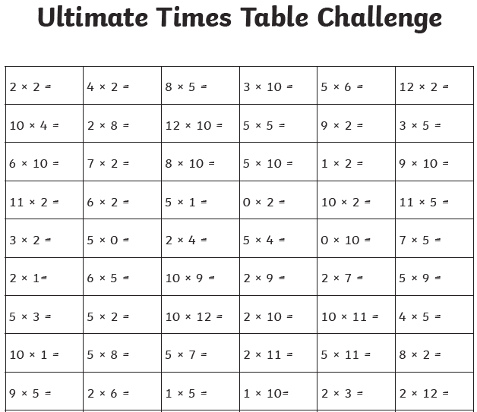
Exceeding Expected
Expected
Week 6: Spelling practise: Look, say, cover, write, check
Look | Say | Cover | Write | Check | Write | Check | Write | Check
any
many
clothes
water
pretty
Christmas
beautiful
busy
poor
kind

Now choose two of the words to write in a sentence.
1. _______________________________________________________________________________________
2. _______________________________________________________________________________________

Expected
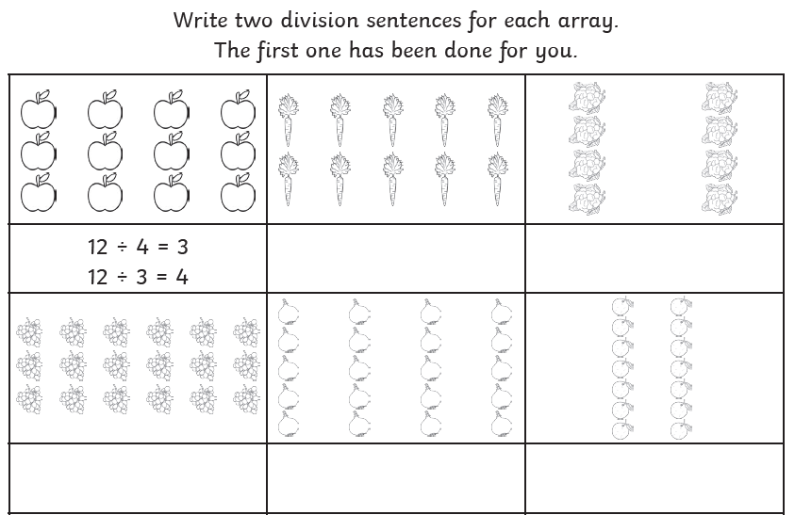
Week 6
Exceeding Expected
Week 6-
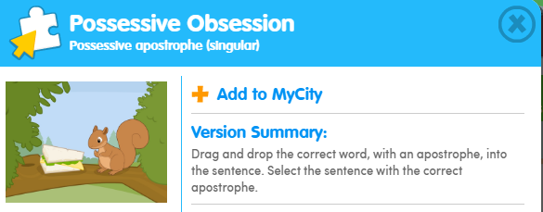
What score did you get?
___________

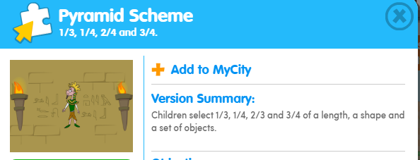
What score did you get?
___________

