Home Learning Booklet
Spring 1
Year 1
This booklet belongs to

Woodlands Primary School
Homework Grid Spring 1

 | Expected |  | Exceeding Expected |  |  |  | Greater Depth
 | These need to be carried out every week |  | Maths |  | English |  | Select 2 projects from the list below to do over the half term
Week 1 | Reading at LEAST 3 times  Revisit all spellings from last term  Complete number bonds sheet to 20 |  | Addition within 20 using tens frames.  Children to count the counters and add them together.
Week 2 | Reading at LEAST 3 times  Complete Spelling Sheet  Complete number bonds sheet  to 20 |  |  |  | Children to write the next day of the week. Choose from options.  Education City |  | - Create a 3D model of a dinosaur using junk materials.  - Research how the dinosaurs lived and what happened to the dinosaurs.  - Visit a dinosaur themed place and take photographs, Can you create a scrap book of your day?  - Create a dance moving like a dinosaur and send it to me using your e-schools login.  - Design and make an item of clothing that would be suitable for a dinosaur! Oh no it better not be pants… we all know dinosaurs love pants!!!
Week 3 | Reading at LEAST 3 times  Complete Spelling Sheet  Complete number bonds sheet  to 20 |  | Telling the time- o’clock  Children to write the time and draw the hands on the clock.
Week 4 | Reading at LEAST 3 times  Complete Spelling Sheet  Complete number bonds sheet to 20 |  |  |  | Children to unscramble the letters to spell the days of the week correctly.  Education City - Reading comprehension
Week 5 | Reading at LEAST 3 times  Complete Spelling Sheet  Complete subtraction sheet – subtraction within 20 |  | Telling the time- half past and o’clock  Children to write the time shown on the clock.  Education City
Week 6 | Reading at LEAST 3 times  Complete Spelling Sheet- Revisit any gaps from the last 5 weeks.  Complete number bonds sheet  to 20 – addition and subtraction. |  |  |  | Common exception words- Spell the common exception words correctly.
Week 7 | Reading at LEAST 3 times  Complete Spelling Sheet- Revisit any gaps from the last 5 weeks.  Complete number bonds sheet  to 20 |  | Months of the year spelling practise.

Expected
Week 1: Spelling practise: Look, say, cover, write, check
Look | Say | Cover | Write | Check | Write | Check | Write | Check
right
bright
light
night
fright
tight
high
I
by
my

Now choose two of the words to write in a sentence.
1. _______________________________________________________________________________________
2. _______________________________________________________________________________________
Expected
Week 1 Number bonds to 20.

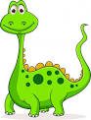
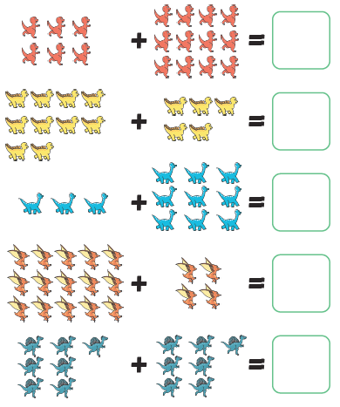
Remember that number bonds to 20 are two numbers that add together to make 20!

Exceeding Expected
Week 1- Number bonds to 20.
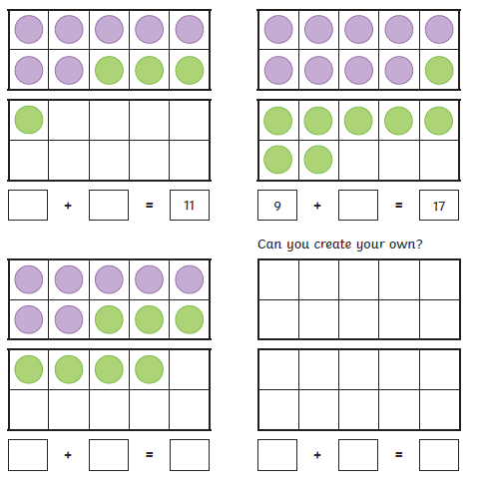
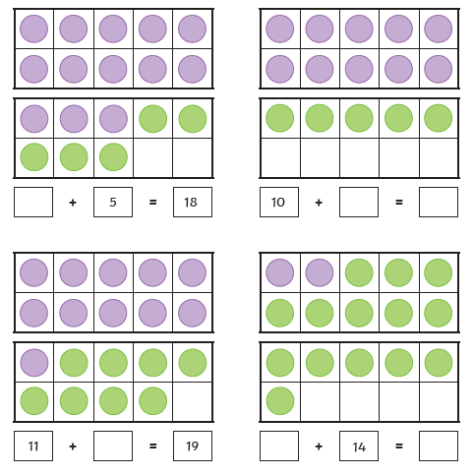

Expected
Week 2: Spelling practise: Look, say, cover, write, check
Look | Say | Cover | Write | Check | Write | Check | Write | Check
car
start
park
arm
garden
artist
star
are
were
our

Now choose two of the words to write in a sentence.
1. _______________________________________________________________________________________
2. _______________________________________________________________________________________
Expected
Week 2 Number bonds to 20.
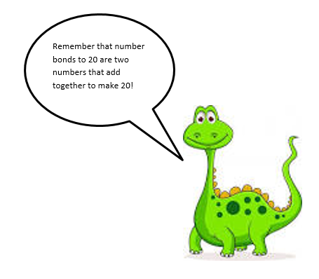
6 + = 20
+ 3 = 20
13 + 7 = hh
1 + = 20
+ 4 = 20
4 + 16 = hh
4 + = 20
+ 8 = 20
- + 19 = hh
10 + = 20
+ 9 = 20
0 + 20 = hh

5 + = 20
+ 6 = 20
9 + 11 = hh
7 + = 20
+ 0 = 20
8 + 12 = hh
6 + = 20
+ 7 = 20
5 + 15 = hh
2 + = 20
+ 10 = 20
3 + 17 = hh

Exceeding Expected
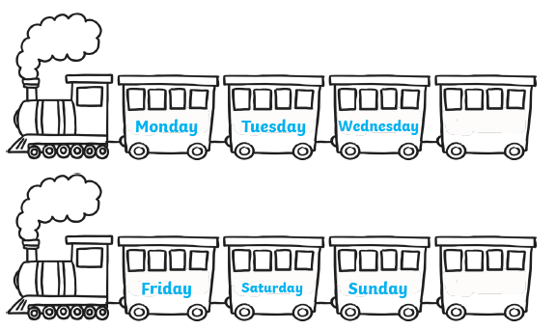
Week 2- Days of the week (Ordering)
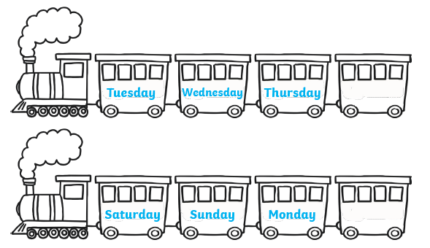
Monday
Friday
Tuesday
Thursday

Exceeding expected
Week 2 – Education City
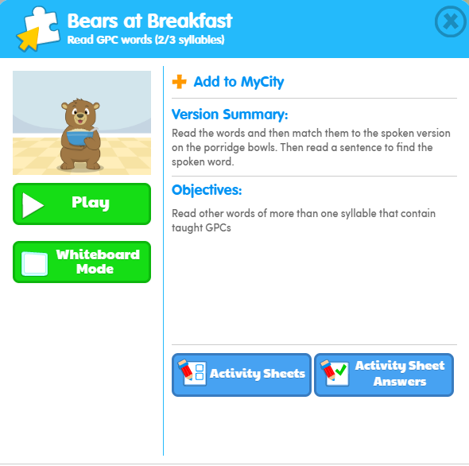
What score did you get?
___________

Expected
Week 3: Spelling practise: Look, say, cover, write, check
Look | Say | Cover | Write | Check | Write | Check | Write | Check
better
under
summer
winter
sister
rubber
her
term
verb
person

Now choose two of the words to write in a sentence.
1. _______________________________________________________________________________________
2. _______________________________________________________________________________________

Expected
Week 3-Number bonds to 20
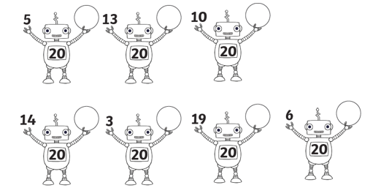

Exceeding Expected
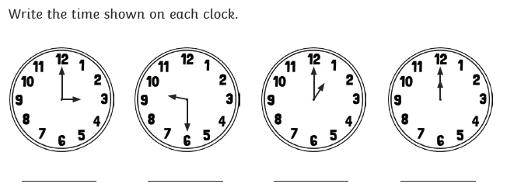
Week 3- Telling and writing the time

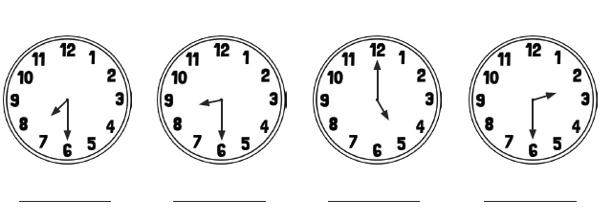

Expected
Week 4: Spelling practise: Look, say, cover, write, check
Look | Say | Cover | Write | Check | Write | Check | Write | Check
girl
bird
shirt
first
third
turn
hurt
church
burst
burn

Now choose two of the words to write in a sentence.
1. _______________________________________________________________________________________
2. _______________________________________________________________________________________

Expected
Week 4-Number bonds to 20
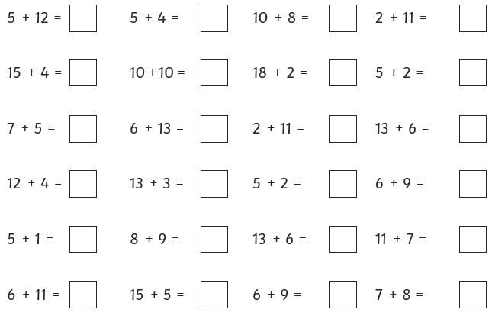

Exceeding Expected
Week 4- Unscramble the letters to spell the days of the week correctly.

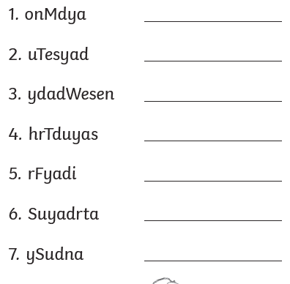

Exceeding expected
Week 4 Reading comprehension
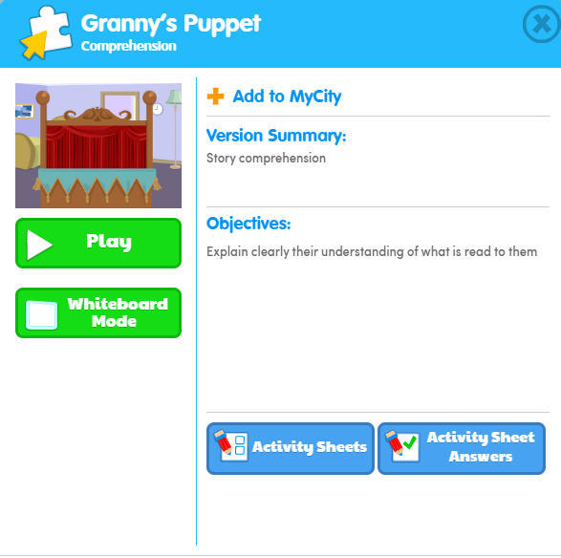
What score did you get?
___________

Expected
Week 5: Spelling practise: Look, say, cover, write, check
Look | Say | Cover | Write | Check | Write | Check | Write | Check
grander
grandest
fresher
freshest
quicker
quickest
taller
tallest
slower
slowest

Now choose two of the words to write in a sentence.
1. _______________________________________________________________________________________
2. _______________________________________________________________________________________

Expected
Week 5 Subtraction with numberlines.
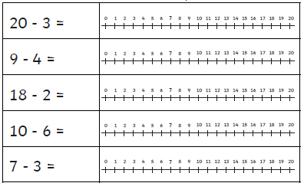
Exceeding Expected
Week 5- Telling and writing the time to the nearest half hour (half past).
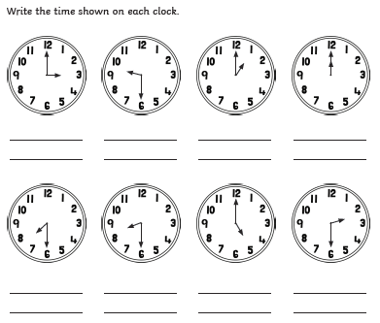
Exceeding Expected
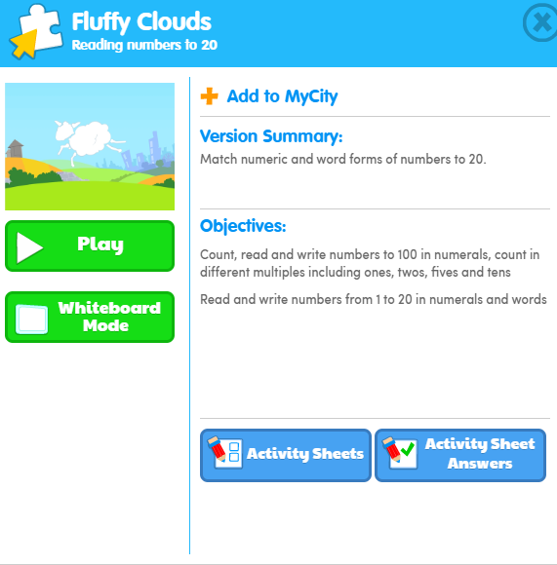
Week 5
What score did you get?
___________

Expected
Week 6: Spelling practise: Look, say, cover, write, check
Look | Say | Cover | Write | Check | Write | Check | Write | Check
Monday
Tuesday
Wednesday
Thursday
Friday
Saturday
Sunday
there
here
they

Now choose two of the words to write in a sentence.
1. _______________________________________________________________________________________
2. _______________________________________________________________________________________
Expected
Week 6 Number bonds to 20.
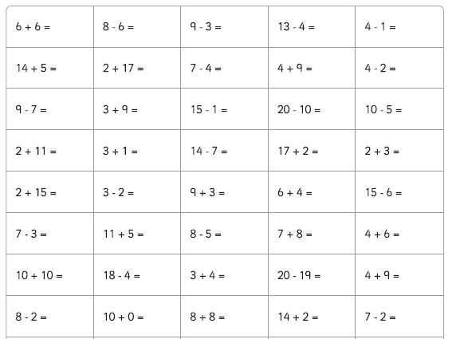

Exceeding Expected
Week 6- Common exception words- Read and apply the correct common exception word to the sentence.
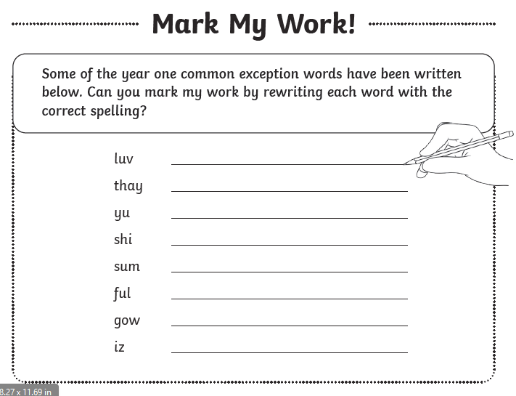
Expected
Week 7: Spelling practise: Look, say, cover, write, check
Look | Say | Cover | Write | Check | Write | Check | Write | Check

Now choose four of the words to write in a sentence.
1. _______________________________________________________________________________________
2. _______________________________________________________________________________________
3. _______________________________________________________________________________________
4. _______________________________________________________________________________________

Expected
Week 7-Number bonds to 20
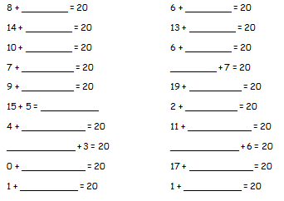

Exceeding Expected
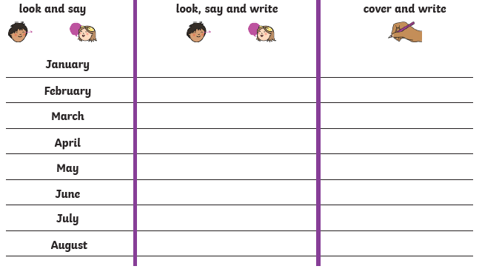
Week 7- Months of the year spelling

